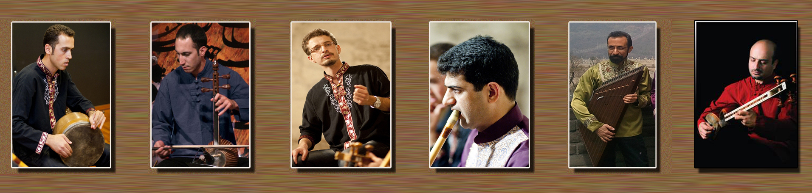
Rahavarde-Parsian; A Present from Persia!
“The Night of Persia…”
Shiraz Rahavarde-Parsian music group concert has announced:
Tbilisi Museum
July 2014-07-15
06:00pm

