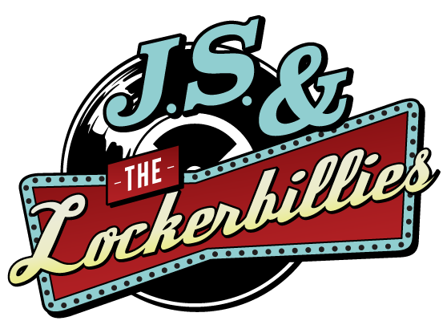

Quartet Tech Spec

Bass, guitar, vocals
Drums
Bit of everything
Keys mon
Keys/Sax
Gtr Amp
Drum mon
Bass amp

Kit provided  Guitars  Vox ac30  Double bass  Fender rumble  Drums  Kick  Snare  1 rack tom  Floor Tom  Hi hat  Crash/Ride  Vocals  Backing vox  Keyboard  Saxophone | Kit required  1x mic  1x DI  1x mic  1x mic  1x mic  1x mic  Overhead  Overhead  1x mic  1x mic  1x Di box  1x mic
Stage front
Guitar, vocals
Bass, vocals
Vox mic
Gtr pedals
Bass mon
Vox mon
Many thanks,

Josh Locke
Band Leader of J.S & the Lockerbillies

Telephone: 07939479672
Email: joshlocke@hotmail.com

