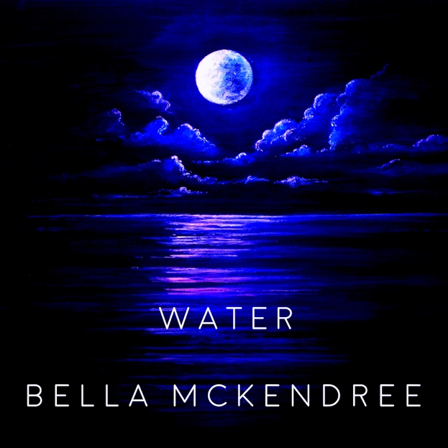

BELLA MCKENDREE
SINGLE RELEASE - ‘WATER’
2nd MARCH 2018

British singer-songwriter Bella McKendree has announced the news of her new single, ‘Water’, self –released on 2nd March 2018.

Bella’s new sounds are highly anticipated after her Debut E.P ‘Waiting’ received a great reception in summer 2017. BBC Introducing Kent picked up ‘Baby Let’s Fall’ naming it Record of the Week and spun the lead single ‘Grieve’. The single was premiered by Clash (Record of the Day) and featured in Music Week.

Fragile yet upbeat, ‘Water’ tells a beautifully honest story. Sticking with the same producer, Grammy Award-winning Brett Shaw (Ed Sheeran, Lady Gaga), the new single sees Bella take on new ground adding strings and brass for the first time with a strong emphasis on the percussion. Bella’s transparent lyrics are brought to life by her powerful voice complemented by her deep connection to the piano. ‘Water’ was written in an attic during a winter in Notting Hill while reminiscing of a previous summer. Influenced by a crossover of artists from Beirut, Alt-J to Nick Mulvey, Bella’s haunting voice transports you to a state of reflection while the rhythms carry you to a lighter space.

Though London-based, Bella is an artist born out of the countryside, using landscapes to convey emotions in her lyrics, creating songs that stay with you.

Following last year’s release, Bella played numerous London shows and U.K festivals with her band including Gorjys Secrets, Sunrise Celebration, Camper Calling and an E.P Launch at St Luke’s Church, Kentish Town. In October 2017, Bella embarked on her six-week Solo European Tour promoting her E.P. She played numerous Sofar Sounds shows from Berlin to Rome in addition to independent venues, a national TV feature and radio sessions.

Water is out 2nd March 2018.
Online Socials:

https://www.musicglue.com/bellamckendree
https://bellamckendree.bandcamp.com
https://www.facebook.com/bellamckendree/
https://www.youtube.com/bellamckendree
https://soundcloud.com/bellamckendree
https://twitter.com/bellamckendree

