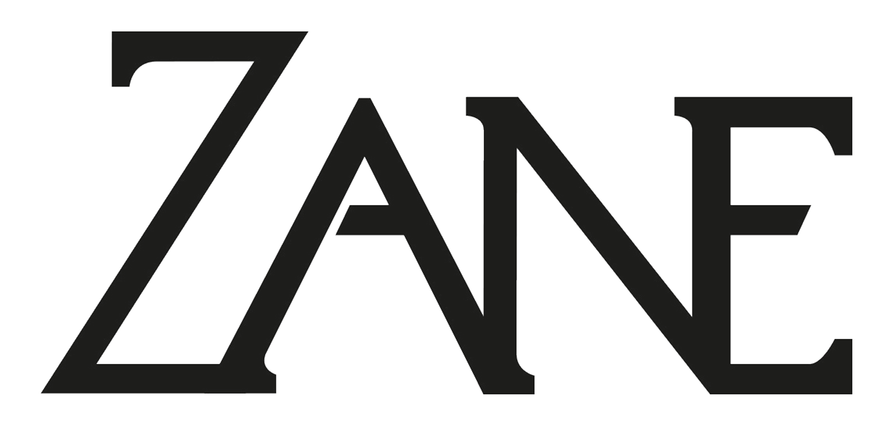
www.ZaneBarratt.com
(778) 926-2655

Zane is a musician with a story to tell. From teenage years busking the streets of Vancouver, Zane has travelled the world, lived outside with punks, meditated for months on end, volunteered in Nicaragua, and played in the bars, trains and streets of Berlin where he recorded his premier EP Les Biens with Rob Willis. Back in Canada, Zane has since recorded his first LP Likeness House, a second EP Empire and most recently a single about the culture of drought named Desert Blossom.
Zane's sound is characterized by his deep expressive voice and electric baritone guitar, which features heavily on his tracks. Catchy hooks combined with innovative arrangements, creative recording and electronic sounds give Zane's music a unique character, which draws influence from Grizzly Bear, Mother Mother and Jack White.
His fresh sound and charisma has secured him attention of promoters around Berlin, warming up at a sold out show for Sheppard (Universal), and recording as a featured artist for Chi Thanh and MC Fitti.
Outside the world of music, Zane writes poetry, runs live music workshops in contemporary dance, is involved in the gay community - as a result of his gay parentage and has written about his experience as a street musician for Shlur magazine.

