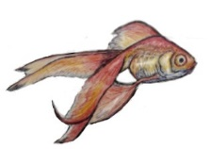
AASS
TECH-RIDER
AASS consists of Arthur Adam en Stefan Schneider. Together they make experimental, intense and largely improvised music that sounds like postrock-meets-(free)jazz-meets-movie-soundtracks, and bears resemblances to and influences by Efterklang, James Blake, Motorpsycho, Radiohead, Bon Iver.

Our set-up:

ARTHUR (lead vocals, guitar, bass guitar, keys):
2x xlr for vocals (I have my own microphone with stereo effects)
1x DI for guitars (all my instruments go through the same effect channels)
1x mic for amplifier (DI signal for instruments will be patched through to a small fender tube amp)

STEFAN (drums, digital drums, samples, percussion and synths):
3x xlr kick/floor; snare, overhead
2x DI voor drumpads (roland spd sx)
2x DI voor el. piano
1x mic vocals (optional)

GENEREAL
4x Mic Stands min. 2,10 m
2 monitors
PA with mixer
Tripod or something similar for the beamer
(If possible a big white projectionscreen )

On stage we are closely together, actual set-up will differ, but somewhat like this: (2,50m x 2,50m)

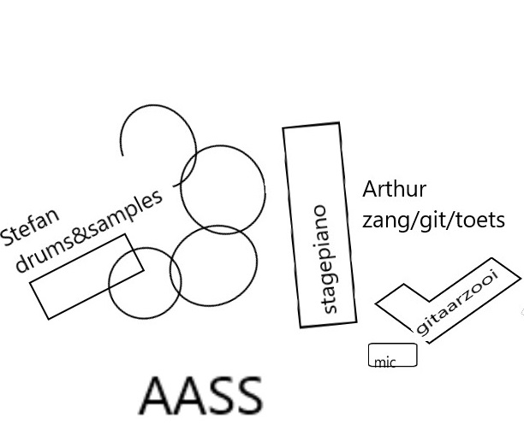

Contact: Arthur Adam ten Cate - arthuradam@bandbusrecords.nl - 06-27441201 - www.aass-stereo.de
FOOD RIDER

We are four persons, who all eat vegan.
For the show, we would appreciate a couple of bottles of water on stage.

