Technical rider & Stage plan

First of all, thank you for your interest in booking a show for Gayana.
Below is a list of our technical requirements. It might sound a bit formal to you, this is not meant to cause any inconveniences on your behalf. We designed this rider for optimum effectiveness at the day of the show. If there are any questions or if you have trouble providing any of the below mentioned please get in touch with us before the day of the show and we will work out a solution.

Soundcheck:
We will need an absolute minimum of 60 minutes soundcheck, 90-120 minutes including setup would be perfect.

PA:
We assume that there is a well sized PA system provided for the concert room with sufficient power to supply a clean and undistorted 105dBA SPL to the mixing desk and a powerful and feedback-proof monitor system. It is very important that each musician have their own monitor speaker with separate mix. We will need LR sidefills for large venues.

FOH:
Any digital console (preferably Avid Profile/ Midas Pro/ Allen&Heath dLive, GLD / Midas M32 / Yamaha CL)

Backline:
DRUMS:
-Drum kit, preferably Yamaha, Sonor, DW, with drummers throne.
-Bass Drum 22”x16” (dampened with any kind of soft material)
-Floor Tom 16”
-Cymbals kit Zildjian K (A) custom or Sabian AAX, HHX
-Cymbals stands - 4 pcs.
-hi-hat stand
-snare stand
-kick pedal
-empty rack/stand for PC
-active DI BOX, preferably Radial J48 - 6 pcs.
-floor carpet 2х2m
BASS:
-Bass Amp - preferably Ampeg SVT Pro, Mark Bass
-active DI BOX, preferably Radial J48 - 2 pcs.
-keyboard stand
-bass guitar stand

GUITAR:
-guitar amp preferably Marshall JVM 205C (JCM 800, 900, 2000),
Any other amp should have a Return Send option!
-guitar stand

Other:
Straight mic stand for lead vocalist

Staff:
We need a qualified stage technician and lights technician.

Input List & Stage Plan

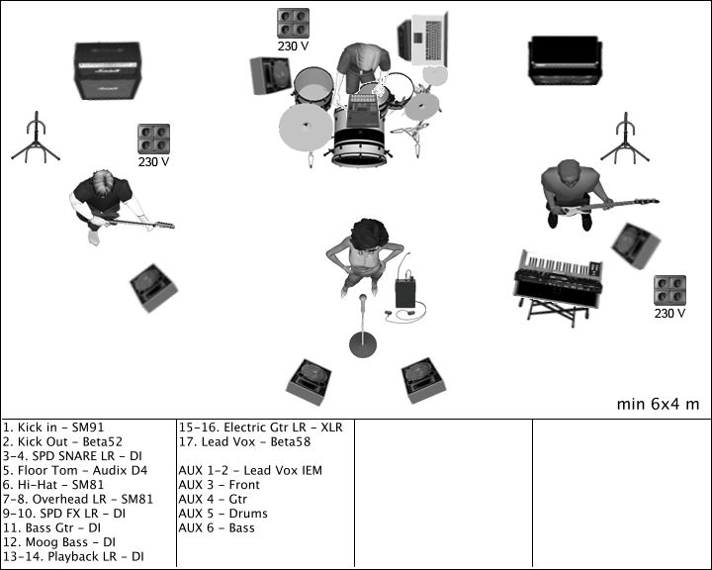

Facebook: facebook.com/yury.barbuk
Skype: yorendj
Tel: +375296318646
e-mail: yoren@yandex.ru
www.gayanamusic.com

Domestic Rider

Arrival:
Please provide detailed directions two weeks before the date of the show with the complete address of the venue and a telephone contact.
We need a safe parking space available for the van close to the venue. Please provide arrival, soundcheck and doors-open and on-stage times. The promoter or another person should be at the venue at arrival time.

Food & drinks:
6 regular meals or 6x15$ for buy-out
12 bottles of cooled non-carbonated water for stage and backstage
3 liters of other cooled drinks (juice and coke)
Breakfast for 6 persons the morning after the show

Backstage:
A separate room for the band to get some rest before and after the show. It would be great to have some sofas, tables, chairs, a mirror and sink.

Sleep:
A warm, clean, dark and quiet accomodation for 6 persons with mattresses, bath room, shower and mirror. A safe parking space near the sleeping accomodation should be available.

Merchandise:
A table of approx. 1.5m length and a small light or some candles for our merchandising in the same room as the show, if possible.

Advertising & Promotion:
There`s a large amount of promo material we can send to you for advertising purposes. Don`t hesitate to write, if you need posters or flyer and promo templates, logos or pictures in various file formats. Just get in contact with us. There`s no corporate identity in our advertising, but a corporate feeling for what the band is.

Thanks a lot for all your help!
www.gayanamusic.com

