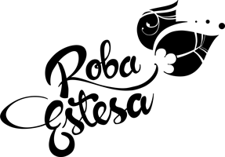

CATERING RIDER ROBA ESTESA “DESGLAÇ TOUR 2018”

- 24 water bottles without gas for soundcheck
- 24 water bottles without gas before concert
- 12 lemon schweppes
- 12 tonic schweppes
- 6 orange schweppes
- 12 Coca cola.
- 1 Gyn Bottle (like Seagrams)
- Fruit (banana, oranges, apples)

