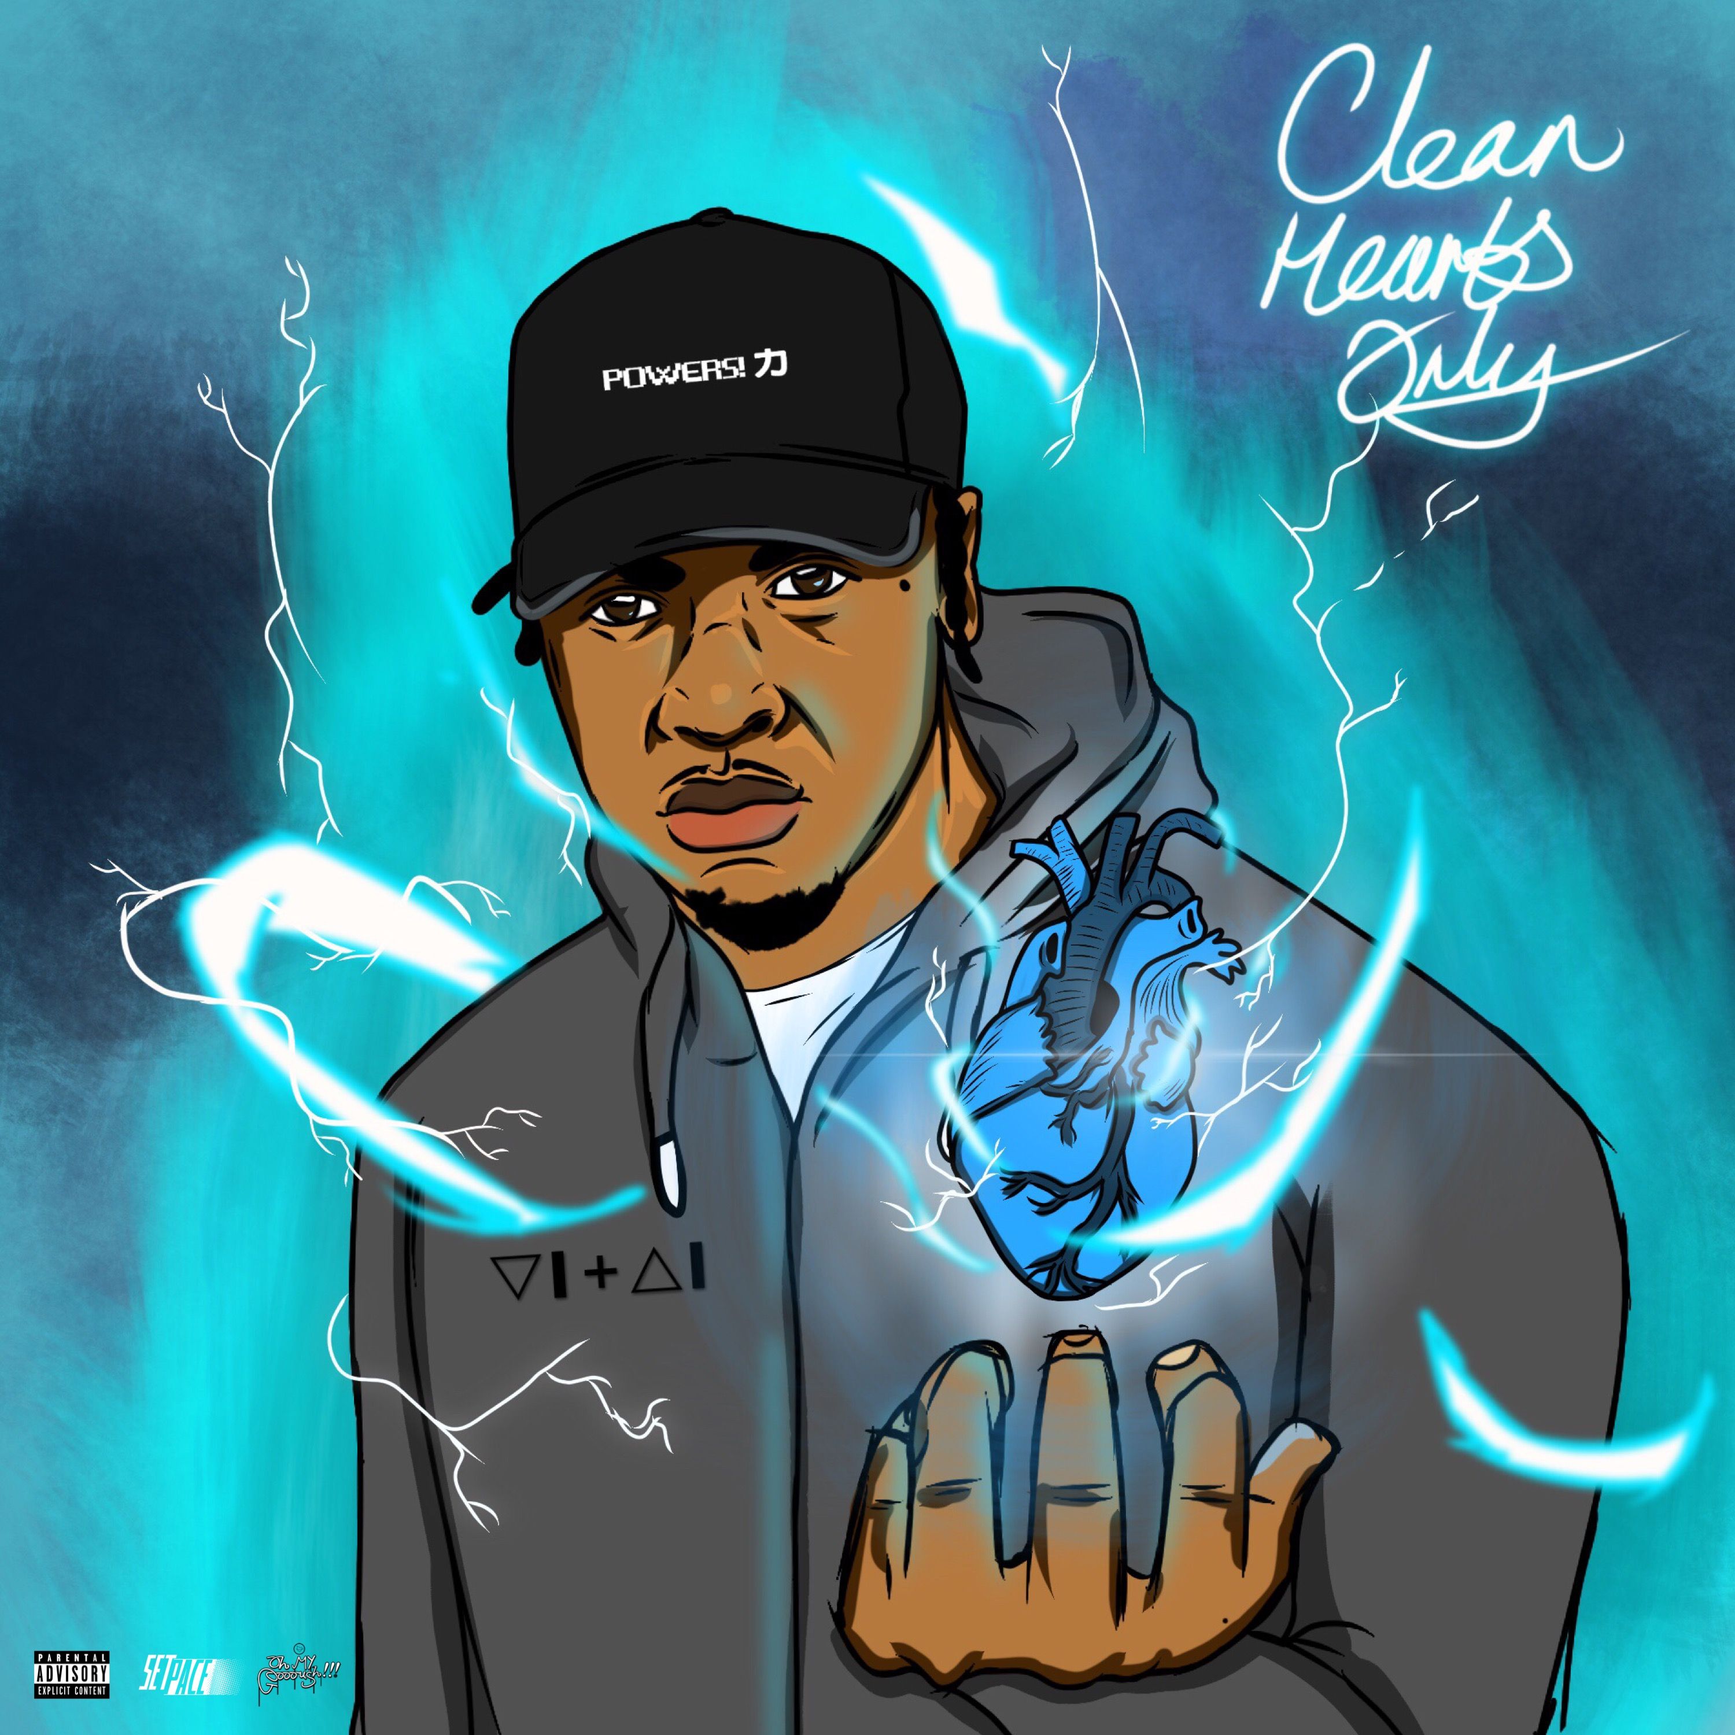

VITAL - Clean Hearts Only

After the success of POWERS!
E.P hitting top 20 on the iTunes Hip Hop Charts!
which led to the POWERS Headline Show, self-promoted / organised, bringing in over 400 people.

VITAL is Back again with a new Project, with no time since his last release, Vital hasn't stopped,
this release offers a collective of 12 tracks, from Dancehall to Grime and back to element completely more heartfelt.
Featured sounds of Heckz, Westlee, BeeNiice & Phundo Art and Production from Detonator, Heckz, IvoryBlocc, Juxta & City of Gxd.

From start to finish you further understand what Vital is about but also get to see a more aggravated, controversial side, you get a strong glimpse of pain Vital feels and how he handles it, better yet the lack of handling it.

Cleanest Heart is what Vital says he has but in this it feels as if he is fighting demons and trying to in fact reclaim his clean ways.
Its perfect for the times and an even better set of music to listen back to for countless times.

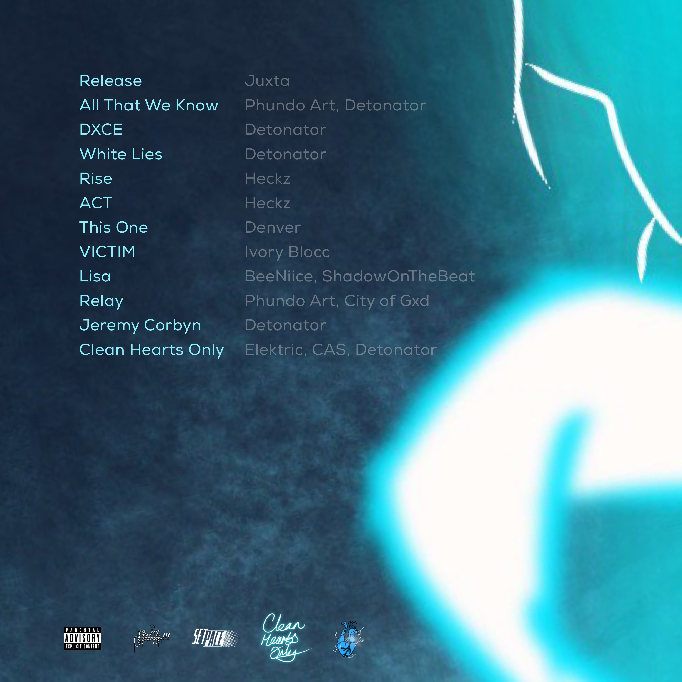

#CHO - Out Now!

Mixed, Mastered & Co-Produced by Heckz - Setpace.

----------------------------------------------------------

(Your Personal Copy: Clean Hearts Only.zip [ Full ] [Dont Share This Link])

Purchase Link: #CleanHeartsOnly

----------------------------------------------------------

Current Visuals!

Victim - https://www.youtube.com/watch?v=pHDqz4cZhr8

All That We Know - https://www.youtube.com/watch?v=1jbKM9UNCBU

[Promo] Ghost - https://www.youtube.com/watch?v=oOsS0KjS5MU

[Promo] CHO Freestyle - https://www.youtube.com/watch?v=OWFYTr4s-yw

[Promo] Pagans - https://itunes.apple.com/gb/post/idsa.aa2bacb0-9382-11e7-a9dc-405a6056facb

Previous Material

Chromosome X & Y
https://www.mediafire.com/file/y1jaf1z75c1z8oh/VITAL%20-%20Chromosome%20X%20%26%20Y%20-%20E.P.zip

POWERS! - E.P - https://www.mediafire.com/folder/15um9ouwj0ven/VITAL_-_POWERS!_-_E.P_%5BProduced_By_Heckz%5D

Dead Or Dying - Single - https://www.mediafire.com/folder/nwsuu40rfu6v4/Dead_or_Dying_-_single

--------------------------------------------------------

All the music videos on available via my Instagram / youtube account.

Stay Connected
@Vital0 - Insta / Snap / FB/ Twitter / Soundcloud: etc.
#CleanHeartsOnly: OUT NOW!

