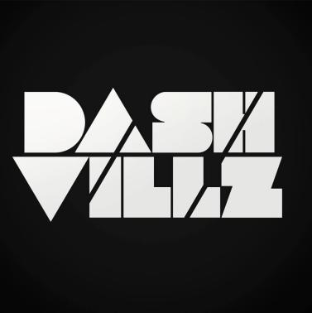

DASH VILLZ: Technical Rider:

- 2x Microphones

- Dj Desk/Table Mixer

- Serato

- CDJ + USB

