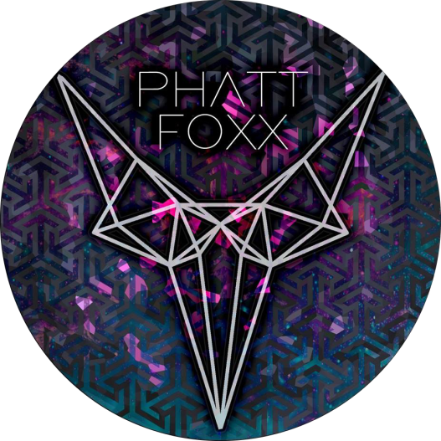
PHATTFOXX
Tech Rider

Marty Kelly- Vocals 1 (main)
Lewis Brade- Vocals 2 (main)
Gawain Wright (Guitar)
Danny Webster-Hurd (Bass)
Aidan Pitchfork (Drums, left handed)

The band will supply: drum breakables including symbols and snare, guitar, bass, one guitar head, one bass head.
The venue will supply: drum throne, toms & kick drum, symbol stands (if possible) drum carpet, 1 left xlr lead, 1 right xlr lead, 1 bass head, 1 guitar head, 2 microphones.

If the venue is unable to provide any of the equipment above, please contact Manager Emily Bitton at Emily.btnevents@outlook.com so we can coordinate other arrangements.

