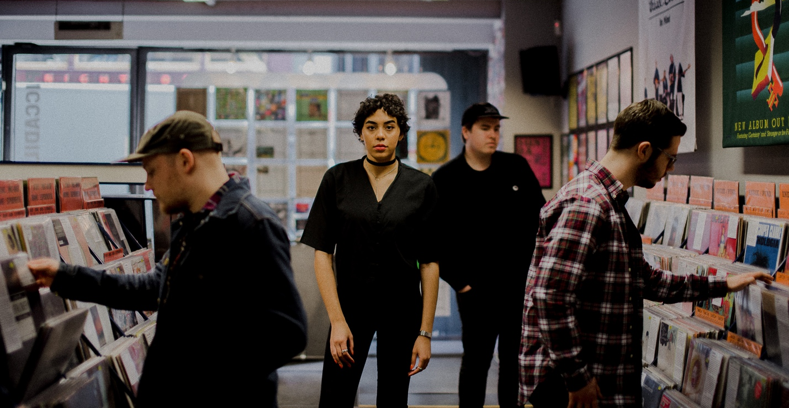
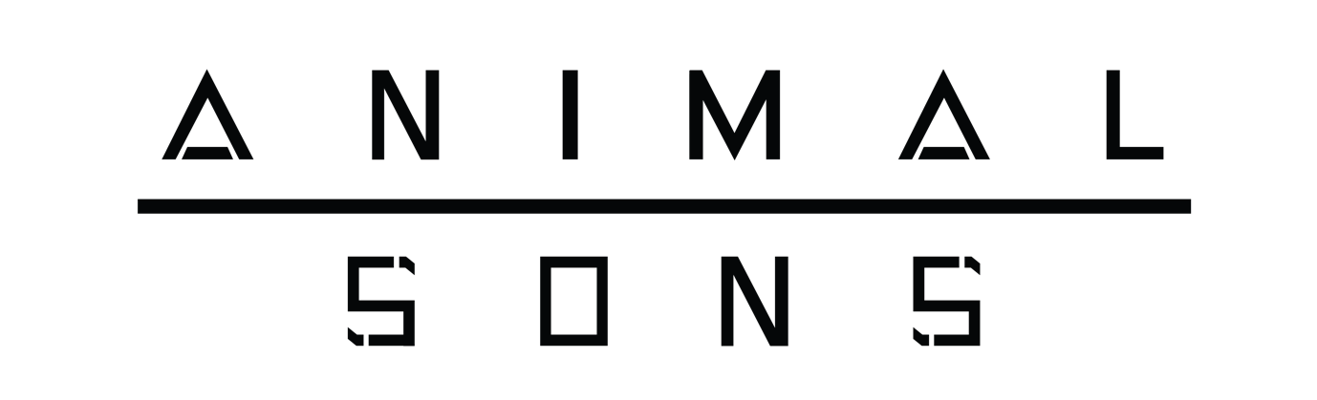
Animal Sons are an alt-rock band, hailing from Manchester UK. After releasing their debut single ‘In the Dark’ in April 2017 they went on to play a sold out headline show at Soup Kitchen in Manchester.

This was closely followed up with a number of shows across the country including Dot to Dot Festival alongside acts such as Sundara Karma and Amber Run.

BBC Introducing Manchester have championed the band from the start, playing ‘In the Dark’ just two days after it was released. They have offered continued support since giving the band regular play on the show and inviting them to do a live acoustic session for Introducing show in May 2017.

September 13th was a landmark day for the band where they released a second single titled ‘Hold On’ and played a show at Selfridges Ultralounge London which was streamed live online.
October saw the band play their first notable support slot, performing alongside Welsh rock band Pretty Vicious in association with SJM Concerts and United Talent Agency. The act is signed to Virgin EMI Records and have themselves supported artists such as Noel Gallagher, Catfish and the Bottlemen, Stereophonics, Wolf Alice and Nothing but Thieves. On 2nd October the band play Sound Control in Manchester.
On November 30th 2017 the band released their debut self titled EP and went out on a short UK tour playing in Leicester, Sunderland, Middlesbrough, Liverpool and Manchester.
To close the year Animal Sons play arguably their biggest show yet supporting Boy Jumps Ship at the 1200 capacity Newcastle Riverside.

Stream / Download ‘Animal Sons EP’ here
Stream ‘Hold On’ via Spotify / iTunes / Apple Music
Stream ‘In the Dark’ via Spotify / iTunes / Apple Music
Watch the ‘Hold On’ music video here
Watch the ‘In the Dark’ music video here

Animal Sons – UK Shows
17.12 / Riverside / Newcastle (w/ Boy Jumps Ship)

www.animalsons.com

