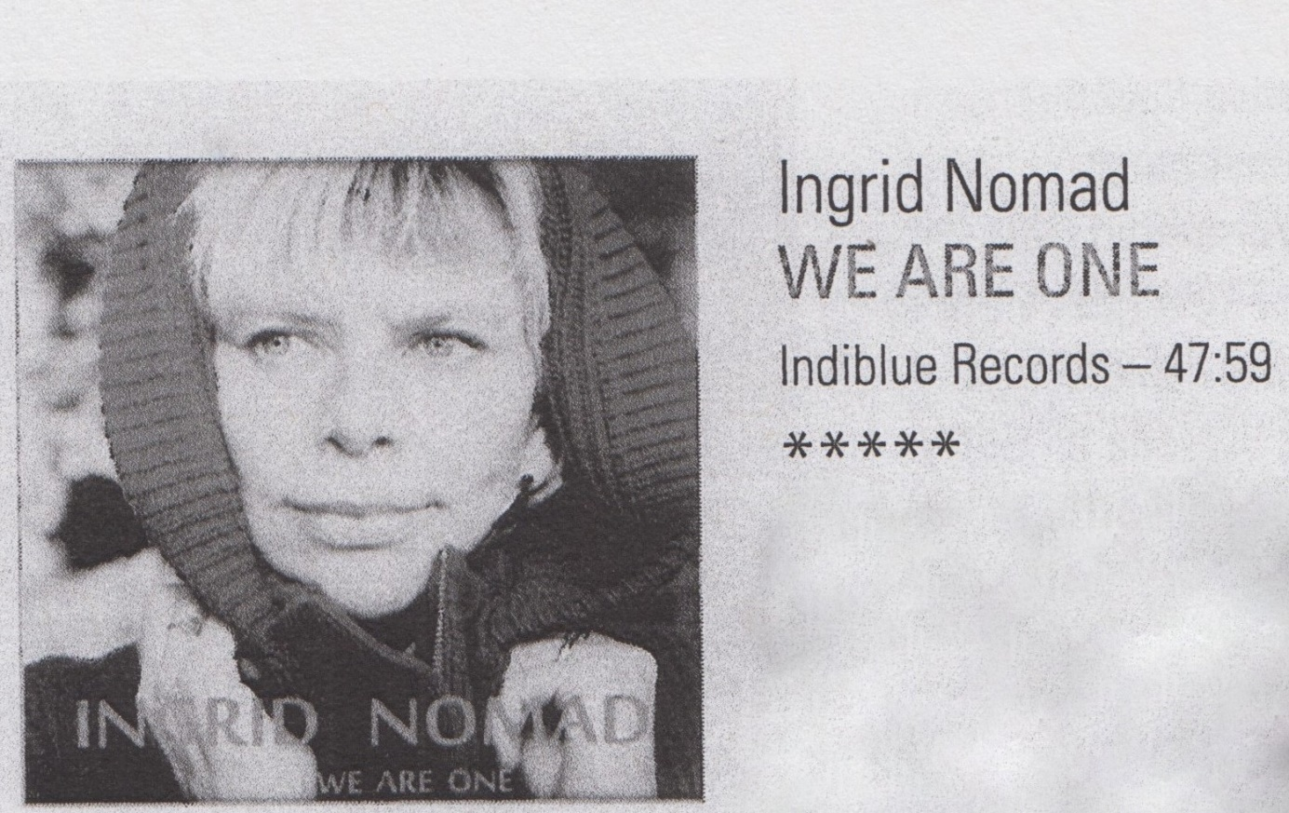
What we first noticed about this first album of Ingrid Van Hoorebeke (Jazz of Ghent) – was the warm, clear and simultanously transparent voice of the singer. Much appreciated in the eleven self-written songs.
Most of the tunes are actually immersive songs (often lyrical ballads), within a ferm amount of smooth jazz.
The singer brings her own lyrics to life with lots of expression and thus weaves her own universe in which the musicians play a beautiful part. Sabin Todorov emphasizes the lyrical character of the album, not only through beautiful and intimate accompaniment but even so with his solos.
This is by no means woolly, no, she sets out a firm melodic line that stands strong. She signs up for refined arrangements, not much we can say about that, as this album is very homogenous in atmosphere and level.
The bass follows expressively and neatly with the melody : the appropriate note with the right intonation at the right time. An art that stands on itself. The drummer keeps it sober but plays very responsive with the fluctuations in the music – not an easy job – but executed with verve. Especially as Stephan Pougin uses the percussion with an adequate sensitivity. This makes the rhythmic section very interesting.
The collaboration with cellist Annemie Osborne let’s us know what possibilities this band has. Subtlety is one. This instrument brings very pleasant highlights and a fluid approach with the voice. ‘Time and Water’ are outright beautiful.
We were pleasantly surprised by this album of a singer and a quartet, who complete each other. With this debut work you have every reason to be proud. Keep in mind that this is not a full-fledged jazzalbum – although this is less important – you’ll get entrance to a very beautiful build up world of lyrics and tunes in harmony with each other. A voice with a lot of potential and lyrics that have something to say.
“Jazzmozaiek” – March 2017 – Marc Van de Walle
Ingrid Nomad (voc), Sabin Todorov (p), Sal La Rocca (db), Stephan Pougin (d, perc), Annemie Osborne (cello)

