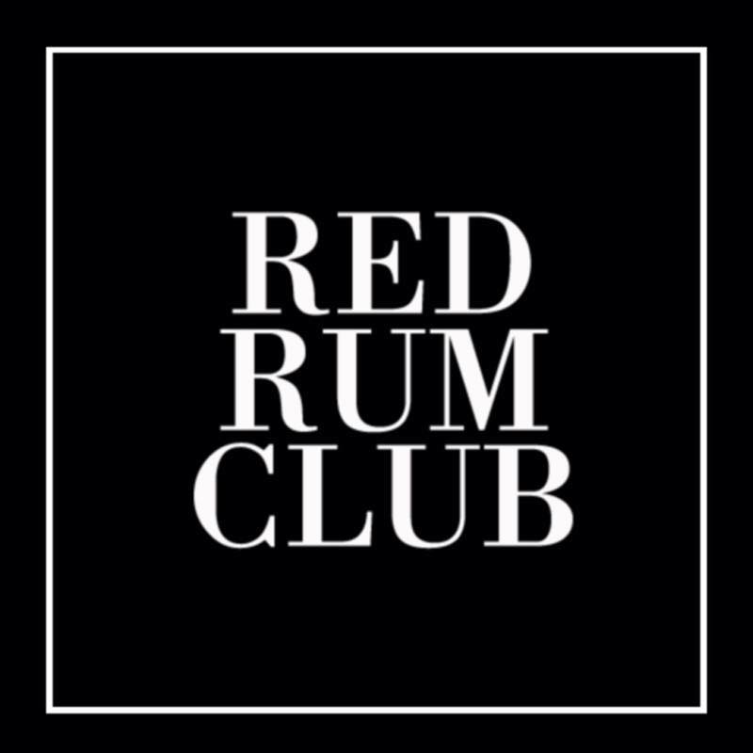

Red Rum Club are a sextet from Liverpool, channelling ‘Tarantino-esque’ wild western vibes with the help of a solitary trumpet. With both singles ‘Everybodys Friend’ and ‘Alone Together’ receiving frequent Radio X, 6 Music and Radio 2 plays whilst also being championed by BBC Introducing in Merseyside with constant plays and live sessions. Amongst the 80s Liverpool influence they also deliver a modern twist of poetic yet catchy lyrics combined with melodies that blend to create the sound that is unmistakably, Red Rum Club.

Selling out shows in the northwest and with UK tours completed in May and July as well as numerous festival appearances nationwide, they prepare for UK headline dates in October.
“Stinging angular guitar riffs, rasping vocal snarls and that trumpet proved to be the winning ingredient adding an Americana twist to their Mersey rattle” – Peter Guy, Liverpool Echo, Get Into This

Social Media

Facebook - https://www.facebook.com/RedRumClubBand

Twitter - https://twitter.com/RedRumClubBand

Instagram – https://www.instagram.com/redrumclub/

Soundcloud - https://soundcloud.com/redrumclubuk

Videos

Sofar Sounds Live Track
https://www.youtube.com/watch?v=clyLpKi0UAI

Live Gig Video (Fan Filmed)
https://www.youtube.com/watch?v=qv_8-r1M1XU

Alone Together – Official Music Video
https://youtu.be/JCO-J4A5KQY

Reviews

http://www.liverpoolecho.co.uk/whats-on/music-nightlife-news/red-rum-club-bringing-big-11786103

http://www.getintothis.co.uk/2016/08/red-rum-club-unleash-stunning-debut-single-everybodys-friend/

http://www.getintothis.co.uk/2016/08/merseyside-musics-best-new-acts-2016-getintothis-new-breed-ones-watch/

http://soundcity.bidolito.co.uk/2016/05/sound-city-sunday-paul-fitzgerald/

https://poppedmusic.co.uk/2016/05/05/festival-review-festevol-2016/

http://www.getintothis.co.uk/2016/03/lying-bastards-red-rum-club-psycho-comedy-floormen-dave-mccabe-black-lodge/

http://www.getintothis.co.uk/2016/12/getintothis-top-merseyside-tracks-2016/

https://www.fredperry.com/subculture/profile-this-feeling-big-in-2017

