DogOn Stageplan/Rider
Eric Hunziker, Guitar
Thomas Tavano, Bass
Tobias Hunziker, Drums
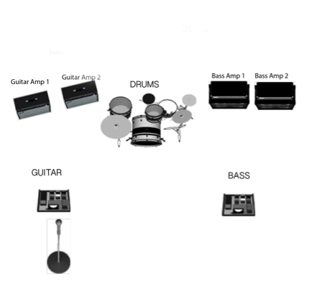2 Guitar-Amps (Stereo) 2 MIcs (Fender Hot Rod – or similar)
2 Bassamps (Stereo) - 2 Mics/or DI
Drums: 20" BD,
10",14" oder 12"Toms 16" Floor-tom,
3 Cymbal-Stands,
Hi-Hat St.,
Snare St, with Ball Joint if possible
Carpet
1 Mic for Announcements
DI-Box Stereo-Minijack (to connect one i-Pad)
(Kontakt bei Fragen: Eric Hunziker: +41 79 507 81 27 eric.hunziker@dplanet.ch)

