MORA lit up the musical radar in 2016 when she realized she could combine two great passions in her life: justice and singing. Gifted with a voice described as, “Janis Joplin meets Nina Simone”, MORA quickly found herself gigging, in demand on the festival circuit and recording her first album of carefully chosen songs by her favoured writer, George Borowski and with her hand-picked top drawer players. She is captivating audiences with songs reflecting our times and sharing compassion with conviction whilst also shattering glasses with power ballads and rock out anthems …… defying genre by creating her own. 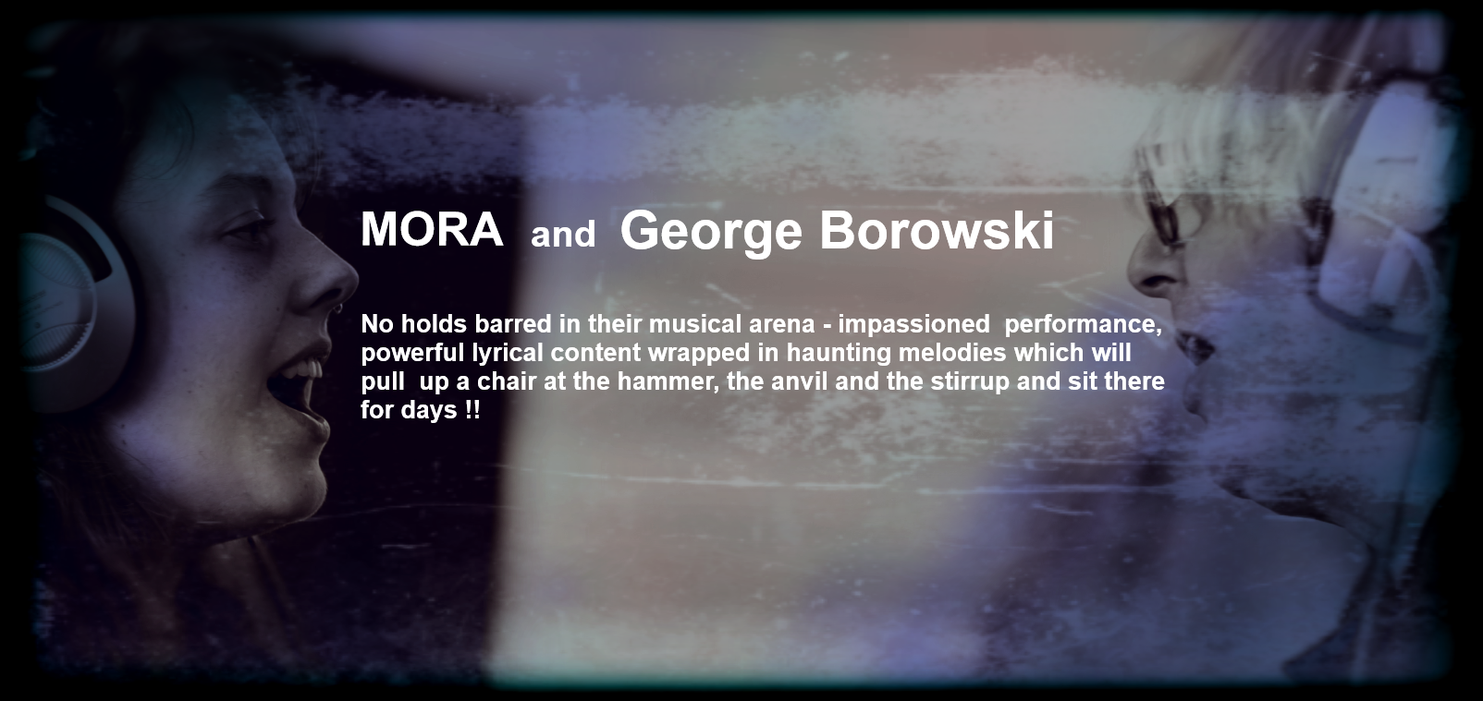
Online - tracks, pictures and gigs:
https://www.mora.uk.com/
https://www.facebook.com/moramusic1/
Videos:
The Narrowboat Sessions – ‘Landing Lights’
http://www.facebook.com/thenarrowboatsessions/videos/1133635903388424/
Songwriters Circle – ‘Queen of Hearts’
https://www.facebook.com/nicholas.sumner/videos/10154322579438366/
Music Video – ‘The Fall’
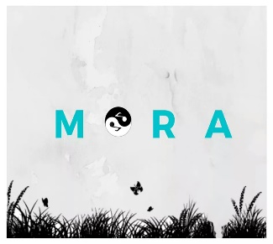
https://www.youtube.com/watch?v=s-kTUfTzy14&feature=youtu.be

