Technical Rider HongkongFive

Besetzung:
Lori – Vocals
Jens – Keyboards, Backing Vocals
Julian – Gitarre
Stefan – Drums
Karsten – Bass, Backing Vocals

Stageplan:
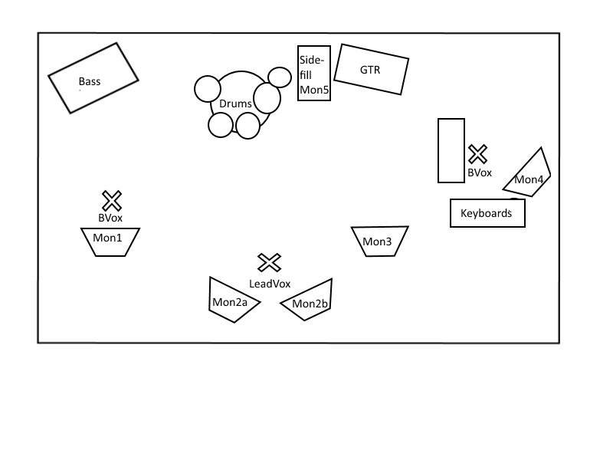

Kanalbelegung:

1 - Kickdrum Micro Sennheiser e902, Shure PGA 52 o.Ä.
2 - gr. Snare Micro (Clip) Sennheiser e906, Shure Beta 98 o.Ä.
3 - kl. Snare Micro (Clip) Sennheiser e906, Shure Beta 98 o.Ä.
4 - HiHat Micro Sennheiser e914, Shure PGA 81 o.Ä.
5 - Tom 1 Micro (Clip) Sennheiser e904, Shure Beta 98 o.Ä.
6 - Tom 2 Micro (Clip) Sennheiser e904, Shure Beta 98 o.Ä.
7 - Tom 3 Micro (Clip) Sennheiser e904, Shure Beta 98 o.Ä.
8 - Overhead links Micro Sennheiser e914, Shure PGA 81 o.Ä.
9 - Overhead rechts Micro Sennheiser e914, Shure PGA 81 o.Ä.
10 - Bass XLR (Line out)
11 - Gitarre Micro Sennheiser e906, Shure SM 57 o.Ä.
12 - Keyboards links DI-Box (Line out)
13 - Keyboards rechts Di-Box (Line out)
14 - Lead Vocals Micro Shure SM 58
15 - Backing Vocals Micro Shure SM 58
16 - Backing Vocals Micro Shure SM 58

Monitoring:
5 Wege, 5 Wedges, 1 Drumfill. Begrüßenswert ist eine seperate Monitoringkonsole incl. Operator.
PA:
Der Location angemessene, zeitgemäße und das Auditorium abdeckende Beschallungsanlage.

FOH:

Angemessene, zeitgemäße Konsole mit ausreichender Kanalanzahl (mindestens 24),
ausreichend Standardeffekte (Gates, Reverb, Delay, Dynamics).

