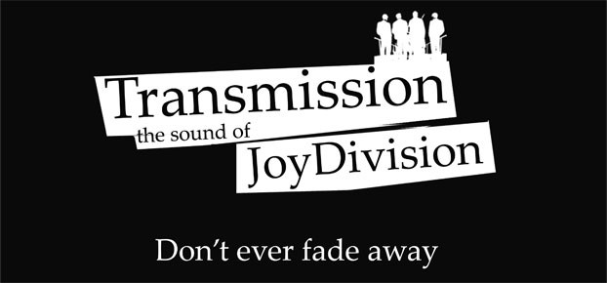
On the road contact information
Mail to transmission-live@hotmail.co.uk
Tel (Road) 07889899759

Technical Rider & Stage Plan
On stage set up
- 1 Drumset - 1 X DI
- 1 Bass Guitar
- 1 Electric Guitar
- 1 Keyboard - 2 X DI
- 2 x Main Vocals

We assume that there is a well sized PA system provided for the concert room with sufficient power to supply a clean and undistorted 110dB SPL RMS to the mixing desk and a powerful and feedback-proof monitor system. It is very important that the singers and the drummer each have their own monitor speakers with separate mixes.

TRANSMISSION THE SOUND OF JOY DIVISION

MINIMAL SET UP
For small venues, up to 150 people (microphones are listed in order of preference)
DRUMS KICK AKG D12E, Sennheiser MD421, Electro Voice PL20 / RE20, Beyer M88, AKG D112
SNARE Shure SM57
OVERHEAD LEFT Neumann or Gefell small diaphragm condenser, AKG C451, small diaphragm condenser
OVERHEAD RIGHT Neumann or Gefell small diaphragm condenser, AKG C451, small diaphragm condenser
BASS amplifier has DI output
GUITARS LEFT Shure SM57 RIGHT Shure SM57
VOCALS E LEFT Shure SM58 RIGHT Shure SM58

THE COMPLETE SET UP
For venues larger than 150 people (microphones are listed in order of preference)
DRUMS KICK AKG D12E, Sennheiser MD421, Electrovoice PL20 / RE20, Beyer M88, AKG D112
SNARE TOP Shure SM57
SNARE BOTTOM Shure SM57
HIHAT Neumann or Gefell small diaphragm condenser, AKG C451, any small diaphragm condenser
RACK TOM Sennheiser MD421, Beyer M88, any suitable dynamic mic
FLOOR TOM Sennheiser MD421, Beyer M88, any suitable dynamic mic
OVERHEADS Neumann or Gefell small diaphragm condenser, AKG C451, any small diaphragm condenser (left & right)
BASS amplifier has DI output
GUITARS LEFT Shure SM57 RIGHT Shure SM57
VOCALS E LEFT Shure SM58 RIGHT Shure SM58

TRANSMISSION THE SOUND OF JOY DIVISION
ADDITIONAL REQUIREMENTS
Floor carpet (approx. 160cm x 200cm) for drums on the stage
STAFF We will need a qualified sound engineer, stage technician and lights technician. At the moment we do not have a regular engineer, so we depend heavily on the staff on-site.
SOUND & LIGHTING We prefer an overall natural sound with minimal processing and effects. The two main vocals are best with slight reverberation. Lighting can be discussed during soundcheck before the show.
We will need an absolute minimum of 45 minutes soundcheck, 60 to 90 minutes including setup would be perfect. ARRIVAL Please supply two weeks before the date of the show the complete address of the venue and a telephone contact. We need a safe parking space available for the van close to the venue. Please provide arrival, soundcheck and doors-open and on-stage times. The promoter or another person

FOOD & DRINKS
4 x meals or 4 x 12 euro for buy-out
Minimum 4 bottles of cooled non-carbonated water for stage and backstage
Minimum 6 litres / 12 cans of beer, 1 litre wine
Breakfast for 4 persons the morning after the show.
BACKSTAGE
A separate room for the band to get some rest before and after the show. It would be great to have some sofas, tables, chairs, a mirror and sink.
SLEEP
A warm, clean, dark and quiet accommodation for 4 persons with mattresses, bath room, shower and mirror. A safe parking space near the sleeping accommodation should be available. MERCHANDISE
A table of approx. 1.5m length and a small light or some candles for our merchandising in the same room as the show, if possible.
ADVERTISING & PROMOTION
There a large amount of promo material we can send to you for advertising purposes. Don`t hesitate to write, if you need posters or flyer and promo templates, logos or pictures in various file formats. Just get in contact with us.

