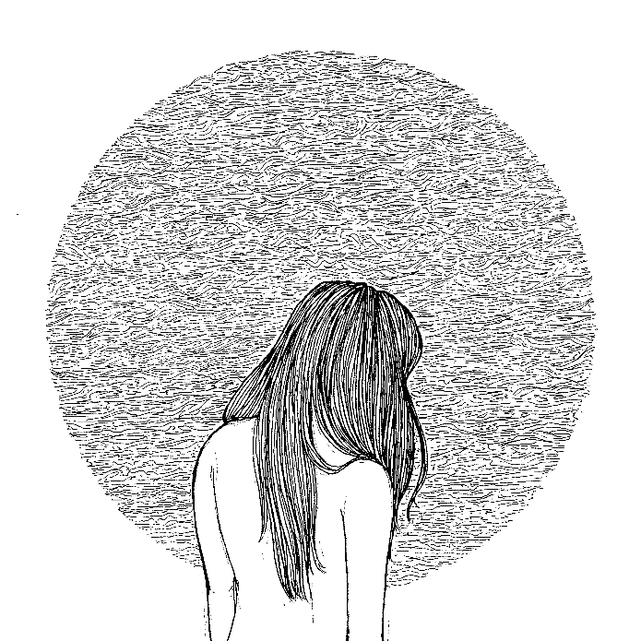
“The dual vocals of Ryan McGlone and Alice Anderson create an immensely uplifting experience that, combined with their all giving live presence, has made this band one of the most promising acts of this ilk on show just now."
Biography
Formed in 2012, The Youth And Young are an 8-piece noisy folk band from the east coast of Scotland.
Since the 2013 releases of their self-titled E.P. and follow up single: “Our Father’s Wars”, The Youth And Young have traversed across the country spreading and developing their brand of “panoramic indie-folk”. From playing iconic venues like Glasgow's King Tut’s and Edinburgh's Liquid Rooms, to appearances at festivals including Belladrum; Brew at the Bog; King Tut’s Summer Nights; ButeFest; Tiree Music Festival, and XpoNorth, The Youth And Young have developed a burgeoning reputation for engaging and raucous live performances which have earned them coveted support slots with heavyweight compatriots; We Were Promised Jetpacks, Fatherson, and There Will Be Fireworks. As well as sharing stages with fellow upstarts; Foreignfox, and Mt Doubt.
2016 saw the release of their debut album "Gestures" to a sold out crowd at Edinburgh’s La Belle Angèle. “Gestures” gained high praise from the countries most respected blogs and music critics, most notably from The Herald/The National’s music editor Alan Morrison, noting that "The songs on this record are painted on a bigger canvas than anything before them" and that "The expanded strings on 'Blueprint's and howling guitar on 'Escher Drawn' are just two examples of how every individual element is now working harder within the united force of the eight-piece band". Lead single "Little Sky" was featured as BBC Radio Scotland's single of the week in October 2016 on the Janice Forsyth Show and received heavy airplay on Amazing Radio by industry favourite Jim Gellatly.
Having touring the record nationally throughout the remainder of 2016 and spending the winter in the studio, The Youth and Young plan to kick off 2017 with the release of their next single "Lanterns".

The Youth And Young are:
Ryan McGlone: Lead Vocals.
Alice Anderson: Lead Vocals.
Robbie Leiper: Violin/Backing Vocals.
Alex Logan: Acoustic Guitar.
Jordan Russell-Hall: Guitars/Backing Vocals.
Cuán Thomas: Guitars/Backing Vocals.
Keir MacNab: Bass Guitar.
Jamie Clapton: Drums.
Press
"Taking the energy of Celtic rock and marrying it to the exuberance of modern Scottish indie-folk, Gestures – the debut album from Edinburgh’s The Youth And Young – proves that past comparisons to Arcade Fire aren’t all that far off the mark." - Alan Morrison - The National

"Utilising the dual harmonies of lead singers Alice Anderson and Ryan McGlone, The Youth and Young create epic soundscapes, but aren't afraid to veer off in other directions" - Jim Gellatly - Amazing Radio
"The debut album from The Youth and Young is a confident collection of panoramic indie-folk. Bursts of strings and impassioned vocals are contrasted with delicate acoustic guitars and intertwining harmonies, making for a record that’s both majestic and intimate, with moments that rival the euphoric lifts of groups like Frightened Rabbit and Band of Horses." - Alan Henderson, The Gaudie.
Online
Facebook: www.facebook.com/TheYouthAndYoung
Twitter: www.twitter.com/tyaymusic
Youtube: www.youtube.com/theyouthandyoung
Soundcloud: www.soundcloud.com/theyouthandyoung-1/sets/gestures
Bandcamp: www.theyouthandyoung.bandcamp.com
Spotify [Gestures]: https://open.spotify.com/album/1DIPop1uCYORNsityt8ftk
Contact
Email: theyouthandyoung@hotmail.co.uk
Telephone (Ryan McGlone): +44 7584 304694

