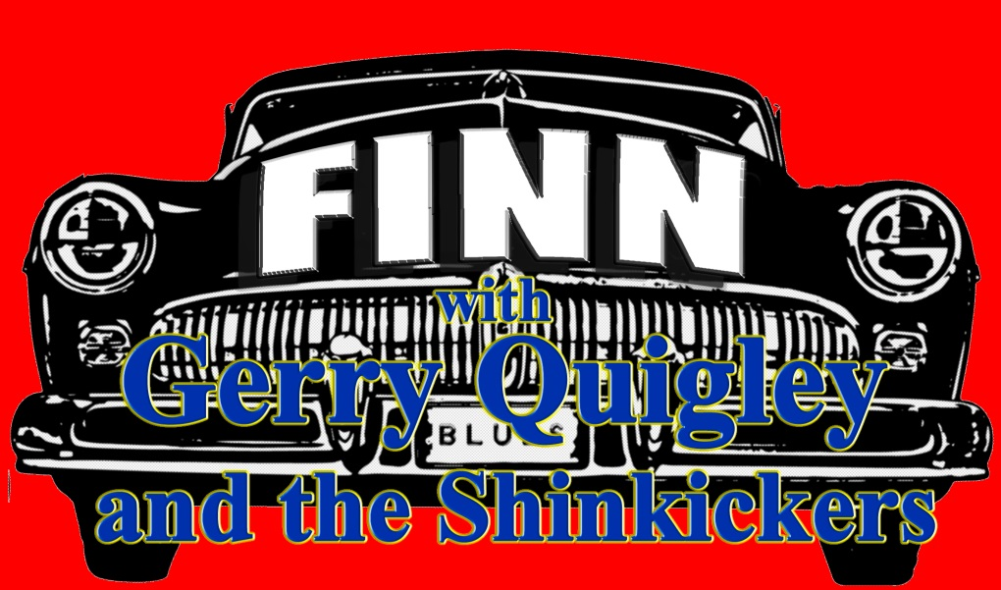

Jim Finn was born in Australia of Irish descent and has been travelling back to the old country every year since 2012. He runs his own band called Finn in Australia in which he sings and plays drums. Jim also has co/written most of the songs and produced and engineered all of Finn's 7 albums.
​
Jim returned to Ireland this year on a promotional tour drumming up work for 2017, an also got his player situation sorted.
He found some great players and now has a band that can tour all of Europe with.
​
Enter Gerry Quigley and the Shinkickers from Cork City, with Gerry on an assortment of stringed instruments, Sharon Quigley on keys, Brian Hyland on bass and Jim on drums and vocals. This line up did gigs in 2016, with the last: - at the Cobh Blues Festival receiving a standing ovation.
We have plans to release an album for next year’s tour and will have some video snippets from 2016 very soon.

The Shinkickers
Pumping out some of the best blues, classic rock, spine-tingling originals with a hint of Celtic magic are Gerry Quigley & The Shinkickers, who in 2015 are celebrating their 24th anniversary.

Formed in Perth, Western Australia in 1991, some 4 years before Rory had passed away, this is the first and original Shinkickers band named after the classic Rory Gallagher song. So much is Gerry's respect for Rory and his music, Gerry and his band have always played at least one Rory Gallagher song at every show for the past 24 years.

After 30 years touring and recording in Western Australia, Gerry Quigley is now based in Cork, Ireland where the set list has grown due to local demand to include even more great Rory Gallagher tracks. Although the band is fast gaining a reputation in Cork for their Rory Gallagher music, don't expect a pure tribute band - you'll also hear plenty of those spine-tingling originals and classic blues/rock you've come to know and expect from Gerry Quigley over the years.

With his eclectic collection of 7 or 8 guitars and other things with strings including his "No.1" - Gibson Les Paul; Fender Stratocaster; Gibson 135; Dobro slide guitar; Telecaster; Mandolin and a unique Double-neck two-in-one Mandola/Bouzouki, Gerry Quigley & The Shinkickers will mesmerise you with such a great variety of blues/rock and originals it really is like having 7 or 8 different bands in one show!

Jim Finn Lead vocals and drums.
Jim is truly the last of the ‘Aussie highwaymen, he is on the road 50 weeks of the year, travelling all round the world plying his trade, he began playing drums at age 5, first professional gig at 11.
Has been leading his own band ‘Finn’, singing, writing, playing drums and producing 7 studio cd’s and has taken the band to the US, playing in Memphis and San Francisco as well as Europe 4 times.
Performed with: - Phyllis Diller, Mick Taylor, Lucky Peterson, Charles and Cyril Nevil (Neville Bro), Robert Susz (Dynamic Hepnotics), Chris Turner, Dave Tice and Pete Wells (Buffalo, Rose Tattoo) whilst in Sydney.
Has recorded with Wendy Saddington, Kate Dunbar, Jeannie Lewis, Margaret Roadknight, Sally King, John Power, Don Hopkins, Dennis Aubrey, Al Britton and Mike Gubb, to name a few, performed at most major Australian Blues festivals, Cork Roots festival and the Blackstairs Blues festival in Ireland. Jim’s also produces music with his company ‘front room records’

Gerry Quigley has been described as both a guitar wizard and a string magician by the Blues Matters magazine (UK) in their latest edition! (Issue #94)
Weeping Willow is described as "in excess of eight minutes of exquisite progressive rock mastery" while Gerry himself has been described as "your archetypical Irish guitarist along the lines of Rory Gallagher, Gary Moore and Phil Lynnott of Thin Lizzy".
Both albums have been described as "the purest of quality in terms of the guitar playing and deserve to be highlighted for the very special ability Quigley demonstrates with his overall strings playing on both albums with their unique and infectious brand of Celtic hard edge blues and rock" the tracks on both albums are described as "every one of them an emerald in it's own right".

PRESS

"Shinkickers: now we are talking about my local "blues band". Their music is so distinctive, great blues numbers with a lot of Irish music thrown in thanks to Gerry, the lead guitarist. Love 'em."
Janice Dunning, Journalist - ABC South West, Blues at Bridgetown Festival 2010

“The Shinkickers from the first listen have thoroughly impressed me with their talents. The guitars, the sound and the energy behind what they play is absolutely astounding. The commitment they’ve shown thus far to their music has been proven evident with every song. These are people who love music! ”
Ash Fierro - The Chaos Box 99.3 FM Los Angeles, California

“The West Coast Blues and Roots Festival was billed as the "music lover's weekend" and this was not an understatement. Boasting 50 acts over three stages, it promised to be big - and it delivered. On the Saturday, I arrived just in time in the afternoon to see The Shinkickers on the Crossroads stage, which was located just next to the gates. Ignoring the heat, the band impressed with their jam-styled blues, and ended their set with a scintillating version of their instrumental, Weeping Willow. The Shinkickers are a fantastic ambassador for the Perth blues scene.”
Shichi - The West Coast Blues and Roots Festival 2008

