**Keishera James**

With a voice that can only be described as a cross between Anita Baker and Sade, Singer/Songwriter Keishera James exudes originality. With her raspy alto pipes, Keishera infuses her Jamaican heritage and R&B/Neo-soul melodies, resulting in an unmistakably sultry sound.

Born in Kingston, Jamaica and raised in Brooklyn, NY, Keishera has always been fond of the reggae and Soul music. She recalled attending stage shows as a child seeing the best of the best rocking the stage and being mesmerized and wondering if she could ever be that free. Her dream of being a Singer and Songwriter emerged much later, when she ran into influential icons Patti Labelle, Maya Angelou and Ahmet Ertegun. These Icons encouraged her to focus on her dreams. After those serendipitous encounters, her drive became more confident when David Passick, who at the time managed the careers of Maxwell and Herbie Hancock, took interest in her. Keishera then formed her own band performing at venues around NYC such as CBGB's Gallery, Joe's Pub, Central Park Band shell, Cafe Woa and Village underground just to name a few.

Her musical background stems from her cultural diversity from traveling and living in Germany, Paris and London where she discovered her true passion to singing and songwriting. Thereafter, she returned to Jamaica where she laid down the acoustic tune "So Good" on the Soul Food Riddim, "Feels Right" featuring Shaggy, on the Kylmaxx Riddim "Cry No More" on the Cry Baby Riddim and later resulted in the music video 'Break free', which became popular reaching the top ten charts on Music Media.

In late 2011 Keishera decided to move to Berlin, Germany to pursue music full time and venture into new territory, which proved to be successful. From 2012 - 2014 She began to gain world experience performing in different festivals across Germany, and Europe stretching into Morocco, She slayed Sista Gracy’s Bash - Friesland Reggae Open Air in Varel, Reggae Jam 2012 and 2013 in Bresenbruck, Festival of Hope in Berlin and Fete de La Musique in Krezberg. She’s brought down the house at venues like Tausand Bar, Asphalt, Waldo, Quasimodo Bar, Café Des Artistes, Rosa Caleta, Badehaus with The Swag Band, Picnick – Hip Hop don't stop, Yaam - Radio live event and Bohannon soul club, 14 room Art Basel in Switzerland, and Sun festival 2014 just to name a few, in Marrakech Morocco Keishera is definitely proving she is a star in the making.

Keishera release her debut EP entitled “Body language” which was the perfect introduction to the world. She collaborated with hit- maker producers Paul Henton AKA Computer Paul, Barry O’Hare, Klyerecords - LLamar Riff Raft and Raul Moncrieff and Di Kru Productions. Her debut single “Rock Star” was released late October 2013. With a hot follow up music video directed by Jamaica’s finest Director Kevin Lee,

Now she will release her new single ‘**Pull Over’** December 14th 2015 off her upcoming Debut album, ‘**Its Just Me’** giving you a raw synapsis of her truest self the way she love!, Keishera is ready to slay the masses. Her stage presence and sultry vocals will leave you wanting more.



**Keishera James “ Pull Over”** Single

Off her up coming album titled –**It’s Just Me**

**Coming early 2016**

**Pull Over Release date:**

December 14, 2015 – Digital Download

**Label:** Keishera Music

**Distribution:** Tunecore

**Track List:**

**Pull Over**

Online: [**www.Facebook.com/Keishera.James**](http://www.Facebook.com/Keishera.James)

[**www.SoundCloud/Keishera**](http://www.Reverbnation.com/Keishera)

**The Debut EP – BODY LANGUAGE**

**Release:**

EP “Body Language” October 2013 - Digital Download

**Discography: Discography:**

2004 “So Good” (Soul food Riddim) young Blood Records

“It Feels Right” Feat Shaggy (Kylmaxx Riddim) Green Sleeve

2005 “Cry No more “(Cry Baby Riddim) release VP. Records

2006 “Tired of Fronting” (Twice again Riddim) Studio 2006 release Green Sleeve

"Move Inside" Lord Kossity feat Keishera and Shaggy, Universal Records France 2006 release

2010+ Various publications of original compositions in BMI,

2013 “Gota Put Me First” (Reggae Jam Rriddim 2013) House of Riddim

2013 Keishera James - Body Language EP Sound Quake

2014 Keishera James - Body Language EP Tunecore

2015 ‘Sorry’ El Toro Riddim Cellblock records

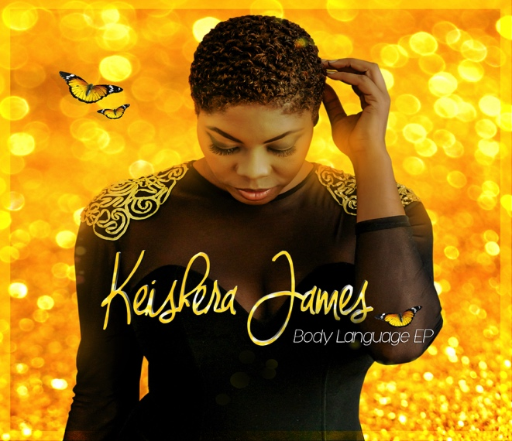

**Previous Release**

**Keishera James “Body Language” EP**

**Release**

**Date**: 15.October 2013 – Digital Download

**Label:** Keishera Music

**Distribution:** Sound Quake

**Track list:**

01. Body Language

02. Thought You Were Mine

03. Return the Favor

04. Let’s Get Busy

05. Sweet Man of Mine

06. Rock Star

**- Festivals Performance:**

2005 The Ark club open for Beenie Man, Africa House open for Anthony B

2008: New York City Marathon, the International Reggae Festival NYC

2009 Fort Greene Music festival opened for Talib Kweli NYC

Caribbean American Labor Day Festival with Daville NYC

2010 NYC African American Music festival

2011 Forte Green Music Festival opened for Common

2012 Friesland Open Air, Reggae Jam, Live Demo Open Air, Festival of Hope, Fete de La Musique Germany.

2013 Friesland Open Air, Reggae Jam, Picnick-Live Demo Open Air, Festival of Hope, Fete de La Musique, Hip-hop don’t stop Open Air,

Indie Live on the beach open Air Negril-Jamaica etc.

2014: Sunfestival 2014 Morocco, Swag Jam Anniversary Yaam, Art Basel, Live Demo Open Air, Festival of Hope 2014, Crosskultur festival 2014, Ashphalt featuring Keishera, Hip Hop charity Jam Presents Keishera James at Yaam Berlin, Musicboard Berlin presents: THE SWAG (Berlin) feat. **Keishera James** (Jamaica/ USA, Reggae Jam 2014 Music festival Present Keishera James Live Sunday - August 3rd, Keishera James Reggaejam 2014 Interview by African life magazine August 2014, Rosa Carleta Block party part of Fete De la Musique: feature act Keishera James, at muskauer Str. 9 10997 Berlin, Germany June 20, Artist/ performer in 14 rooms Sponsored by Art Basel Switzerland for world Renowned Artist Oto Nkanga - June 7- June 19, Tausand Bar presents Keishera James Live in Performer at Myfest - Real Rock Hifi stage & Soul food stage -  May 1st 2014, Featured Artist to perform Acoustic set live at OLYMPUS PHOTOGRAPHY at Playground, Recorded background vocals to support Mark McRea productions indie project .

**Booking & Management:**

**Keishera music**

**BMI Publishing**

**Tel: +49 (0)17672/54152/ +1876-587 6976**

**Mail: keisheraj@gmail.com**

[**http://www.soundquake.com**](http://www.soundquake.com)

**Distribution:**

**Sound Quake**

**Elisabethstr. 14|32791 Lage| Germany**

**Tel.: 049[0]5232/6991-0**

**Fax: 049[0]5232/6991-20**

**Mail: info@soundquake.com**

**http://** [**www.soundquake.com**](http://www.soundquake.com) **|** [**www.mp3.soundquake.com**](http://www.mp3.soundquake.com)

