The Youth and Young - Technical Specifications 2016

# Stage Plot

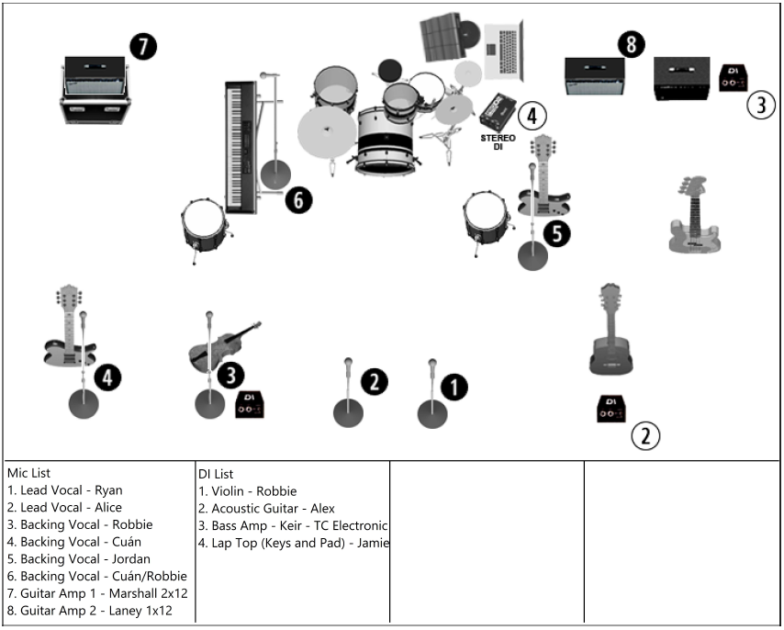

1

# Monitors

The Youth and Young carry 3 LD Systems MEI1000G2 stereo in ear monitoring systems and a single hard wired monitoring system each requiring a – preferably stereo – aux out.

N.B If stereo feed is not possible, note that for mono operation aux cable is connected to the RIGHT input of monitoring systems.

|  |  |  |
| --- | --- | --- |
| Mix No. | Mix Description | Monitor Type |
| 1 | Lead Vocals (Mics 1 + 2) and Acoustic Guitar | IEM RF |
| 2 | Electric Guitar 1 and Violin | IEM RF |
| 3 | Electric Guitar 2 and Bass | IEM RF |
| 4 | Drums | IEM Hard Wired |

## Mix Notes

All monitor mixes call for a general mix of all instruments/mics with the following additional requests:

### Mix 1 – Lead Vocals and Acoustic Guitar

General mix of all instruments with emphasis on Lead Vocals (Mics 1+2), Acoustic Guitar (DI 2) and Violin (DI 1). Additional slight emphasis on Bass (DI 3). If stereo, general mix centred, with Mic 1 panned left and Mic 2 panned right.

### Mix 2 – Electric Guitar 2 and Violin

General mix of all instruments with emphasis on Electric Guitar 1 (Mic 7), Violin (DI 1), Keys/Pad (DI4) and Acoustic Guitar (DI 2). Additional emphasis on Electric Guitar 2 (Mic 8), Backing Vocals (Mics 2, 3+6), and Lead Vocals. If stereo, general mix centred, Electric Guitar 1 panned right and Electric Guitar 2 panned left.

### Mix 3 – Electric Guitar 2 and Bass

General mix of all instruments with emphasis on Electric Guitar 2 (Mic 8), Bass (DI 3), Acoustic Guitar (DI 2), and Electric Guitar 1 (Mic 7). Additional slight emphasis on Lead vocals (Mics 1+2) and Backing Vocal (Mic 5). If stereo, general mix centred, Electric Guitar 1 panned right and Electric Guitar 2 panned left.

### Mix 4 – Drums

General mix of all instruments with emphasis on Bass Guitar (DI 3) and Acoustic Guitar (DI 2) and Kick. NO feed from Keys/Pad (DI 4) required.