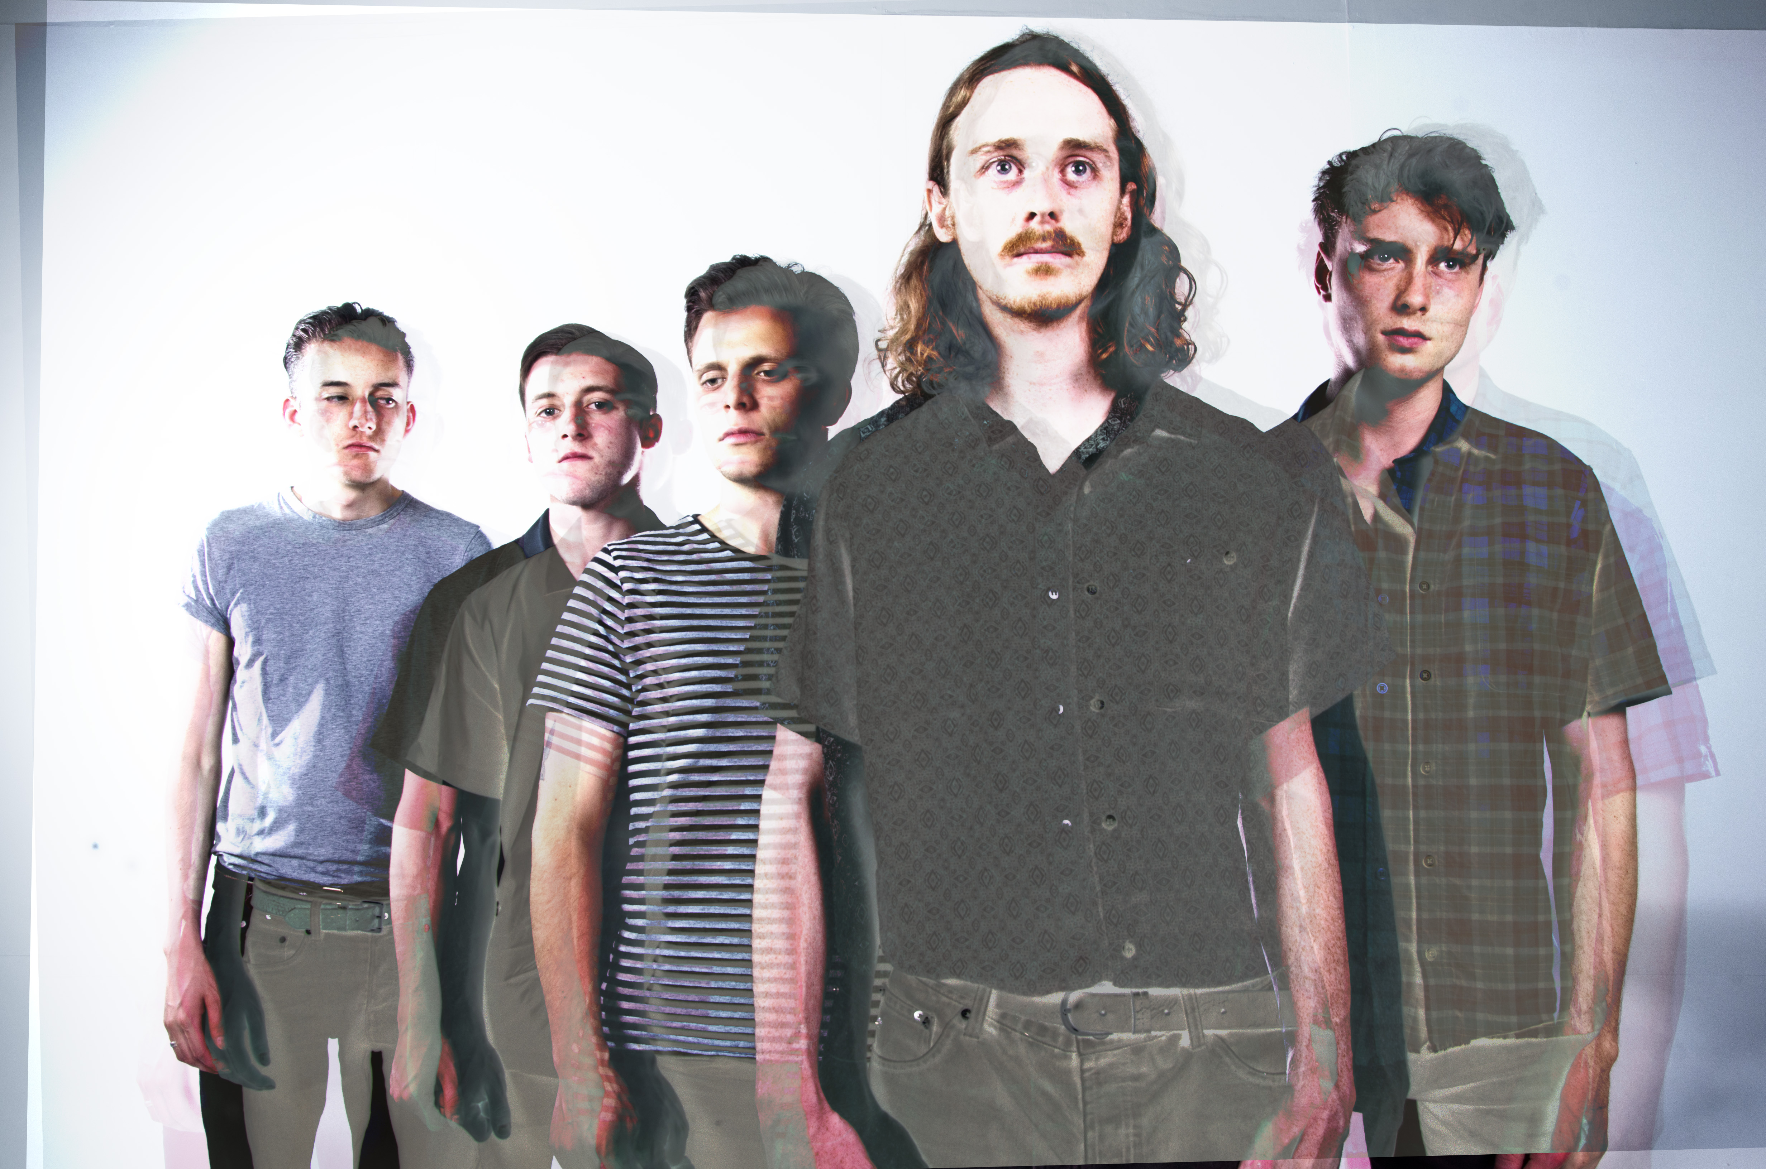

FIGHTING CARAVANS

‘A tacky disco meets a Last-mile wake’…Fighting Caravans is an alternative-rock sextet from Leeds. Taking influences from early American Blues and more contemporary Rock music, the group delivers bold social commentaries akin to sounds of Fat White Family, Grinderman and QOTSA, with subtle Country, Jazz and Psychedelic overtones. The vintage guitars lend to an aching exposition of lyrical variety; from the final confessional moments of a felo-de-se to narcotic anthropomorphism, Fighting Caravans have a burden only alleviated via public execution…

In 2015, Fighting Caravans released their debut EP, Beasts Of England, alongside a UK & EU tour, earning strong local and international plaudits. In 2016 the success of singles Tyrannosaur and Blue Heart Motel, provided the opportunity for the band to complete their first ever UK & EU headline tours and feature at a number of festivals, including; Reading & Leeds Festival, Live At Leeds, Liverpool Sound City and Tramlines. The band are currently recording their 2nd EP at The Nave (Kaiser Chiefs, Eagulls, etc.), from which the first single will be released by Clue Records in January.

FC is: Daniel Clark (Lead Vocals), Riff James (Guitar), Cinnamon Lees (Bass), Ali Fletcher (Guitar), Dave ‘The Sesh’ Hogan (Drums) and Danny Marlando (Keys).
Live Reviews:

“They rock like an Indie Led Zep as if Alan Vega off of Suicide was in the band” – With Just A Hint Of Mayhem

“The beautifully bizarre manner of their front man was so engaging…” – Sounds Of An Eccentric

“Their tracks rapidly switch from simmering, and moody, to explosive angst” – Counterfeit Magazine

“One of the most exhilarating live acts around right now” – Whisperin’ N Hollerin’

“Intense and unpredictable, it's been a while since we've seen a band like this” – Bang The Drum

“Singer Daniel Clark seems possessed” – Clash Magazine

“Their brand of twisted country and dark Americana is delivered with a psychotic energy” – Whisperin’ N Hollerin’

“The 'belligerent Jarvis' performance of frontman Danny Clark is very good value indeed”- Leeds Music Scene

“A slice of proverbial musical pie with a scoop of sexy psychedelic ice cream” - Leeds Music Scene

Record Reviews & Features

One’s To Watch 2017 - “it is with their storming live performances in which they truly shine, reaching an energy and intensity which few bands can match” - Gigslutz

Best Newcomer 2016 - Gigslutz

“a psychedelic trip with screeching guitars and dynamic haunting vocals” – Indie Buddie

“Fighting Caravans nailing their incandescent live appeal” – Clash Magazine

“the band don’t sound quite like any other going right now” – Whisperin’ N Hollerin’

"[Exec. Style] is a great track and is one that definitely warrants keeping the band on the radar for future releases" – Exploding Head Syndrome

One’s To Watch 2016 - The Music Manual

“It showcases just how dark Indie Rock n Roll can become if done correctly” – Move On Up

“Exec. Style has a musicality that harks back to the heady days of late 60's, early 70's Wishbone Ash, Moody Blues and Pink Floyd mixed with a more laid back, psychedelic smidgeon of The Birthday Party” – Ralph’s Life

“It's a stone cold classic that sounds like it's been smoldering away in Jim Morrison's basement waiting to be liberated” - The Devil Has The Best Tuna

☆☆☆☆☆ – “The EP was a pure delight to listen to with soft melodies, catchy lyrics and an unusual twang to top it all” - Leeds Music Scene

“Leeds quintet Fighting Caravans have only been knocking around a year but you’d put them up there with the best” - Never Enough Notes

“Fighting Caravans have a knack for taking simple ideas and putting them together in bold aural statements” - Never Enough Notes

Fresh On The Net:
http://freshonthenet.co.uk/2015/01/mixtape20150119/
http://freshonthenet.co.uk/2014/12/faves134/

“The release of ‘Bootmakers To The King‘ proves a timely thirst-quencher for the already eager following whilst providing extraordinary insight to the bands future potential” - TMS Mag

“Bluesy swagger along with a fair dose of Americana thrown in” - Backseat Mafia

Interviews

FEISTY Magazine

Northern Exposure

Vents Magazine

The Mouth Magazine

Vents Magazine

Beat2aChord

Radio/Podcasts

- Audio Graffiti
- BBC6 Music
- BBC Intro WY
- BC FM
- BCB Radio
- BRB Radio – 106.6FM
- ICR FM
- Is This Thing On?
- Leeds Student Radio
- Meridian FM
- Noize Level Critical
- Penistone FM
- Radio Kaos Caribou
- Ram Air
- RaW 1251AM
- Riviera FM
- Route 66
- Salford City Radio
- Shoreditch Radio
- Sine FM
- The Alternative FM

Releases:

DEC 2016 – ‘In Sicily’ – women are more dangerous than shotguns.

Youtube: https://youtu.be/wwZxpbF5BcU

JUL 2016 – ‘Blue Heart Motel’ – metaphoric of love lost.

Youtube: https://youtu.be/EzJLA7sihP0

JAN 2016 – ‘Exec. Style’ – based on an episode of American TV series, ‘Fargo’. Exec. Style is about the extravagant lengths people will go to in achieving perceived societal success.

Youtube: https://youtu.be/GQt8Y8fCGtg

OCT 2015 – ‘Beasts Of England’ – Debut EP

OCT 2015 – ‘Tyrannosaur’ – Love is war…

Youtube: https://youtu.be/Ylp6OsSE-6k

Upcoming Shows:

www.bandsintown.com/FightingCaravans

Contact Info:

Daniel Clark (07552747295) – info@thecrowknowsmusic.com

Website: www.fightingcaravans.com

Bandcamp: www.fightingcaravans.bandcamp.com

Spotify: http://spoti.fi/1H2TkEy

Facebook: www.facebook.com/fightingcaravans

Twitter: www.twitter.com/fcaravans

Youtube: www.youtube.com/c/FightingCaravans

Instagram: http://instagram.com/fightingcaravans

