Bullet Height launch mini documentary video!
June 07, 2016

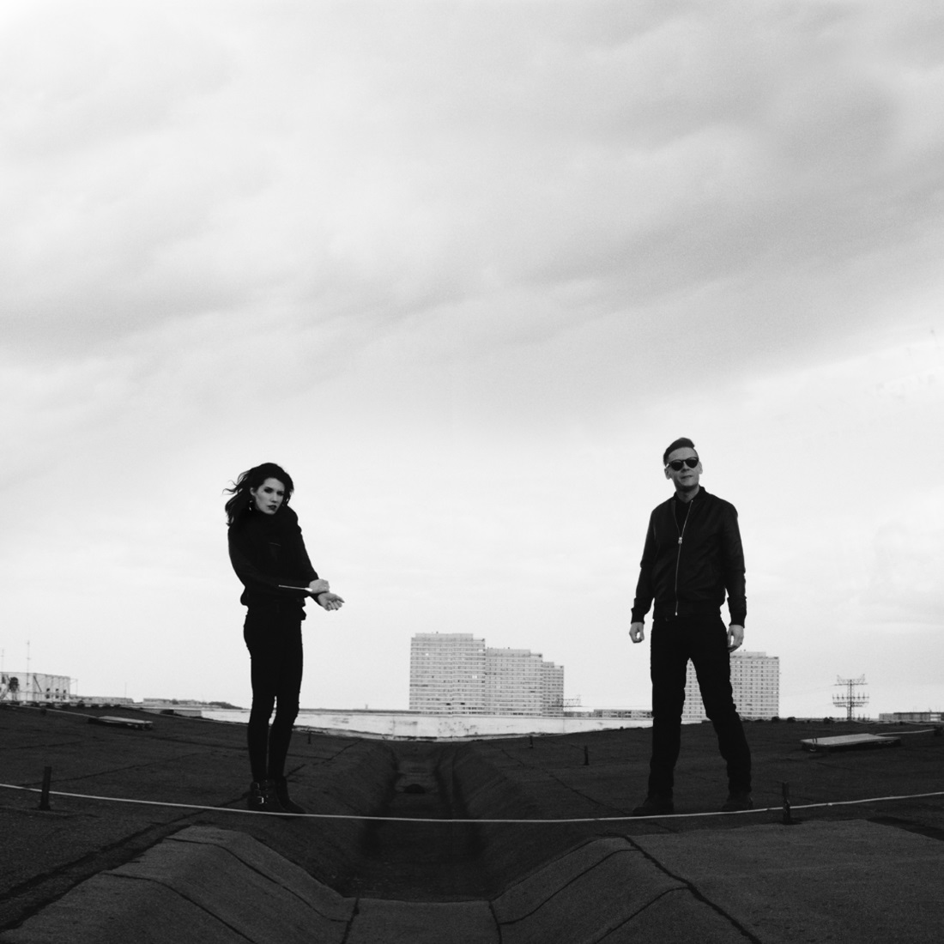

Berlin-based electronic-rock duo Bullet Height have launched a mini-documentary exploring the groups formation and their Berlin base. Watch the video now here: https://youtu.be/9v9DsKk0kGE

Sammi Doll had this to say: “Continuing in the same cinematic vein to our ‘Bastion’ lyric video with director Valquire Veljkovic, We were able to create a small, visual statement of who we are and what is yet to come.
Filmed in & atop our Berlin studio, under the Funkturm and around the city.”

Featuring the talents of Jon Courtney & Sammi Doll (IAMX), the two met in Berlin one Halloween night, and shortly after started recording together, creating what is now known as Bullet Height. Check out their first single ‘Bastion’ here: https://youtu.be/D-vOHeyJXZ8

Purchase the digital single here:
http://smarturl.it/bastionITUNES
http://smarturl.it/bastionAMAZONMP3

Stream the single on Spotify here: http://bit.ly/bastionSPOTIFY

Jon previously commented on the bands formation: “I left London, moved to Berlin, rented a dirt-cheap room in an old DDR building & started battering out the music that would go on to become Bullet Height. I wanted to create something darker & heavier than ever before – I’d always written & produced in the past under no creative constraint & that has continued with this new band. From the first vocal session with Sammi I knew we were onto something…Superball caught wind of things…now here we are!”

Sammi adds: “Jon and I met through producer Tom Bellamy at a dirty rock bar in Berlin on Halloween. He was looking for someone to collaborate on his new music, we met up a few days later and it became clear that this would turn into something much bigger than expected. It was exactly the release I needed at the time and became a bit of personal therapy.”

Look out for more news on Bullet Height in the coming months!

BULLET HEIGHT online:
www.bulletheight.com
www.facebook.com/bulletheight
www.twitter.com/bulletheight
www.instagram.com/bulletheight

SUPERBALL MUSIC online:
www.superballmusic.com
www.facebook.com/superballmusic
www.twitter.com/superball_music
www.instragram.com/superball_music

