Bullet Height sign to Superball Music; debut single ‘Bastion’ announced

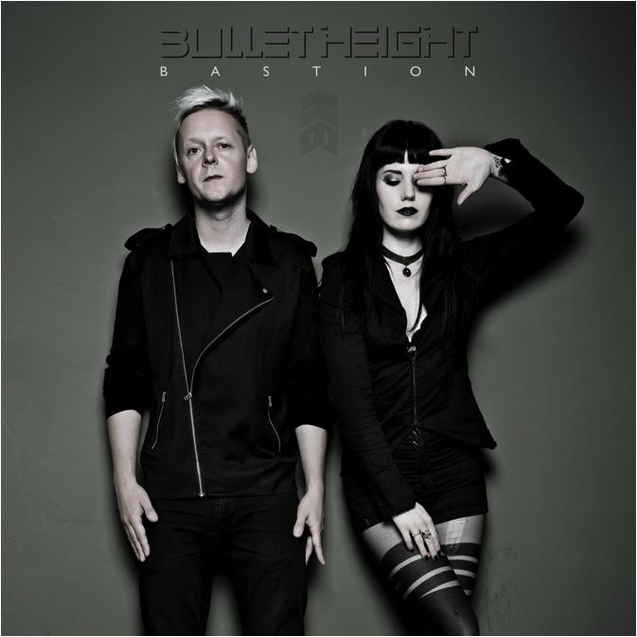
Superball Music are extremely pleased to announce the signing of Berlin-based electronic-rock duo Bullet Height to their worldwide roster. Featuring the talents of Jon Courtney & Sammi Doll (IAMX), the two met in Berlin one Halloween night, and shortly after started recording together, creating what is now known as Bullet Height.

Jon comments: “I left London, moved to Berlin, rented a dirt-cheap room in an old DDR building & started battering out the music that would go on to become Bullet Height. I wanted to create something darker & heavier than ever before – I’d always written & produced in the past under no creative constraint & that has continued with this new band. From the first vocal session with Sammi I knew we were onto something…Superball caught wind of things…now here we are!”

Sammi adds: “Jon and I met through producer Tom Bellamy at a dirty rock bar in Berlin on Halloween. He was looking for someone to collaborate on his new music, we met up a few days later and it became clear that this would turn into something much bigger than expected. It was exactly the release I needed at the time and became a bit of personal therapy.”

She adds on the signing: “This wouldn't be possible without the support and platform of Superball Music who have just signed us on to their label. We are so gracious to have the opportunity to work together, only greater things can come from this.”

The duo has already unveiled their first piece of music, the visceral and melodic first single ‘Bastion’.
Listen to the track here:
https://youtu.be/kmlmn3YHpNs

Look out for more news on Bullet Height in the coming months!

BULLET HEIGHT online:
www.bulletheight.com
www.facebook.com/bulletheight
www.twitter.com/bulletheight
www.instagram.com/bulletheight
SUPERBALL MUSIC online:
www.superballmusic.com
www.facebook.com/superballmusic
www.twitter.com/superball_music
www.instragram.com/superball_music

