Goodall : The Whole Thing Is Moving
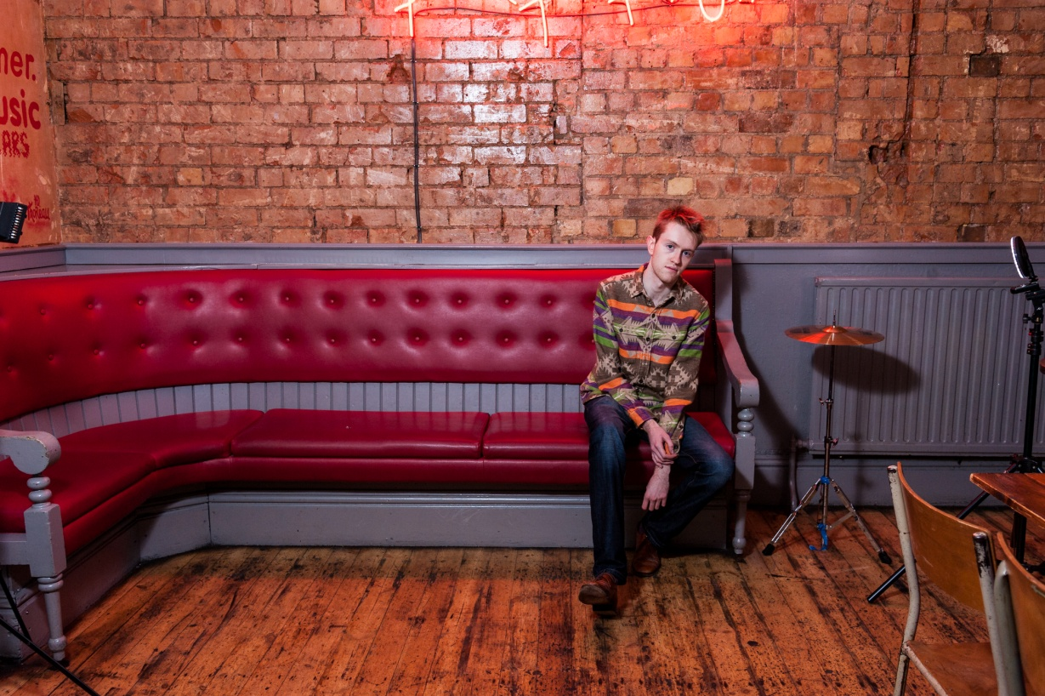
Recorded straight after first release ‘Canada’, ‘The Whole Thing Is Moving’ focuses on funk and rhythm as experienced in Goodall’s live shows.
Inspired musically by the likes of Fela Kuti, Funkadelic and Kendrick Lamar and thematically by dad Geoff Goodall’s experience of living in Lagos, as well as subjects such as communication problems and a medicated society.
Performing predominately in hometown Birmingham and London, Goodall continues to mark a unique and at times contrary path with this new release marking a funkier more groove-based direction.
The album is released on 3rd February 2017 with a launch show at Birmingham’s Sunflower Lounge.

goodallmusic.net
facebook.com/JGOODALLOMF/
goodall1.bandcamp.com

