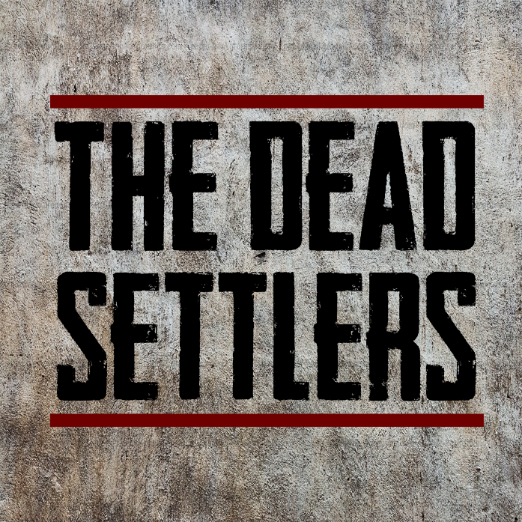

Bio
The Dead Settlers are a 4-piece indie/blues rock band from Glasgow formed in 2013. Their main influences include Oasis, Kasabian and Arctic Monkeys.
The band have played many venues in Glasgow and further afield including a number of slots the illustrious King Tut's Wah Wah Hut. They have also played at various local festivals including slots at The Glasgow Southside Fringe Festival, Edinburgh Fringe Festival, King Tuts New Year Revolution Festival and the Grab Life By: All Dayer.
The Dead Settlers debut EP ‘Burn With Me’ was released on 18th November 2016 on all major online retailers and streaming services, as well as a limited physical release. The EP was launched to a sold out crowd at Audio in Glasgow on the same night. The band are scheduled to headline King Tuts Wah Wah Hut on January 14th 2017, as part of King Tut's New Year's Revolution festival.

Members
Richard Freed – Vocals and Guitar
Scott McGready – Bass
Jonny McGeechan – Lead Guitar
Kris Slavin – Drums

Contact
Rich - 07729734668
Scott - 07921167328
Email: deadsettlers@outlook.com
Music
EP download link (promo use only) - https://www.dropbox.com/sh/23pko2bhblc6wq8/AACIIgTvLUiyH4mfC7FOGekZa?dl=0

Video of ‘The Sun’ performed live at King Tut’s Wah Wah Hut on 5th August 2016 https://youtu.be/XyvOJeMb4uA

Websites
Facebook: https://www.facebook.com/deadsettlers/
Twitter: https://twitter.com/DeadSettlers
Soundcloud: https://soundcloud.com/the_dead_settlers
Youtube - https://www.youtube.com/user/deadsettlers
ReverbNation: https://www.reverbnation.com/thedeadsettlers
Spotify: https://open.spotify.com/artist/4aKaNZd1HwDxUZVmqyAbZb
Bandcamp: https://thedeadsettlers.bandcamp.com/

Gig History
The Record Factory, Glasgow – 23rd May 2014
The Beresford Lounge, Glasgow – 4th June 2014
Box, Glasgow – 30th July 2014
Pivo Pivo, Glasgow – 30th August 2014
Kitty O’Shea’s, Glasgow – 20th December 2014
Box, Glasgow – 12th February 2015
Kitty O Shea’s, Glasgow – 18th April 2015
King Tut’s Wah Wah Hut, Glasgow (headline show) – 13th August 2015
Nice N Sleazy, Glasgow (supporting Cupids) – 11th October 2015
King Tut’s Wah Wah Hut, Glasgow (new year revolution supporting Patersani) – 19th January 2016
The Bungalow, Paisley – 11th March 2016
King Tut’s Wah Wah Hut, Glasgow (supporting Tibet) – 11th March 2016
The Glad Café, Glasgow (Southside Fringe headline show) – 28th May 2016
King Tut’s Wah Wah Hut, Glasgow (Supporting Foggy City Orphan) – 5th August 2016
Caorunn Artist’s Garden, Edinburgh (Fringe Festival Acoustic show) – 14th August 2016
Sweeney’s On The Park (Acoustic) – 15th September 2016
Grab Life By: All Dayer Launch @ Broadcast, Glasgow – 2nd October 2016
Buff Club (Supporting The Barmines) – 29th October 2016
Audio (‘Burn With Me’ EP launch show) – 18th November 2016
Upcoming Gigs
King Tut’s Wah Wah Hut, Glasgow (New Year Revolution headline slot) – 14th January 2017

‘Burn With Me’ EP Launch Poster
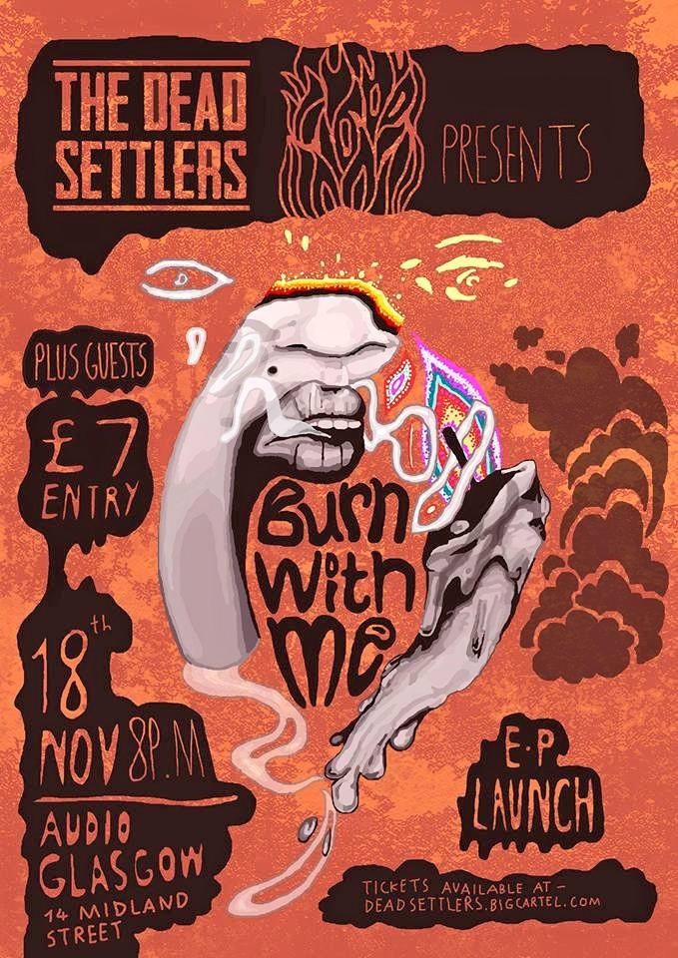

‘Burn With Me’ EP Artwork
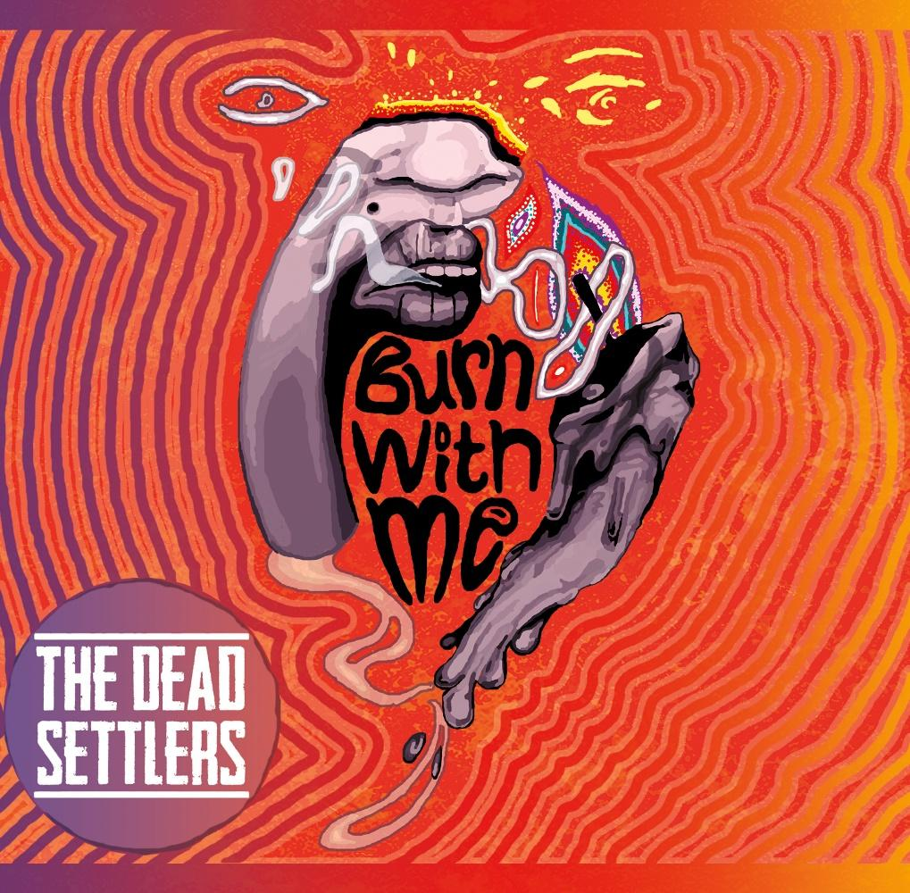

King Tut’s Wah Wah Hut, Glasgow (New Year Revolution supporting Patersani) – 19th January 2016
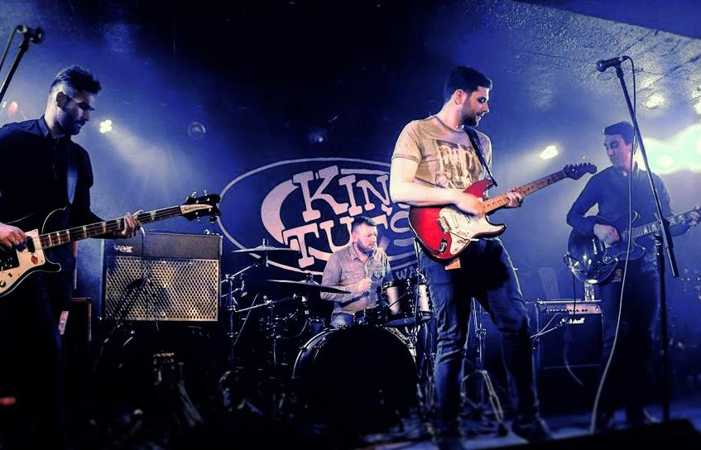

King Tut’s Wah Wah Hut, Glasgow (supporting Tibet) – 11th March 2016
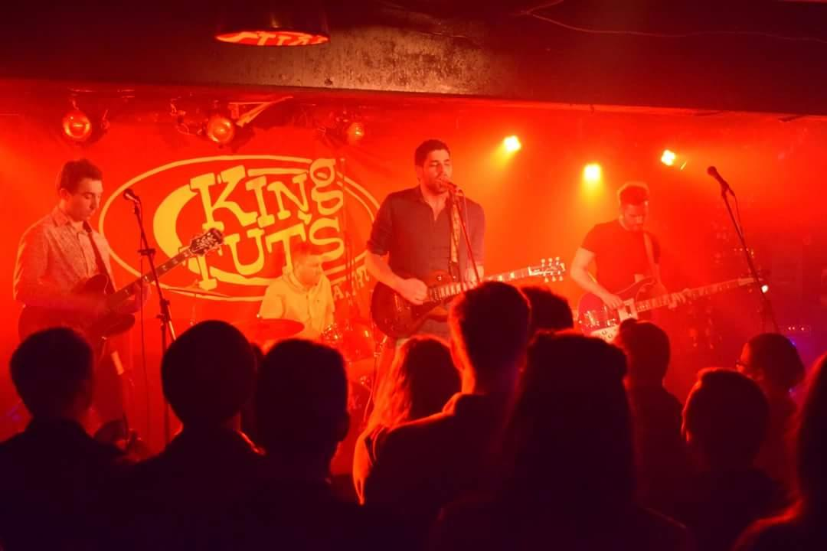

The Glad Café, Glasgow (Southside Fringe headline show) – 28th May 2016
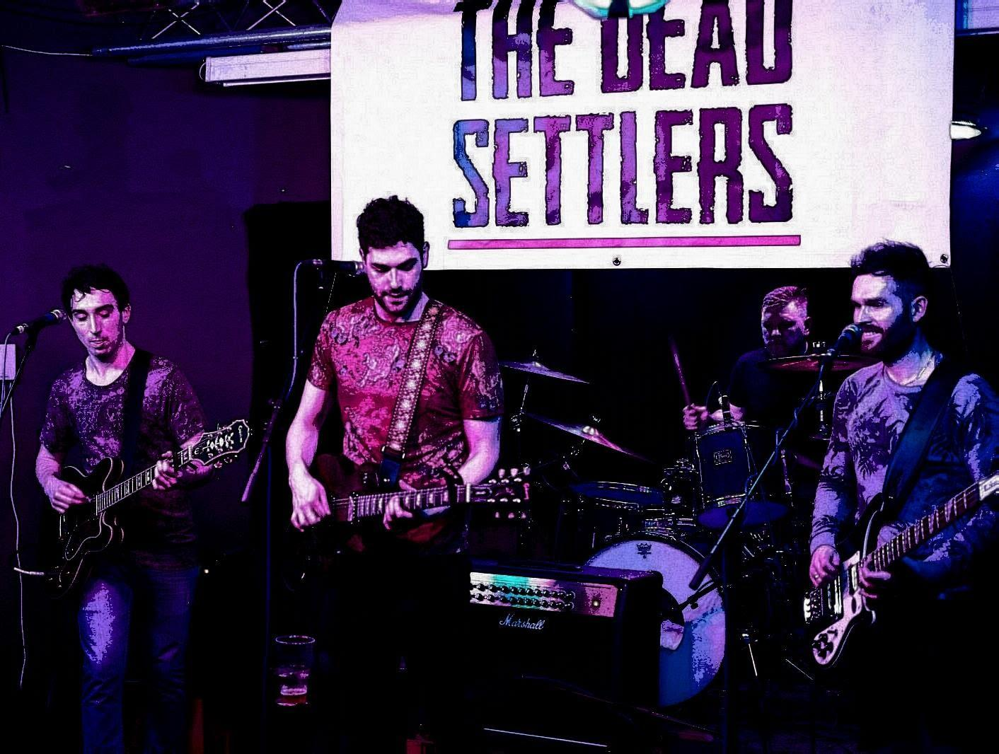
Audio, Glasgow (Burn With Me EP launch) - 18th November 2016
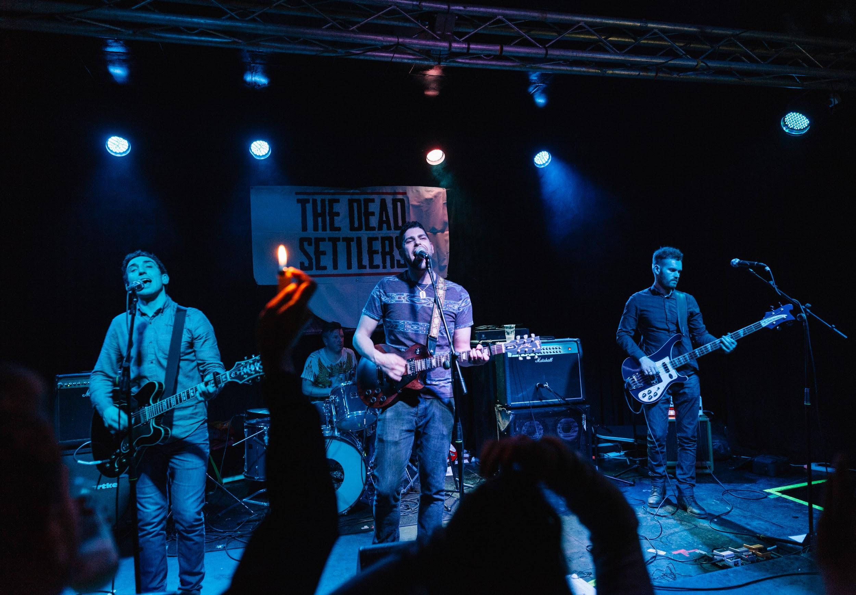

King Tut’s Wah Wah Hut, Glasgow (Supporting Foggy City Orphan) – 5th August 2016
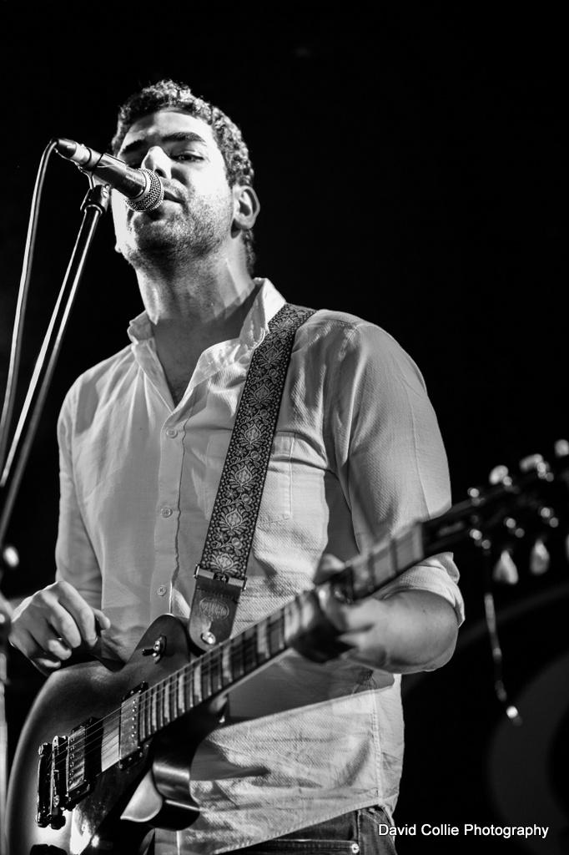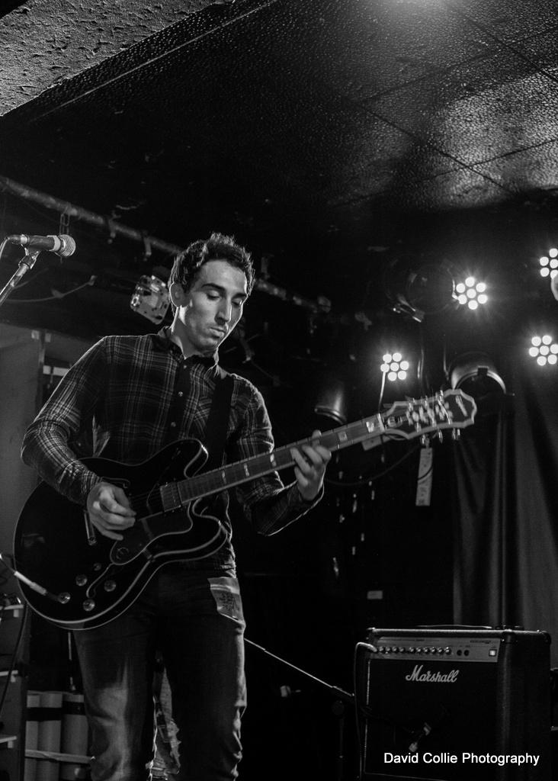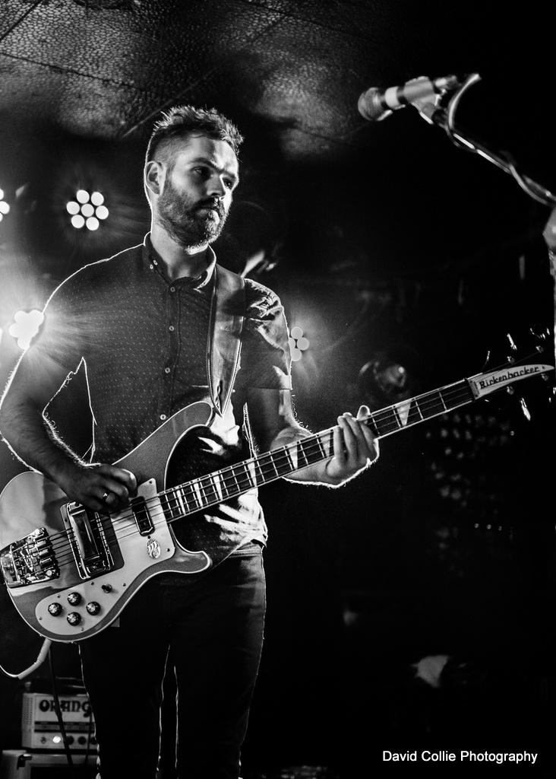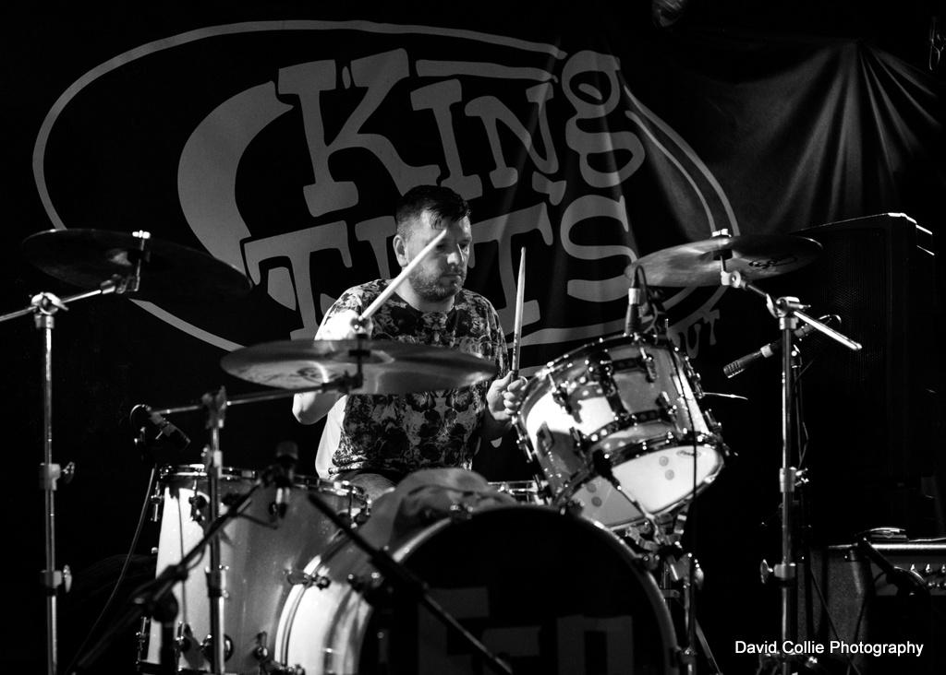

Band Photos
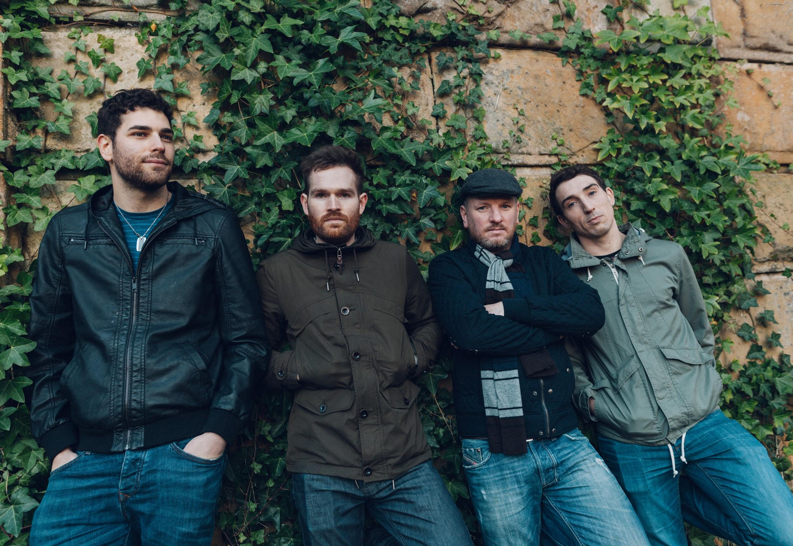
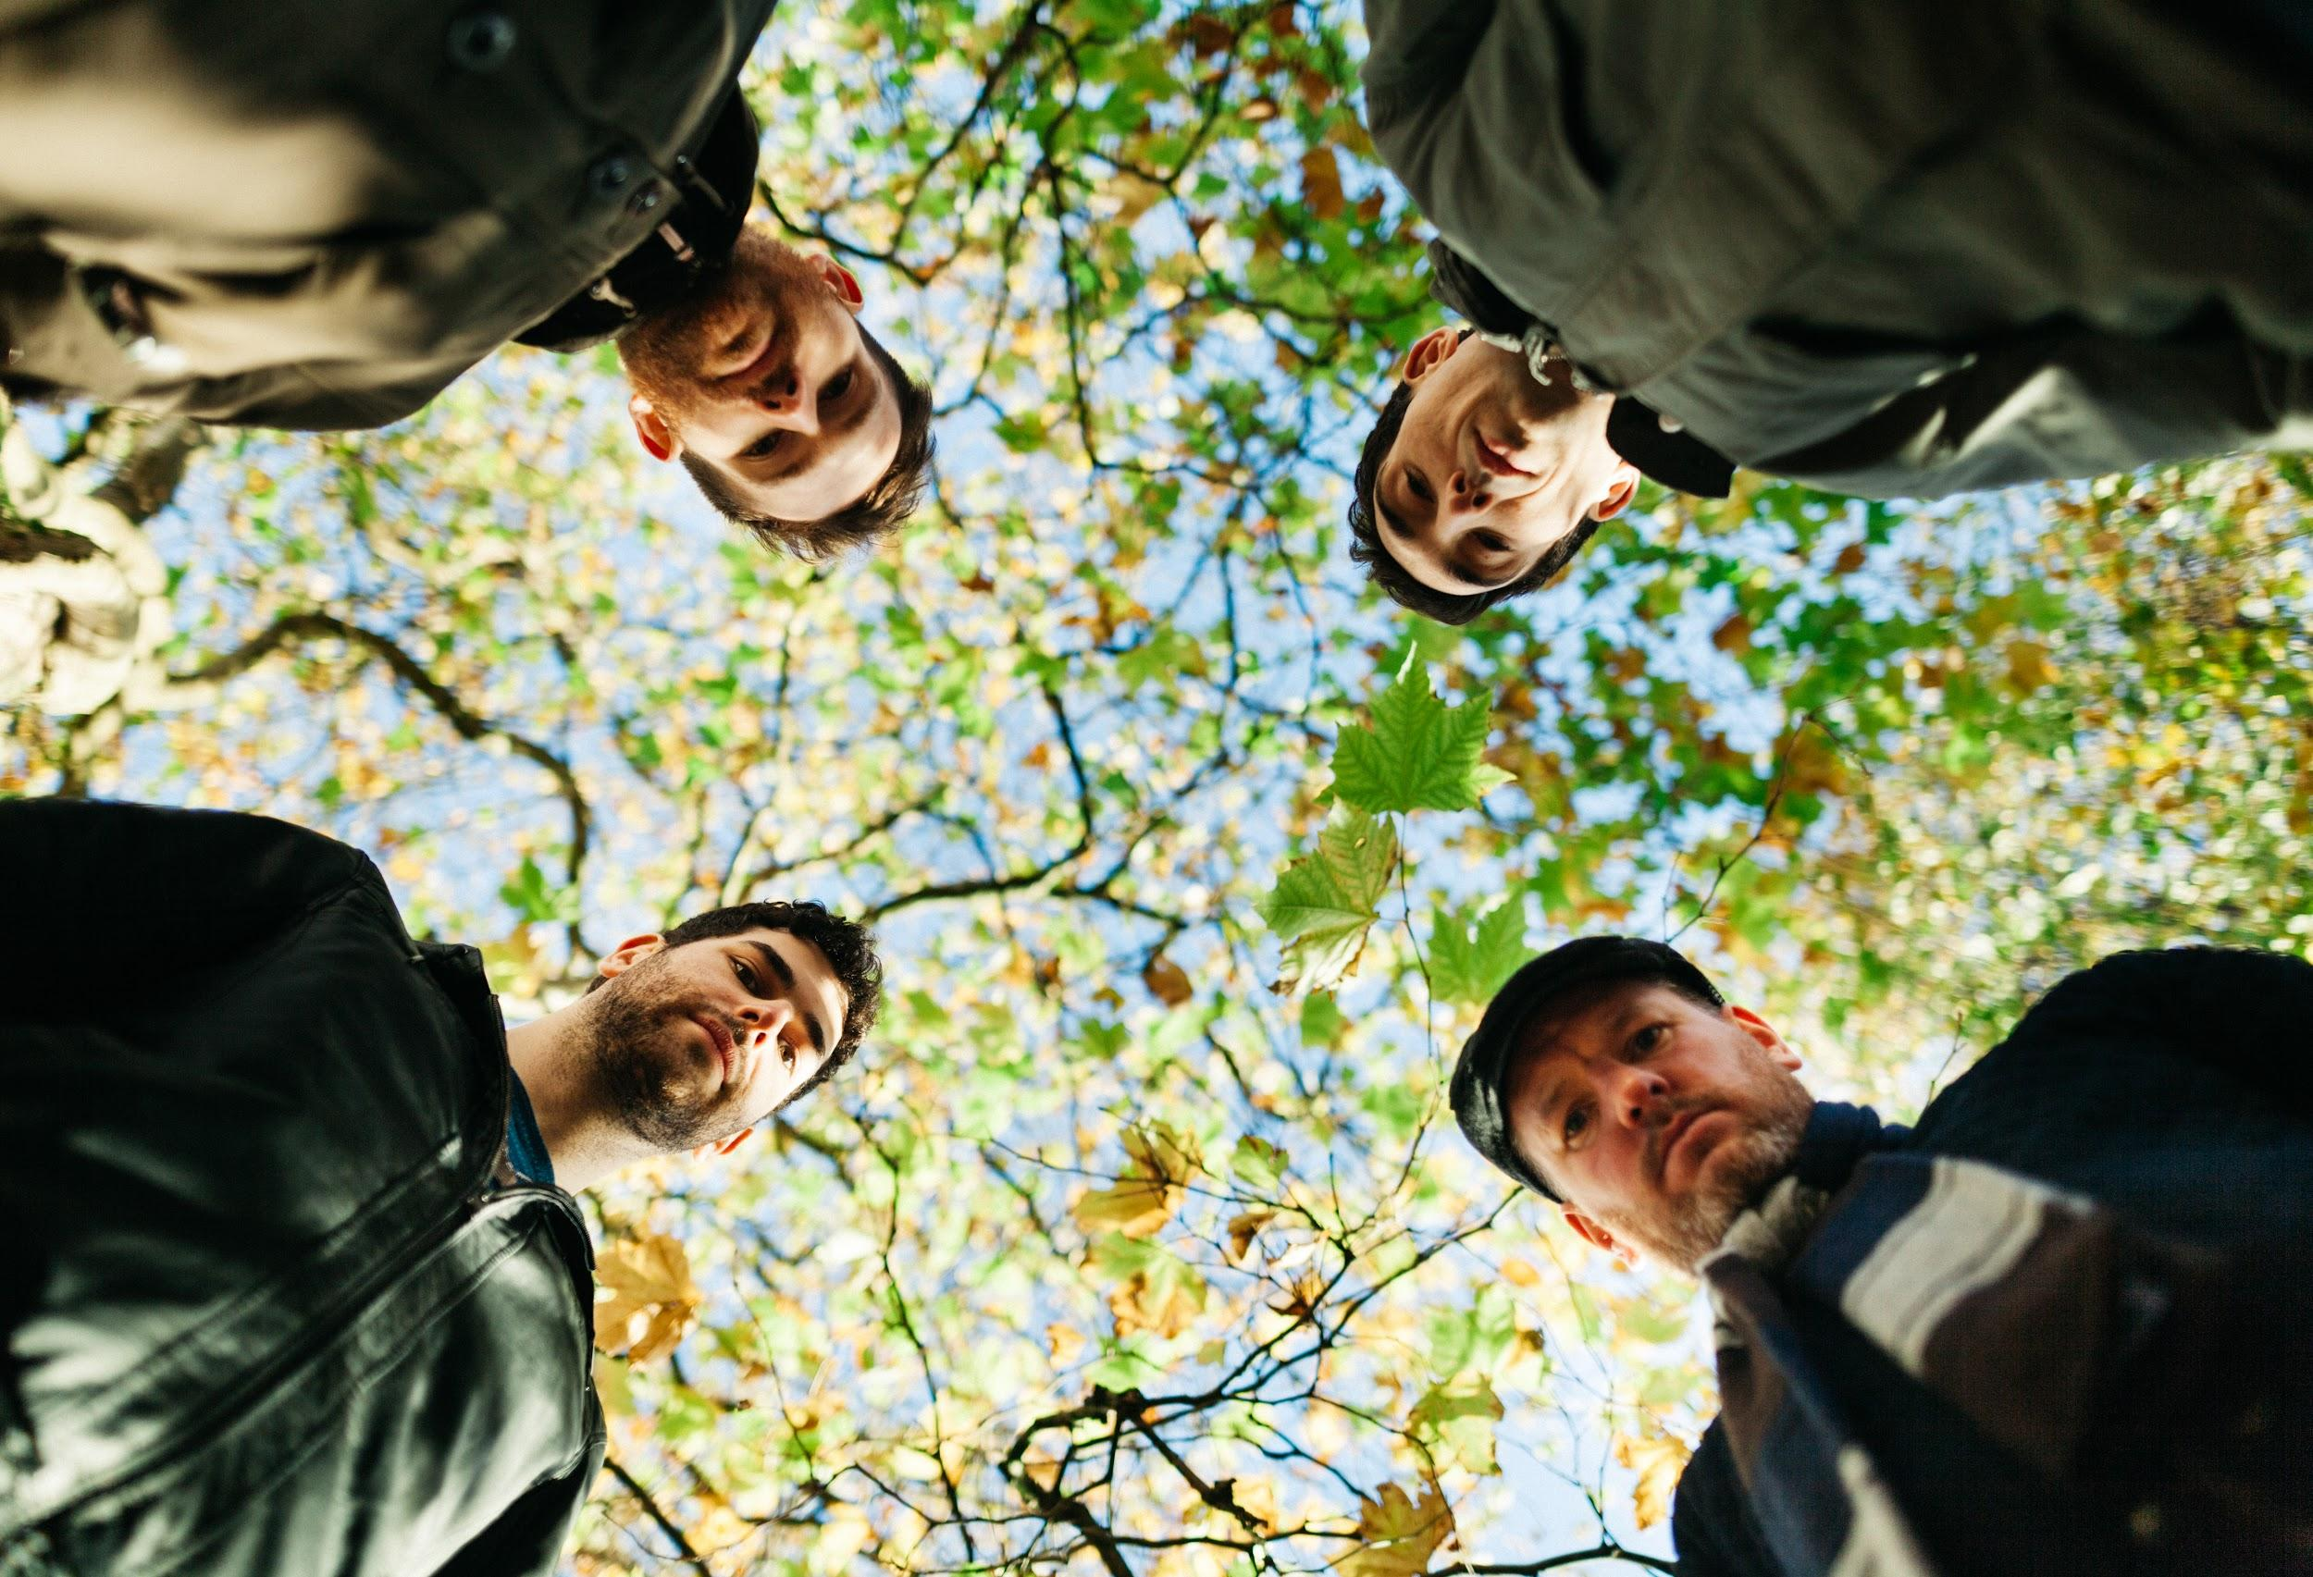
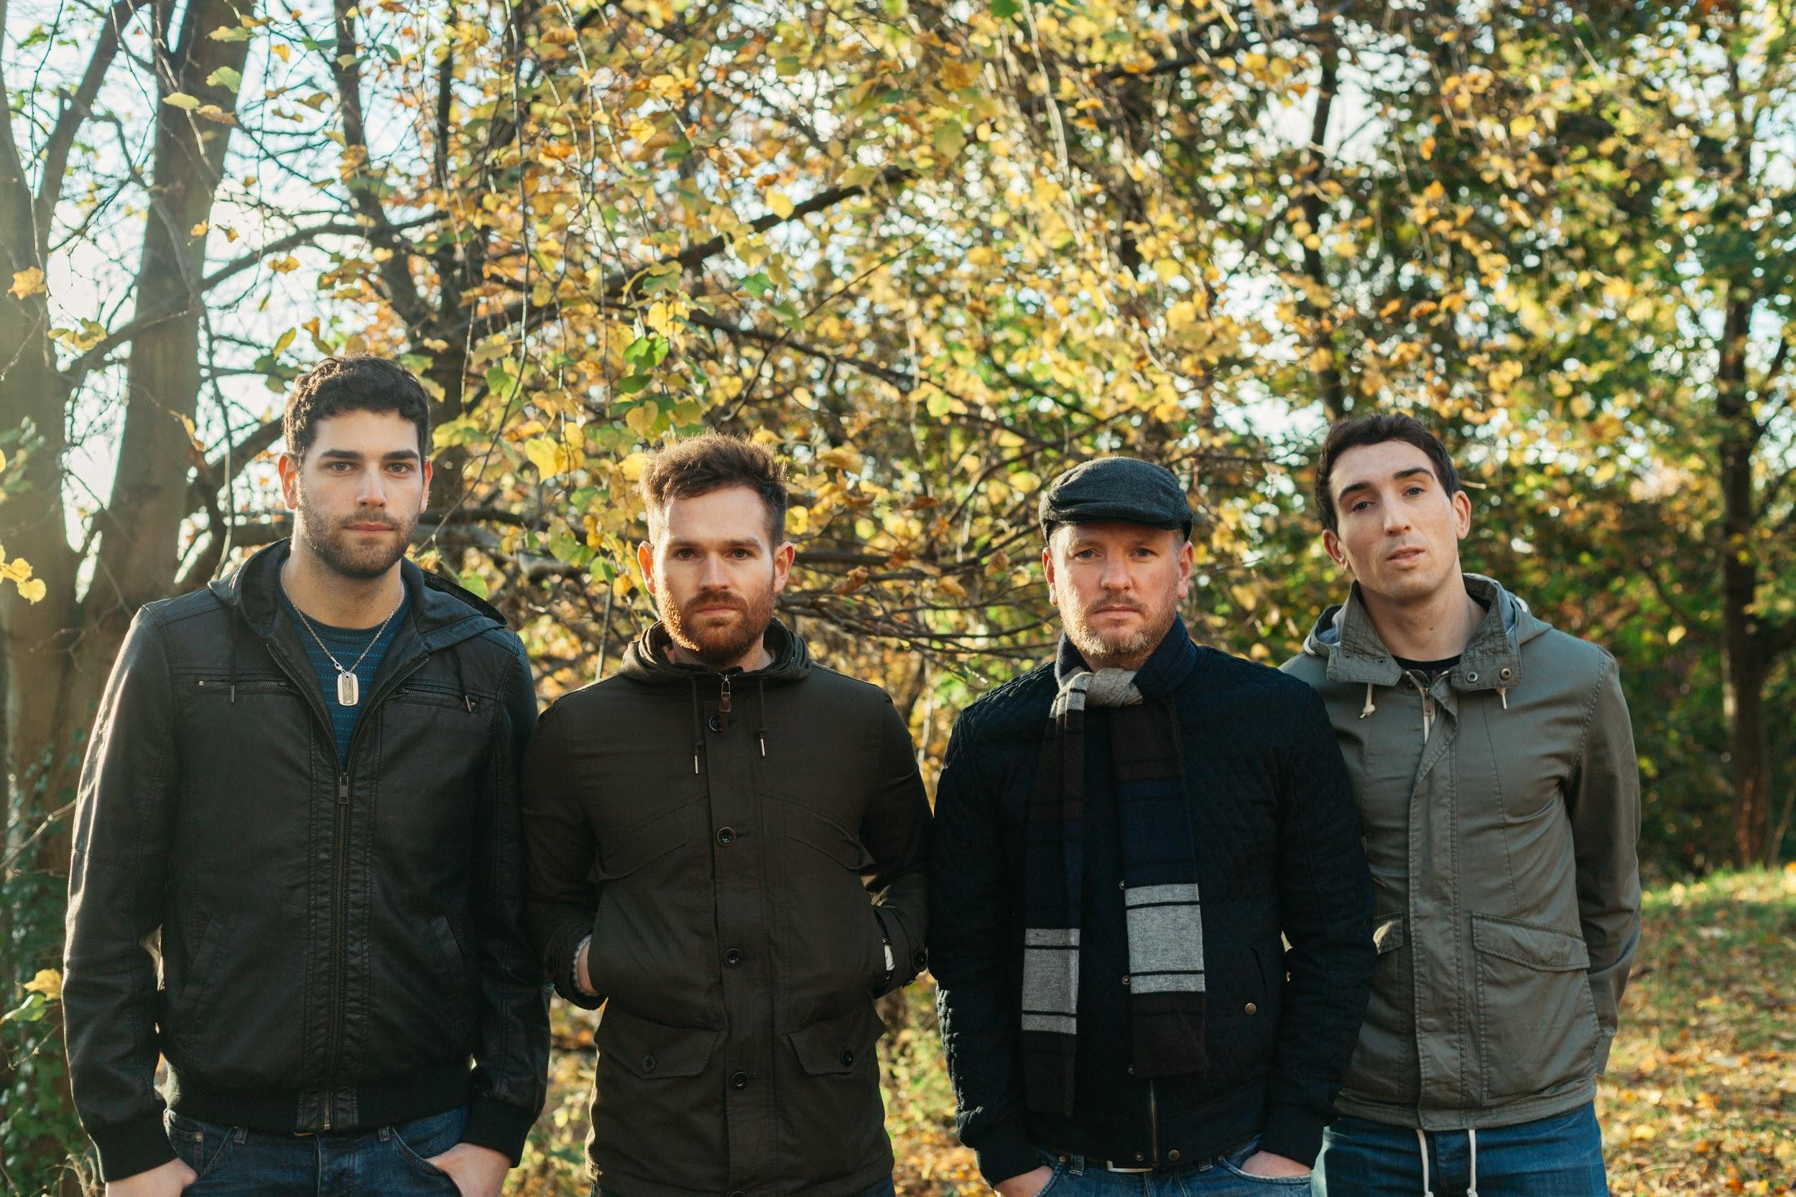
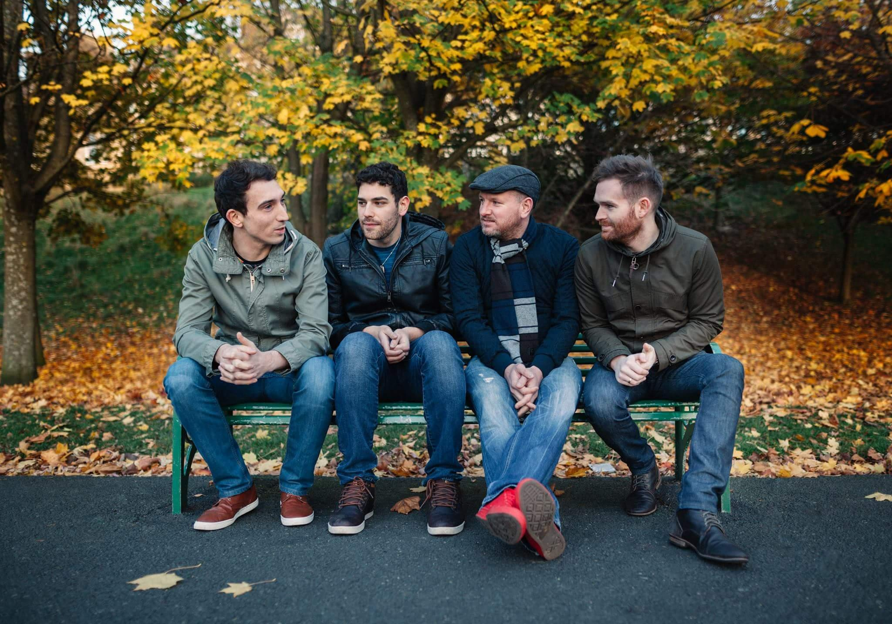

Press
King Tut’s Wah Wah Hut - August 2015 flyer

