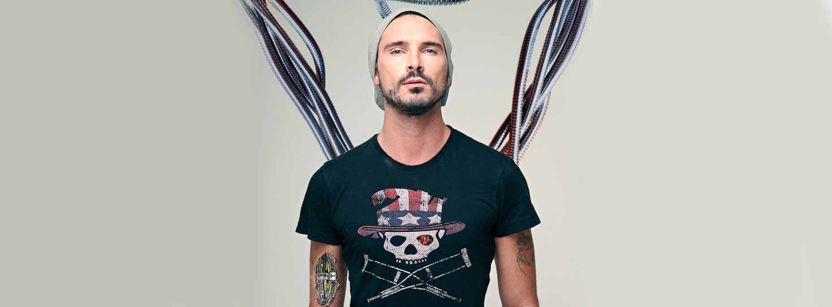

Paolo Pedana better known as Paul Pedana was born on March 25, 1987   
in a small town called Umbertide, in the vicinities of Perugia, Italy. At the tender  
age of 6 he began to play the piano. By the age of twelve he had picked up both the   
guitar and the drums and had started his first band. Paul’s initial interest in music   
was infused in him by his father at a young age thanks to an enormous record   
collection full of everything from 60’s rock to contemporary music which paul would plunder regularly.  
  
At 14 he composed an 11 track symphonic music album created on various synthesizers and other virtual instruments. The album was presented to the great composer Giampiero Reverberi after a live performance. The composer was immensely impressed by young Paul’s musical prowess and potential.  
  
Paul's momentum was abruptly cut short by a tragic accident at the age of 16. On the 4th of June 2003 Paul was run-over by a bus in front of his high school. Both wheels passed  
over his tender body crushing everything under its immense weight. There seemed to be  
no hope for the young musician who was considered by most medics to be beyond  
return.  
  
Despite the odds he made a painful and miraculous recovery, undergoing multiple   
surgeries and medical treatments across long periods of time.   
Paul describes this tragic event as the most nightmarish and harrowing experiences   
of his life to date and admits that the whole ordeal left more than just physical   
scars. It had a strong influence on his life for years to come. It did not however   
brake his spirit and passion for music so as he lay in hospital he ordered   
his first electronic drum set and began to practice obsessively with headphones on from his bed until his eventual release.  
  
His near Death Experience brought with it a strong sense of awakening and lust for  
life which later lead Paul to journey to the USA to live with the Native american   
tribe of the “Lakota”. This insight into tribal culture profoundly touched Paul and gave him a previously unexplored look into the depths of his spirituality. A voyage which stayed with him and echoes through his music.   
  
Back in High School, Pedana teamed up with three friends and created “Anthropos” a band which would later grow to be a success. Pedana was the Drummer and the main songwriter for the band.  
  
After high school, the group recorded their first album “Strangers of The Nowhere”.  
The Album got its name from a chance encounter Paul had with director Terry Gilliam a man who had always had a profound influence on the young musician.  
Some months later, Paul and Terry met again at the Umbria Film Festival. Pedana   
presented the tribute album to Terry who was extremely touched by his gesture.   
  
"Out Of Time" became Anthropos's first hit single. In 2013 Anthropos's EP, “I’m Gonna Smash You Down”, was released to critical acclaim and commercial success   
especially in Belarus where they were immediately offered a place at Most festival  
alongside bands such as Kasabian. Belarus still remains one of their favorite tour destinations, they have many fans there and they alway get a warm reception.   
  
In January 2015 Paul Pedana decided to pursue a solo project in an attempt to express a different musical affinity to his previous work with the band. The project quickly grew into a passion of Paul's and he immediately released two singles showcasing his new sound which drastically departed from his previous musical genre.  
He quickly rose to the top of The “ Reverb Nation” london hit-list thanks to a fantastic Debut at the O2 Academy and his two hit music videos “Free” and “I’m not afraid”.  
Riding the wave of success and new found confidence Paul Pedana has finished his round the world tour collecting great success from the U.S. to the Eastern Europe.

The band has recently finished the mixing of the new album which is going to be released in the early 2017.

Paul Pedana Lead Vocals,Guitars   
Denis Efimenko Lead Guitars   
Lef Germenlis Keyboards and Piano  
Eduardo Fajardo Bass  
Nitzan Ravhon Drums & Percussions