IDestroy Stage Plan

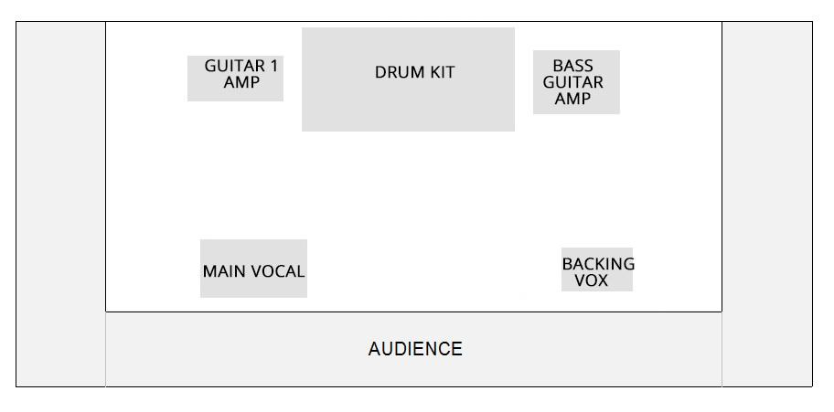
Guitarist and bassist positioning can swap around. Easy set-up!

3 members

- Drum kit - 2 toms.
- 2x vocals (across the front, on stands. Main vocal is guitarist)
- 1 Guitar (combo amp)
- 1 Bass amp (head + cab)

Anything else you need to know? Please email us on idestroyband@gmail.com

