Festival Tech Rider
July 2015- SM
Contacts
Management: Allan Baird: Allan@tijuanabibles.com // 07954569895
Production and Tour Manager: Steven McLean: Steven.mclean0@gmail.com // 07933516884
Touring Party
Mikey Dornan – Drummer/vox
Tony Costello – Vox/guitar
James Brannigan – Guitar
Danny Costello – Bass/vox
John Dennison - Driver
Steven McLean – Tech/Tour manager
Noise restrictions
The venue must inform the tour manager of any noise restrictions or curfews in the venue in advance of arrival at the venue.
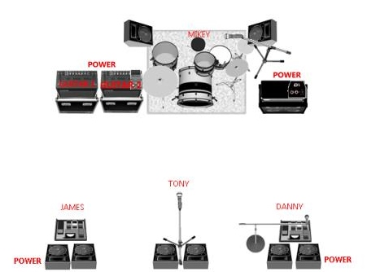Channel list
Channel Number | Channel Name | Mic |  | Stand
1 | Kick in | Beta 91 | Gate
2 | Kick out | Beta 52 | Gate | Short boom
3 | Snare top | SM57 | Comp | Short boom
4 | Snare bottom | 604/SM57 |  | Short boom
5 | High hat | AT Pro37/SE1 |  | Short Boom
6 | Rack tom | e604/Beta98 | Gate
7 | Floor tom | e604/Beta98 | Gate
8 | Ride mic | SE391/AKG C414 |  | LP Claw
9 | Overhead S/L | SE391/AKG C414 |  | Tall boom
10 | Overhead S/R | SE391/AKG C414 |  | Tall boom
11 | Bass D.I |  | Comp
12 | Bass Mic | EV RE20/MD421 |  | Short boom
13 | Guitar 1 | SM57 |  | Z bar
14 | Guitar 1 | e906/606 |  | Z bar
15 | Guitar 2 | SM57 |  | Z bar
16 | Guitar 2 | e906/606 |  | Z bar
17 | Centre Vocal | SM58 | Comp | Tall boom | TONY
18 | Bass Vocal | SM58 | Comp | Tall boom | DANNY
19 | Drum Vocal | SM58 | Comp | Straight | MIKEY
20 | Spare Vocal | Sm58 | Comp

Monitor mixes
We require 4 unique mixes on stage. These are a basic guide for monitor mixes.
Mikey (Drums): SC VOCAL, DRUM VOCAL, SL VOCAL, GUITAR 1, GUITAR 2 LOW, LOUD BASS, KICK SNARE TOMS & CYMBALS
Tony (Stage centre): GUITAR 1, GUITAR 2 LOUD, SC VOCAL, SL VOCAL, DRUM VOCAL, DRUMS BASIC MIX (BASS/SNARE)
James (Stage left): GUITAR 1 LOUD, GUITAR 2, SC VOCAL, SL VOCAL, DRUM VOCAL, DRUMS BASIC MIX (BASS/SNARE)
Danny (Stage right): SL LOUD, GUITAR 1, SC VOCAL, SL VOCAL, DRUM VOCAL, DRUMS BASIC MIX (BASS/SNARE)

