Solid Gone

Original roots music drawing on traditional blues and folk influences. Startlingly powerful vocals, raw delta blues styled guitar, stunning gypsy violin, thumping double bass and an irresistible beat combine to create a special atmosphere. Songs are distinctive and original relating to subjects such as slavery, losing one’s religion, death, cowboys and father-in-law’s going to hell!

Hailing from Gloucestershire, Solid Gone have built up a strong local fan-base and always leaves audiences wanting more during their many travels throughout the UK. Don’t be surprised to see special guest saxophone and harmonica players featuring during a show.

Recorded on at home by the band themselves, debut EP ‘Mr Loverman’ is out now available at live shows or via download from http://solidgone2.bandcamp.com/releases

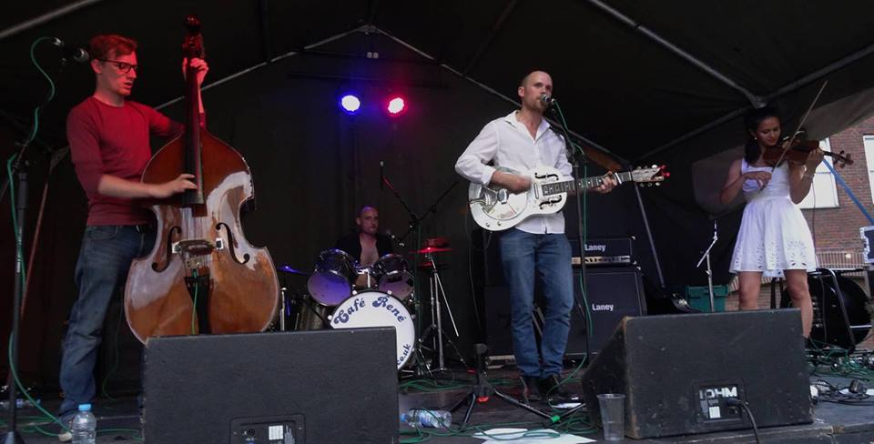

Shows/mp3s/videos @ https://www.reverbnation.com/solidgoneband

Contact:
solidgoneband@hotmail.co.uk
www.facebook.com/solidgone4
07807800260

