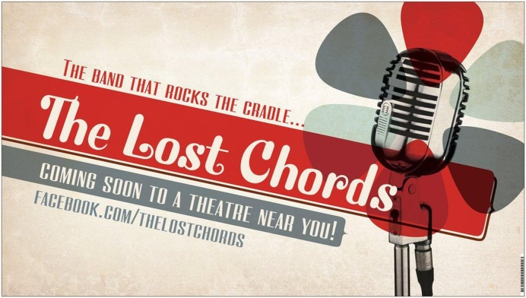
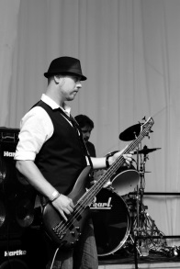
The five members that make up the Dutch band The Lost Chords are singer, keyboard player and guitarist Cornelis, who’s been writing and performing music since he was only 14, guitar player Jürgen, bass player B.J. and the drummers Maurice and Frankie G.
Cornelis and Jürgen formed the band in 2009 when they asked three musician-friends to get together because they’re very close on both a musical as well as on a personal level. The fact that two of the friends are drummers became one of the typical qualities of The Lost Chords. The combination of music and friendship makes the band a very close, family-like group.
Most of The Lost Chords’ music is melodic prog/pop-rock. They do calm, epic, orchestral-like music, danceable pop songs and loud rockers. The band are known for their intelligently crafted lyrics and their original, fresh approach towards their musical arrangements.
Songwriter Cornelis and the band have been influenced by a wide array of artists, from Paul McCartney, The Moody Blues, Twenty One Pilots and Roger Waters to Nick Cave and Eels. One might also discover influences from the 1980s like OMD, Marillion and Ultravox.
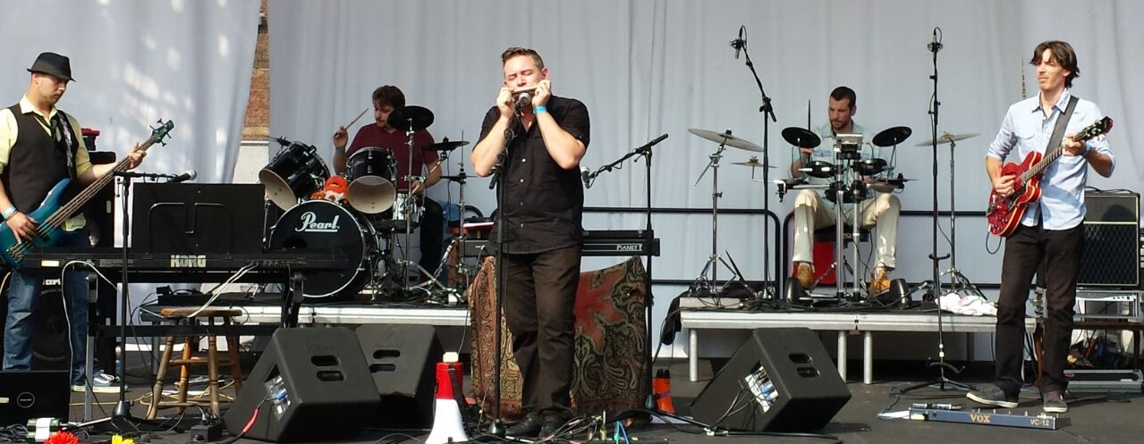
facebook.com/thelostchords thelostchordsinfo@gmail.com

