Technical Rider NIMETU - Spirit Flute Journey

One person on stage with a lot of instruments around! Ideally the venue should have no or very little outside disturbances and no inside noises (ventilation fans, refidgerators, etc.) , ideally also level surface (not stage-podium division). It should also be allowed to smudge if possible (palo santo and white sage - never had a smoke alarm problem, yet)
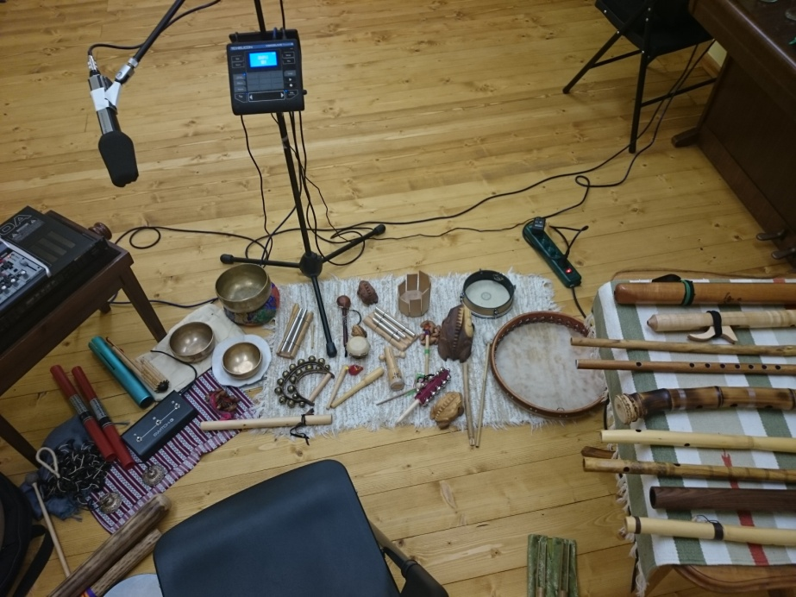

1x solid microphone stand (I use my own MD441N Sennheiser mic and TC Voicelive looper)
At least 2 x 2m stage surface with some rug or carpet suitable for putting down the instruments
1 x small table/surface for flutes
1 x small table/surface for my mixer and two 19inch FX devices.
1 x stage monitor
1x stereo DI box at larger venues (I use my own submixer and feed only a stereo jack OUT to FOH PA mixer)
4 power outlets
For smaller venues - 2x fullrange quality active speakers are enough or an equivalent of two Bose L1 systems.
In smaller venues there is also an option to have a "lie on a yoga mat" listening position with enough room to walk around the participants, instead of sits.

Technical Rider NIMETU - LOCUS SOLUS (individual 1 hour performances)

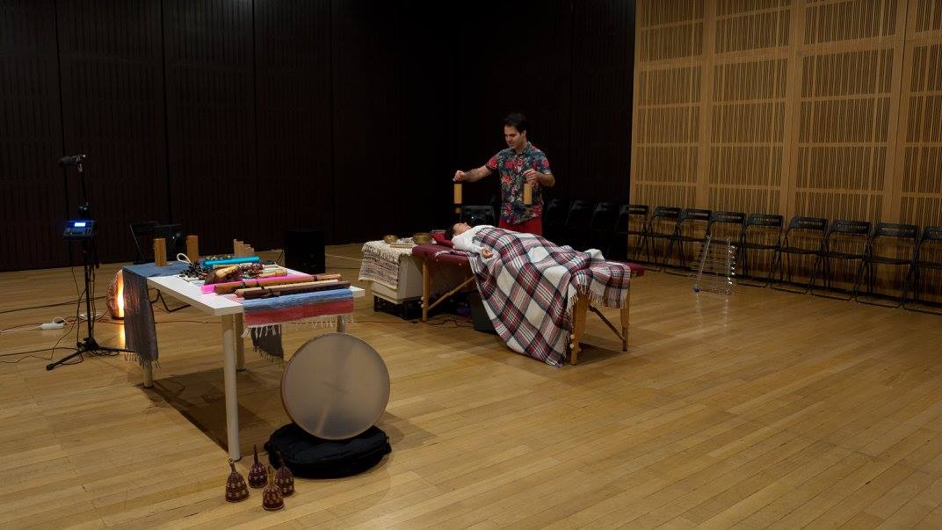
The venue should be sonically isolated, fairly acoustically neutral if possible (not too echoic) and closed - no loud outside activities or other disturbances.!
The size should be at least 7 x 7 meters of equal level surface with solid floor - no squeeky floors... And no inside noises - ventilation fans, etc.
It should be possible to have a fairly quiet and closed space for the duration of the individual performance. Each participant is invited inside individually.
1 x massage table
1 x table for instruments
1 x microphone stand
1 x small table for laptop and soundcard
2 x fullrange speakers of studio monitor quality (I use Neumann KH120A and Yamaha SW10 sub)
1 x fullrange active speaker for below the table with something to position it upwards (I used Schertler Unico Amp or Yamaha HS8)
1 x fullrange active speaker for back "surround" (I used Bose L1 compact)
(I can bring the massage table and Neumann/Yamaha set up, but need the third active speaker provided by the venue, eventually I could also bring another Yamaha HS8 if not available)
At least 6 long (10-15m) XLR- XLR cables
3 power outlets for laptop, soundcard and TC Voicelive and 5 power outlets for the speakers at their positions
It should be allowed/possible to smudge at the venue - palo santo and white sage - if absolutely impossible I can avoid it, but it is preferable to do it! Usual smoke alarms were not a problem at most venues I performed!

