MORUDES – RIDER 2016

includes:

PA-Specs

Inputlist

Light Rider

Stageplot

Backline

Hospitality / Accommodation

Contacts:
Tour Manager:
Henrik Maarud
Tlf + 47 93 61 58 46
E-mail henrikmaarud@gmail.com

Sound Engineer:
Peter Haugen
tlf: + 47 959 66 548
E-mail: peter.haugen@hotmail.com

Agent:
Knut Sannes/Atomic Soul
Tlf: + 47 984 64 614
E-mail: knut@atomicsoul.no

MORUDES – PA SPEC

SPEAKER SYSTEM:
Speakers / amplifiers, both PA and monitoring, will be high-quality systems such as D & B, Nexo, EAW, EV, Meyer Sound.
The PA system will easily provide 110 dBA phases and undistorted sound at FOH, and it should be good sound coverage in all relevant public areas. The PA system will be supplied by a reputable company, designed and rigged up by an experienced technician.

Mixers:
The band is traveling with their own digital mixer category Behringer X32 with Midas DL32 stage rack and network cable between stage and FOH,. It should be fully prepared for the connection of this mixer on the prepared PA by the band's arrival, and the house technician will be available to assist with this.

At festivals and venues with great distance between stage and FOH, and with a large audience area, it is necessary that the organizer in advance has posted a shielded Cat5e or Cat6 cable with ethercon plugs between mixer and stage. It is important that this is placed in an orderly and responsible manner, preferably together with the other wiring during rigging.

Mixer positioned so that soundman sees and hears the band from the same position as the majority of the audience (2/3 back & center). Placement at or below gallery is unacceptable !!

MONITORS:
4 wedges in 2 monitor channels. See Monitor overview in stage plot.

Microphones / DI's / STANDS etc:
See channel list / input list

VARIOUS:
All equipment must be in perfect condition. The system will be prewired and all channels tested before the band's representative arrives. Any difference / adjustments of this specification must be approved before signing of this contract.
The use of equipment provided by venue and Sound System company should not be associated with the risk of any kind neither the public, artists, technicians or equipment.

Sound Engineer:
Peter Haugen
tlf: + 47 959 66 548
E-mail: peter.haugen@hotmail.com

MORUDES – INPUT LIST

Ch Name Mic Stand
1 | Bass Drum | Shure Beta 52 | Short
2 | Snare | Shure SM 57 | Short
3 | Snare Under | Cond. | Short
4 | Snare 2 | Shure SM 57 | Short
5 | Rack Tom | Sennheiser e904/e604 | Clip
6 | Floor Tom 1 | Sennheiser e904/e604 | Clip
7 | Floor Tom 2 | Sennheiser e904/e604 | Clip
8 | Overhead L | 2 x Høykvalitets Kondensatormicer | 2x Long
9 | Overhead R | 2 x Høykvalitets Kondensatormicer | 2x Long
10 | Overhead Ribbon* | Band travels with own | Long
11 | BD Trigger | DI
12 | Perc/Sn Trigger | DI
13 | Keys Amp Drums | Shure SM 57 | Long
14 | Guitar Amp 1 | Shure SM 58 | Short
15 | Guitar Amp 2 | Shure SM 58 | Short
16 | Guitar Amp 3 | Shure SM 58 | Short
17 | Voc Drums | Shure SM 58 | Long
18 | Voc Guitar | Shure SM 57 | Long

* The band travels with their own Ribbon overhead mic, unless otherwise agreed in advance. This should be used in addition to overhead mics.

Since the band traveling with their own audio mixer where much of the show is pre programmed in advance, it is important that the band have access to exactly the microphones that are specified in the input list. We have made an effort to use stock microphones, but if some of these microphones are still not possible to obtain, or there are not enough of them, contact engineer in advance so that we can find a solution together or supply what is needed.

Sound Engineer:
Peter Haugen
tlf: + 47 959 66 548
E-mail: peter.haugen@hotmail.com

MORUDES – LIGHT RIDER

LIGHT:
*The artist does not travel with own light technician at all gigs and would like to use the house light tech unless otherwise is stated.

Lighting technician: HAZER / SMOKE MACHINE:
Where permitted / venue allows.

*Please contact tour manager to get in touch with Light Technician.
Light desk
1! Grand MA 1 light
Front light
6 Par64 LEE #202
Back light
6 Movinghead Profil CMY 6 Movinghead Wash CMY 20 Par64 CP61 3 Atomic 3000
10 2-light blinders
Side light
4! 1 KW Fresnel/PC
Floor light
10! Floorcans Pars64 CP61
Fog:
1! MDG Fog Machine (0r 2 Look Unique2 or 2 Swefog) 2! Fans
Backdrop:
1 Backdrop pip ( The pip must as long as the length off the stage.) Cable / Dim: All necessary cabling and dim channels.

Various:
All equipment must be rigged and tested prior to Morudes's LD arrival. There must be one technician at all times before, under and after show with good knowledge of system. All conventional light should be approximately focused on band area. We need the possibility to refocus light when Morudes`s LD arrive.
Please do not hesitate to contact Morudes`s LD or management if anything is unclear or if you have any kind of question or problems to fulfill this rider.
The most inportant thing however is a qualified and happy system tachnician that available from get - in to get out.

Light Plot will be available on request addressed to TM.

TM Contact:
Henrik Maarud
tel: (+47) 93 61 58 46
E-mail: henrikmaarud@gmail.com

MORUDES – STAGEPLOT

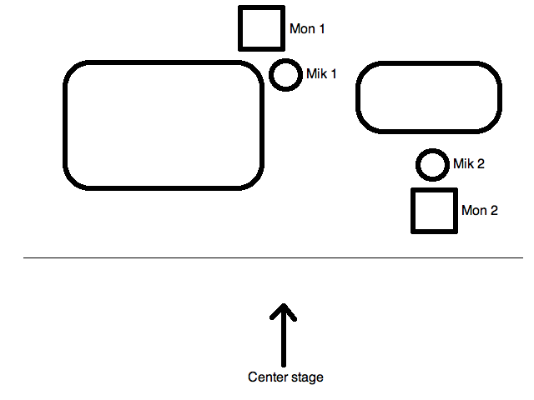

Guitar amps
Drum kit

MORUDES - BACKLINE

Guitar amps: 2 x Guitar Amplifier between 20 and 50 watts.
Preferably Fender, Marshall or Vox:
Marshall JMP 50 w, Marshall Plexi 50W, Fender Super Reverb, Vibrolux, Deluxe Reverb, Vox AC 30 etc. Laney Lionheart series is totally fine.

NOT Fender Twin, Hot Rod Series or other 100 watts and absolutely no digital amps !!

Drums: Pearl (not Export Series), Gretch, Yamaha, Sonor, Premier, C&C, DW. Only top series of DDrum and Tama. Preferably vintage kits like Ludwig, Gretch, Slingerland etc. The kit must be delivered complete and in good condition with new Remo Coated Ambasador or Remo black dot heads on all drums.

Bass Drums 22 "or 24" but no deeper than 16 ".
Toms: 12 "or 13" rack toms on a snare stand and 16 " and 18" floor toms.
2 pieces Steel / copper snare drums 14 "x 6.5 Ludwig Supraphonic or similar.

Hardware:
3 pieces Cymbal stands and 1 Hi-Hat stand
3 pcs Snare Stands (one for rack tom and two for snares)
1 pcs Drum Throne. Round seat and preferable not leather.

Backline contakt:
Henrik Maarud
tel: (+47) 936 15 846
E-mail: henrikmaarud@gmail.com

MORUDES - HOSPITALITY RIDER

This contract amendment is to make arrangements for both parties to be as successful as possible. The points below are not only of practical nature but also accounting the right issues.

AT GET IN:

Minimum 2 stage hands available at rig up/down. Stage hands can only be laid off by tour manager and if absent an invoice of 150 USD each, will be addressed to the person/company that signs this contract.

A heated dressing room with comfortable seating for band + crew.
The locker room is also supplied with white and clean towels for the band + crew. There must be access to toilet with mirror.

Backstage shall be ready upon arrival, and will include the following (enough for 4 people):
• - Coffee / Tea
• - Soft drinks / mineral water
• - fresh, Wheat bread (not pre-cut)
• - Assorted toppings
• - Milk
•- Juice

One hour before the concert backstage will be prepared with the following:
• - 10 bottles of beer
• - Some Fruits
• - Some snacks
• - black or blue sharpies
• - A4 sheet, without lines
• - 6 bottles water at room temperature non carbonated

OTHER CATERING
Hot meal for bands + crew between soundcheck and concert. Á la carte menu, not pizza, pots or fast food. The eventual buyout at USD 10 per person.
STAGE
Bottled water non carbonated for band + crew
LODGING
Single hotel of good standard icluding breakfast for band + crew,
GUESTS
Artist have a minimum of 2 on Guest list / Tickets per person in the band and crew, for the show.

MORUDES - ACCOMODATION

All rooms must be suited with private bathroom and the facility must serve breakfast in the morning!

Names:
Amund Maarud, Henrik Maarud, Peter Haugen (sound engineer), guitar-tech *, light-tech *

Rooms: Position:
1 single Amund Maarud
1 single Henrik Maarud
1 single Peter Haugen
1 single Guitar-tech *
1 single Light-tech *

Claim:
Non-smoking.
Allergy rooms without carpets.

room:
_______ _______ _______ _______ _______ _______
_______ _______
* Is not a part of the traveling crew unless you are informed in advance.

