Andrea Di Giovanni returns with new emotionally-driven pop single ‘Hold Me Once More’ and new EP Soultrip

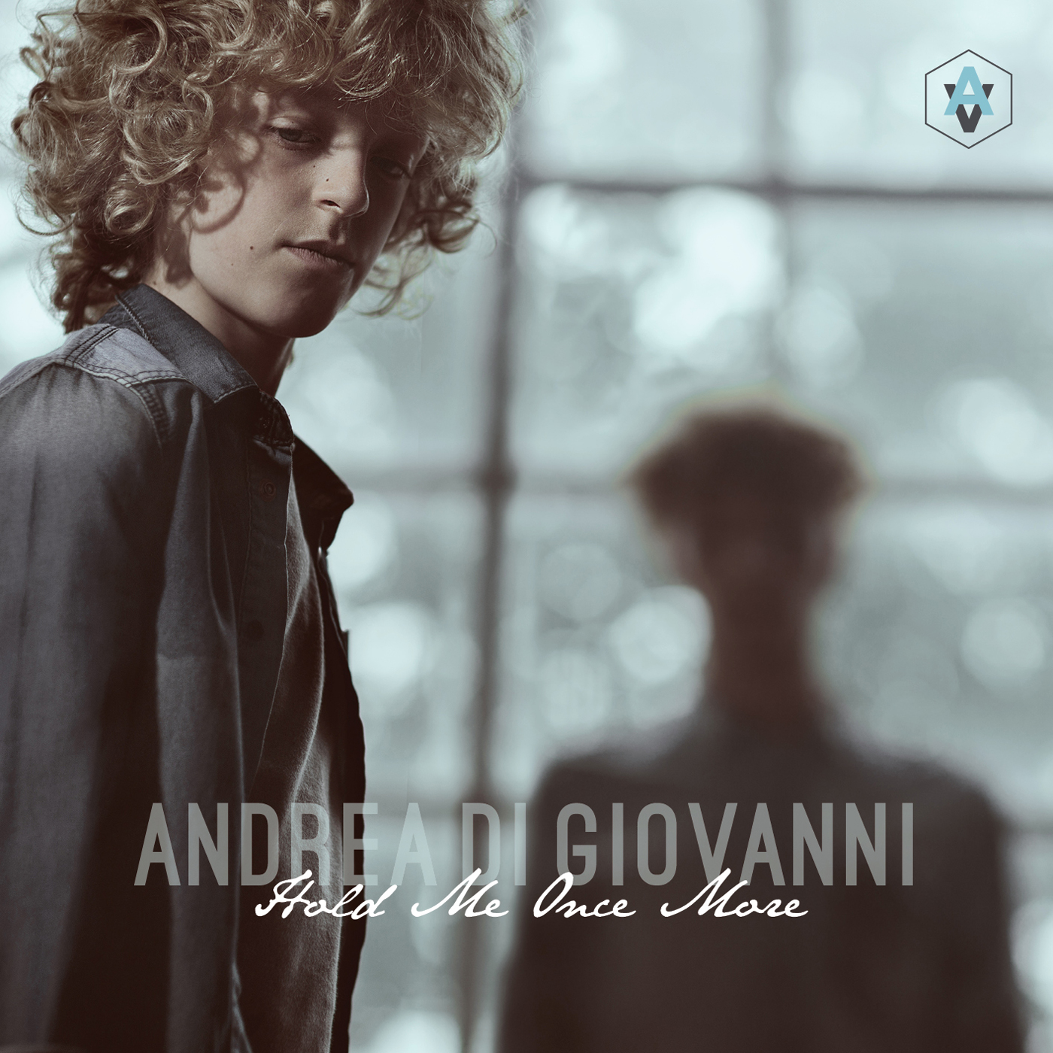

21-year-old Italian-born pop singer Andrea Di Giovanni delivers another fun and equally heart-wrenching single straight off his new EP Soultrip.
Listen to the track: https://soundcloud.com/andrea-di-giovanni-2/hold-me-once-more-explicit-teaser-andrea-di-giovanni
As the singer explains: ‘Hold Me Once More’ is the first song I ever wrote in English, 3 years ago. It talks about the relationship between me and my dad during my childhood and the lack of love and communication within it.’

Rarely speaking to his father as a child, Andrea later learnt that he had been cheating on his mother, which only added to the distance between them.

‘I started to feel very angry towards him,’ Andrea explains, ‘as I felt like he cheated not only on my mom but on all of my family and obviously me as well. In the lyrics of this tune I am quite straightforward, telling him what I have been through, which I never had the courage to do in person.’

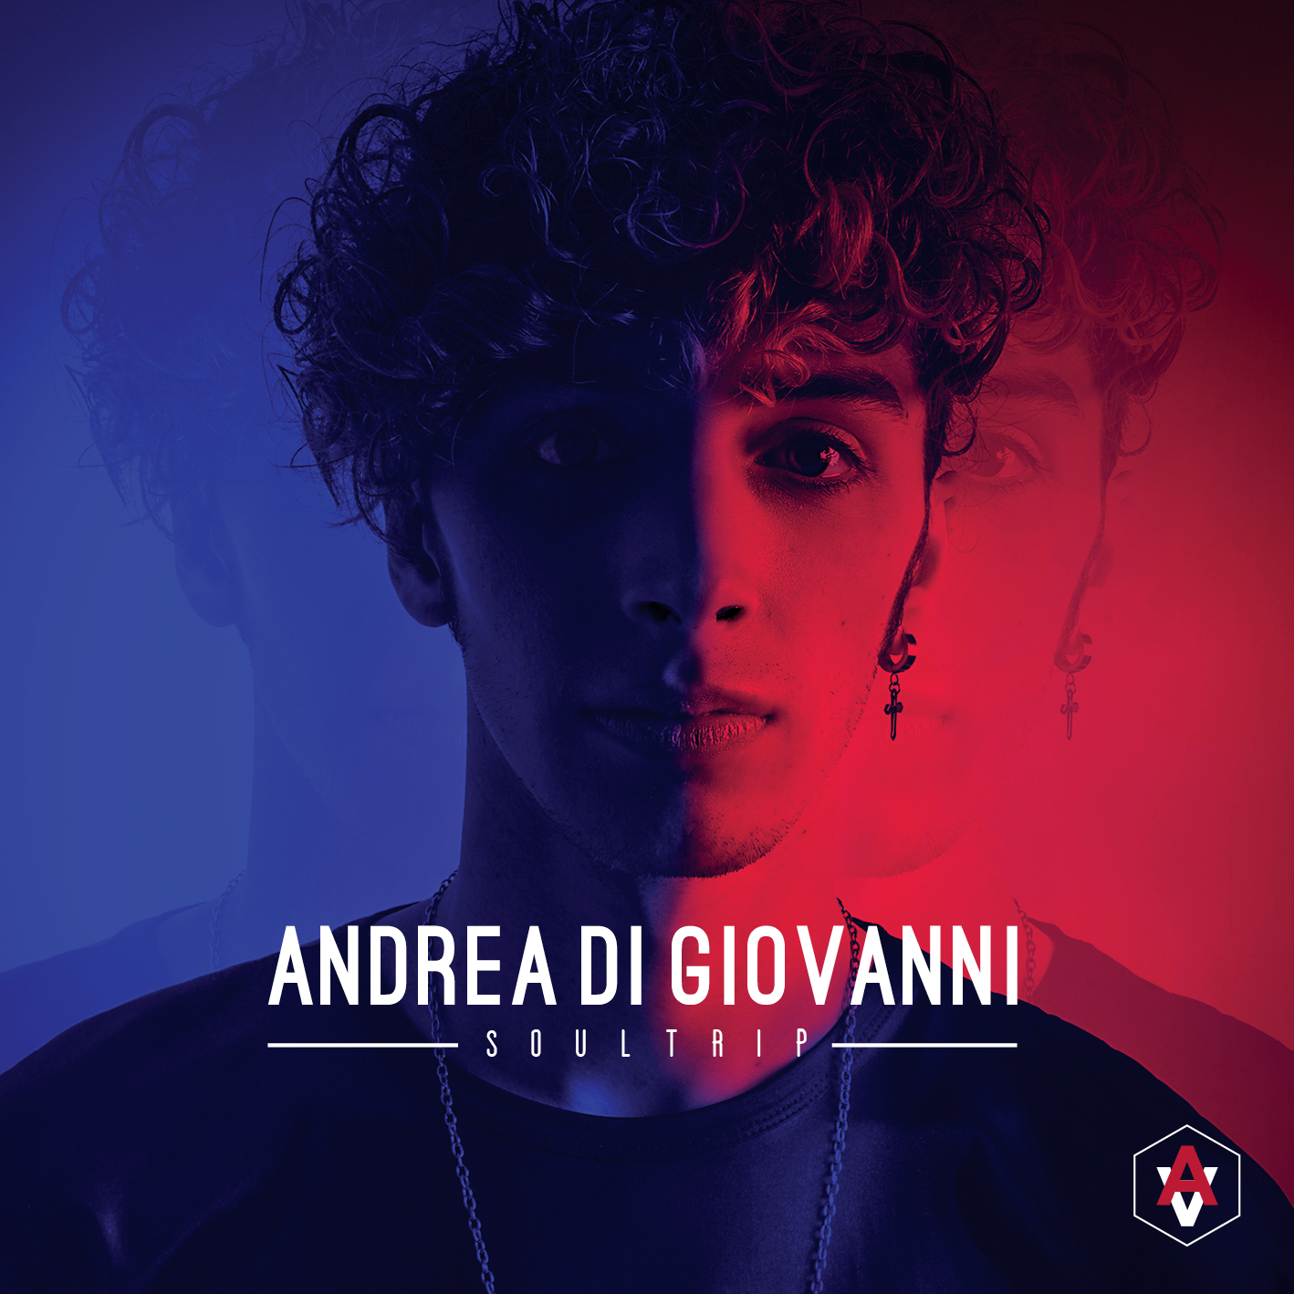
Both tracks will appear on the singer’s new EP Soultrip, which tackles an array of personal topics such as Andrea’s relationship with his father, exploring his bisexuality, as well as overcoming his experiences with vitiligo.

‘As the title explains’ states Andrea, ‘it’s a journey into the deepest corners of my soul, starting with the relationship with my dad, going into the very first time I fell in love with a guy, to my first experience in a gay relationship to the relationship with my ex best friend (actual girlfriend now). The progression of concepts for the EP is: absence, lust, apathy, awareness and resolution.’

‘Hold Me Once More’ is been released on the 15th of June and Soultrip are was out July 15th

Links:
Website: http://andreadigiovanni.it/
Soundcloud: http://soundcloud.com/andrea-di-giovanni-2
Twitter: https://twitter.com/adigiovannioff?lang=en-gb
Facebook: https://www.facebook.com/andreadigiovannimusic/?fref=ts

