TOMI SALESVUO EAST FUNK ATTACK
RHYTHM
SATOMUSIC 010
EAN: 6417698161090
Publiced: 30.09.2016
Distributor: Satomusic/Texicalli
Format: Vinyl(LP) + CD included

SONGS:

Side A
RHYTHM
FUNK THAT WAR
FUNKY FRIDAY
RHYTHM IS DA THING
WE GOT IT GOOD

Side B
MR. PRINCE II
LOVE (I NEED IT)
FUNKING IT WITH J
MESSED UP WORLD
Total: 42:00

“Funk With Full Power!”

The Tomi Salesvuo East Funk Attack has been called a “thickly dynamic invasion of funk”. The powerhouse of a group will release their second title, “Rhythm” on Friday, September 30th, 2016. On the album, Salesvuo leads an amazing line-up of Finnish musicians, brought in from the front line of making sure the funk keeps on thumping.

From the infectious rhythms of guitarist Marzi Nyman, to the passionate vocals of Anniina Karjalainen, this 9-piece group is taking their experiences from their strong live performances to completely new levels on this new East Funk Attack release! Anniina’s vocal stylings, which have hit home with audiences at the group’s numerous performances, are complemented by the energetic and grooving instrumental numbers, which feature the MC talents of Sam Renascent (BE) and the bandleading drummer himself! With musical compositions and album production handled by the leader, the group’s own guitarist and sound recordist, Matias Kiiveri, has taken charge of sound engineering duties, complementing their unified vision of funk.

“During the last few years, I’ve had an idea in mind about a large group, functioning as a melting pot for my idea of playing rhythmic music. I’m presenting my vision of the combinations of the relentless joy of playing music and catchy melodies. Essentially, we’re packaging the hypnotic rhythm of music with jazz improvisation, telling our life stories of growth as humans. I have the feeling that this feeling is now coming to life, and the potential for our growth as a group on “Rhythm” feels limitless!” says Salesvuo, in an inspired mood.

“Rhythm” is released on the heels of the success of East Funk Attack’s debut album, "EFA", which was released in Finland in 2014.
Tomi Salesvuo (b. 1972) is a drummer, producer and educator based in Helsinki, Finland. Originally born and raised in Lappeenranta, in the eastern part of Finland, Salesvuo has been an avid student of the drums since his early childhood. Salesvuo completed his studies at the jazz department of the Sibelius Academy (FIN). His international collaborations with the likes of Wayne Krantz, Jim Beard, Benny Golson, Peter Weniger and Nils Landgren have also played an important role in Tomi’s career. Recently Salesvuo have been playing and/or given Drum clinics in Denmark, Austria, Germany, Switcherland and Turkey. Locally, Tomi has played and recorded with groups such as XL, Bitter Sweet, How Many Sisters and Umo Jazz Orchestra. He has performed and/or recorded with top Finnish Jazz artists like Pekka Pohjola, Severi Pyysalo and Jukka Perko. As a drummer he´s energetic groove has been heard with top Finnish Pop & Rock Singers like Heikki Silvennoinen, Mikko Leppilampi, Osmo Ikonen and Jonna Tervomaa.

TOMI SALESVUO EAST FUNK ATTACK
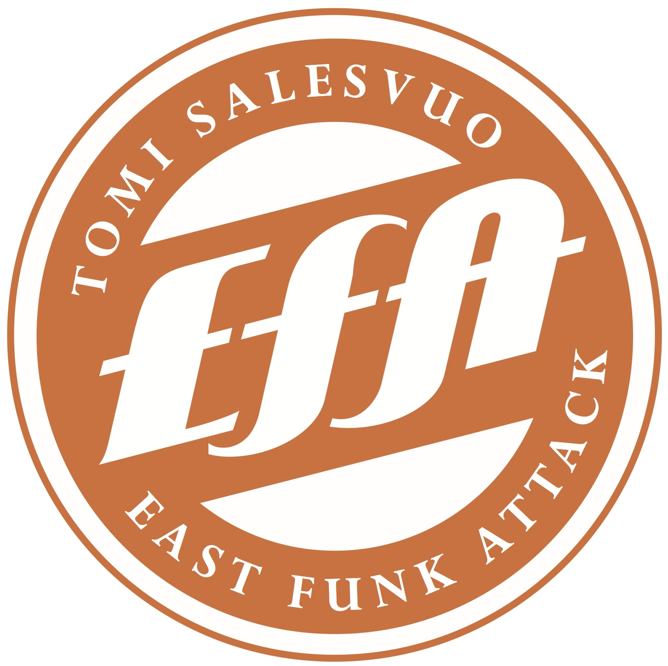
Anniina Karjalainen, Vocals
Kasperi Kallio, Rhodes & Keys
Roope Löflund, Saxophone
Mari Talala, Trumpet
Marzi Nyman, Guitar
Matias Kiiveri, Rhythm Guitar
Jarkkis Toivanen, Bass
Joonas Kaikko, Percussion
Tomi Salesvuo, Drums

Recorded and Mixed by Matias Kiiveri
Produced by Tomi Salesvuo

Contact:
Jonna Salesvuo
jonna@musiikkisato.fi
p. +358 40 159 9602
http://www.eastfunkattack.com

UP COMING GIGS IN FINLAND:
WED 5.10. HELSINKI, Tavastia "Album Release Party"
Feat. MC Sam Renascent (BE)
THU 6.10. LAPPEENRANTA, Kolme lyhtyä
Feat. MC Sam Renascent (BE), Mary Broadcast (AT)
FRI 7.10. KOUVOLA, Bar Downtown
Feat. MC Sam Renascent (BE), Mary Broadcast (AT)
FRI 11.11. IMATRA, Osmos Cosmos

SAT 12.11. JOENSUU, Piimälinna

SAT 10.12. HÄMEENLINNA, Suisto

