DEBUT SINGLE ‘COOL’
RECENT PLAY BY HUW STEPHENS – RADIO 1
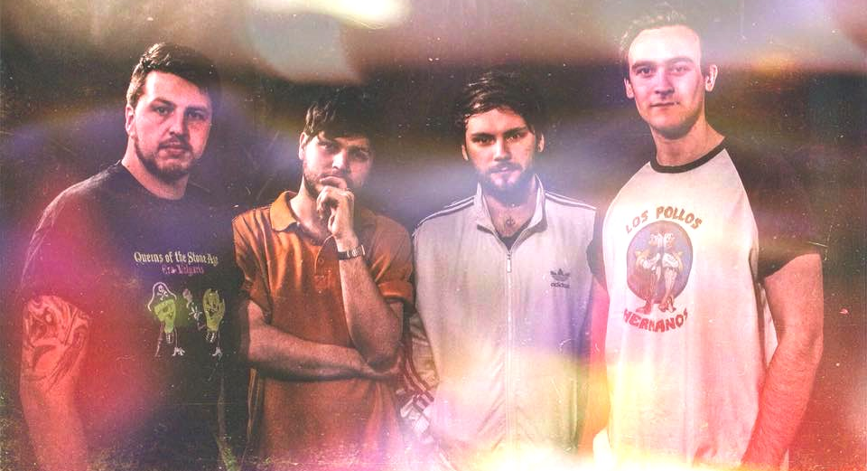
Fears Chella are an evocative Manchester/Stoke based four piece who cheekily blur elements of indie, grunge and pop with sparkles of 90s indie-rock.
Having started out playing dingy basement shows and house parties, Fears Chella honed their craft and developed an energetic and infectious live set before releasing to the world.
Their debut single ‘Cool’ has earned the band a massive platform, with recent play by Huw Stephens on Radio 1 along with earning them BBC Introducing’s ‘Record of the week. ‘Cool’ has stacked up 20,000 plays across various platforms and has gained the band a serious fan base of nearly 6000 followers on Instagram. Fears Chella have been hotly tipped by bloggers and recently chosen for The Unsigned Guide’s Artist Spotlight.
“When it comes to new debut singles, it doesn’t get any better than this!” – Rob Adcock, BBC Introducing.
LISTEN HERE:
https://www.soundcloud.com/fearschella/cool
https://open.spotify.com/artist/5TRTdaiiIluck8JWNq3pD8
Fears Chella are currently they working on getting into a studio to record their hotly anticipated debut EP and have upcoming slots supporting All Tvvins along with shows in Manchester, Leeds and other shows in the pipeline.
Fears Chella are: Andy Gannon, Chris Hewitt, Tom O’Neill and Ben Tansey
Email: fearschella@gmail.com
Social Media
www.instagram.com/fearschella
www.facebook.com/fearschella
www.soundcloud.com/fearschella
https://open.spotify.com/artist/5TRTdaiiIluck8JWNq3pD8

