MONICA PASQUAL & THE HANDSOME BRUNETTES STAGE PLOT

Joshua
CELLO & AMP
Chair, DI for cello

Monica
KEYBOARD & VOX
Vocal Mic, DI for keys
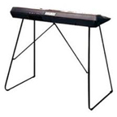

Pam
PERCUSSION & VOX
vox
snare
tom
cajon
overhead
