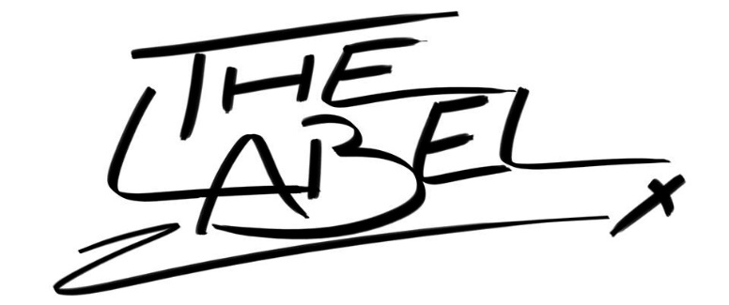
The Label – Press Pack
“It’s the best thing we’ve ever made, without a doubt. Not to say we don’t love our older releases, but this material? It’s something else”. - Ryan
August 2016
Formed by frontmen and childhood friends Michael Kerr and Jordan McGlynn upon their return to Scotland at the end of 2013, The Label are a 4-piece band from Paisley. Backed by Chris Shearer on bass guitar and Ryan Kane on drums, The Label have cultivated their own sound. You couldn’t put a finger on it but you know where it’s coming from. They fuse hard hits, big riffs, delicate melodies and bittersweet lyrics into energy-laden, guitar-based music not constrained by genre or afraid to be big and uncool. They do their own thing. And they love it.
2014 saw them build a loyal following through a series of high-energy performances around Scotland's central belt, before successfully recording and self-releasing their debut EP “Wet Leather” in February 2015. A summer of writing new material seen them return to the live arena with a show at Glasgow's famous King Tut's Wah Wah Hut. For a small band in the west of Scotland, it acted as a huge validation.
“We were originally supposed to be first support for a touring band. We got 8 days’ notice and went all out promoting it as we do any gig. We sold more tickets than the other 3 bands combined. We ended up headlining. Totally surreal”. - Michael
Going from strength to strength, The Label made their return to King Tut’s at the end of 2015 to promote their new single “Private Members Club”; one of two singles to be produced and recorded by the legendary JP Reid (Sucioperro/Marmaduke Duke/Medals). Following the release of their second single “One of the Girls” in May 2016, The Label stepped back from their momentous roll and began writing again. Every song they wrote, reworked and reshaped was better than the next. It was time for the next big step.
Originally conceived as a double EP, “Vodka and Lemonade” would have heavier and rockier tracks on one disc, with “poppier” and upbeat tracks on the other. Down the line it started to become clear that trying to compartmentalise or divide tracks thematically was the exact opposite of what The Label naturally do. Instead, four tracks were chosen to feature on one EP.
The oldest track (Hangover) was originally written at the same time as the tracks on “Wet Leather”, and the youngest track (Black Fiesta) was written a week before the studio dates. Some of these songs conceived years apart, yet still falling into place on the same release. It felt right.
“I think it was a case of ‘we should put our best foot forward’. We didn’t want to put out 8 half-imagined songs. We wanted to put 4 fully polished tracks we could be proud of”. - Chris
Recorded in the heart of Liverpool, The Label quickly got to work on what would later become part of them. The band lived and breathed their music around the clock. Sleep was precious and brief, as the creative process of living in a studio enveloped them. It became clear the band were desperate to birth something that audiences couldn’t ignore. Engineered by close friend Adam Greer, mixed by Bruce Rintoul (Twin Atlantic, Fatherson, WWPJ), and mastered by Ed Woods (The Who, Wilko, Reuben, The Xcerts), The Label sculpted something even they were surprised with.
“We listened to the demos pretty intensely for a month before settling on Bruce and Ed. We were pretty confident those guys could make the EP sound massive. We didn’t know how right we were. Listening to the finished thing is a totally different experience. It was a little strange making the admission to myself that I’d made my own favourite songs. But then shouldn’t every musician feel like that? Or at least aim to feel like that?”. - Jordan
Coming to this point was no mean feat. In the process of creating their work the band have experienced first-hand the heavy tolls of heartbreak, debt, homelessness, corruption, bereavement, black eyes, broken noses and bad blood. From this crucible flows easily The Label’s best work to date. From the poppy “dance-like-no-one’s-watching” indie belter of a title track, right through to the soaring epic closer, “Copenhagen”, the “Vodka and Lemonade” EP concentrates The Label’s dogged individuality, tenacity and fearlessness to do whatever they want however they want, into just over 13 minutes of music. Imagine what they could do in an hour.
Their time is now.
So pray it never ends.

