**BANDINI**

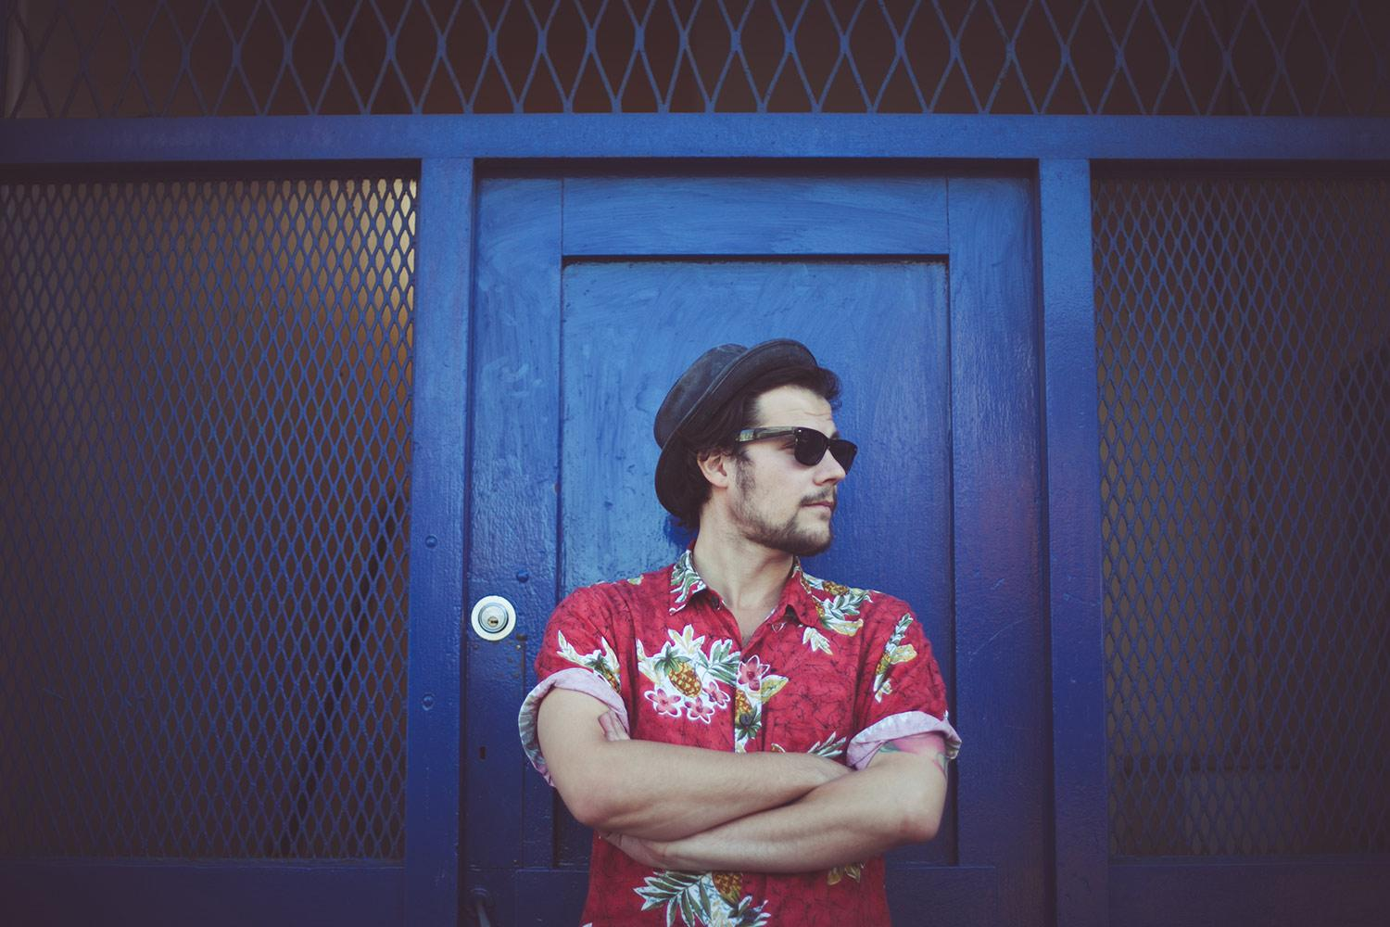

Bandini is a Singer - Songwriter and an Actor born in Italy now based in London. He play guitar, piano, harmonica and sing. Having been brought up on Blues and Jazz through his father, and then schooled in storytelling and song-writing through his uncle (Italian singer-songwriter), Bandini’s musical foundations were set. He started his career in London in 2015 performing on the streets as a busker, then he made a name for himself on the London open mic circuit with his special blend of gypsy blues.

One year later start studying at the London Contemporary Centre of Music, songwriting, piano and voice. At LCCM he met most of his band, these are: Luigi Rignanese (Bass), Richard Blenkinsop (Guitar), Richard Castle (Saxophone), Marie Lathi (Clarinet) Oliver Presman (Mellophone), Jacob Powell (Drum), Giorgia Piper Millie Cluet Jenny Lagerholm and Sandra Sorio (Choir).

Back to italy he studied acting, creative writing and he act for one year in different theatre. Bandini combining his passion for litterature and his acting knowledge with his music, wants to give to the audience a complete show.

In 2016 he mastred “Small Room” Bandini’s first Ep, 3 traks recorded with half of the actual band and produced by Nick Hunt in north London.

Bandini has played trought out London constatly for 2 years as both solo artist and with the full band: The Magic Garden, The Troubadour, Bedroom Bar, Number 90 bar and kitchen, The Dublin Castle, Paper Dress, Cargo. He also host the “Jazz Session” at The Troubadour. .

At the moment is working on his first album with Camelle Hinds (little bio) as a producer which will be recorded in the studios of Forest Hill.

**Bandcamp**

<https://bandinimusic.bandcamp.com/>

**Soundcloud**

<https://soundcloud.com/bandinisongwriter>

**Youtube**

<https://www.youtube.com/watch?v=kx4Re4cwqlE>

**Facebook**

<https://www.facebook.com/bandinimusic/>

**Website**

[www.bandinimusic.com](http://www.bandinimusic.com)

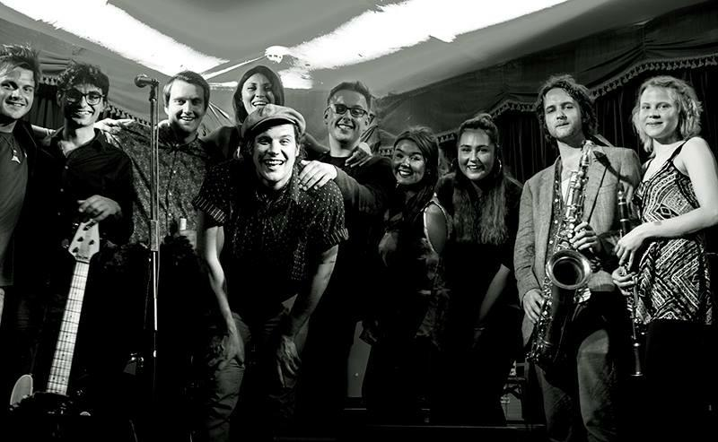

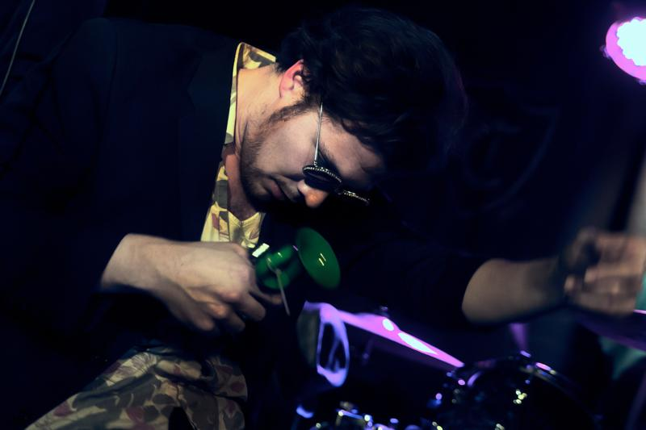

12810019_10208960805083148_103871901_o.jpg

“Bandini is such a free spirit who is able to galvanize an audience with his infectious, uninhibited sense of passion for art. A one off organic being…who delivers a refreshing blend of DrJohn, meets The Neville bros fronted by Tom Waits with Kid Creoles Coconuts supplying some seductive harmonies”

*Camelle Hinds*

“Bandini is the bastard son of Cab Calloway and Tom Waits”

*The Troubadour, London*

**Interview for RockShot**

<http://rockshot.co.uk/20145/bandini-nomadic-jazz-and-blues/>

**Show**

17th of July JAZZ Session @ The Troubadour

19th July @ Bedroom Bar, Shoreditch

24th of July JAZZ Session @ The Troubadour

28th of July @ The Troubadour opening for Dr Schwamp

Past Gigs:

17th of March presenting Small Room @ The Troubadour, London

30th of April @ Bun & Bar, Palmers Green

4th of May @ Bedroom Bar, Shoreditch (W/Huw Joseph and The Hamiltons)

17th of May @ The Fiddlers Elbow, Chalk Farm

26th of May @ The Troubadour, Earl’s Court (W/Dr.Schwamp) semi-acoustic set

31st of May @ The Good Ship, Kilburn (W/ Huw Joseph)

23rd of June @ The Magic Garden, Battersea, London (introducing The Bandini’s Band)