MUSIC BAND "ANTIKVARINIAI KAŠPIROVSKIO DANTYS
The name of the band in English means "The antique teeth of Kashpirovski". This name is very complex and deep, it's like ancient magic words... Nah, just kidding - actually it's just fancy sounding almost meaningless joke:) Antikvariniai Kašpirovskio Dantys plays music style, which they named "smagis" (Lithuanian word for "fun", "merry", "gay"). The audience gets everything from polka, mariachi, postpunk and heart-wrenching ballads to psychedelic reprises.
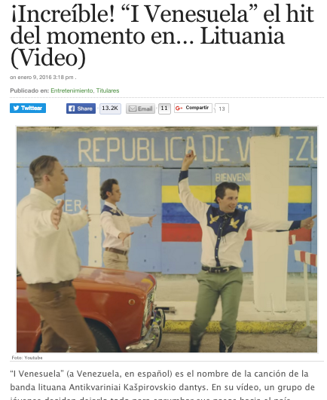
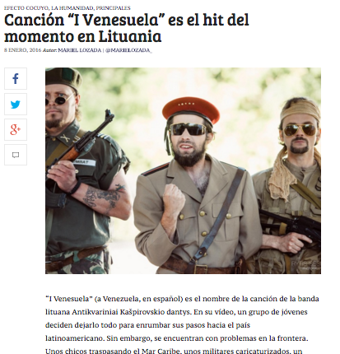
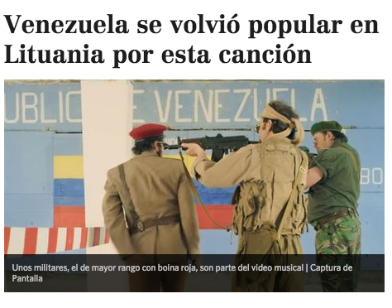
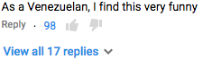

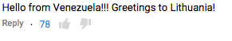

Antikvariniai Kašpirovskio Dantys emerged from altenative music scene, where it became famous with the songs "Apie Tai, Kaip Žirafa Sumindė Kaunietį Antaną" ("About How Giraffe Stepped on Antanas from Kaunas") and "Joga -Jega!" ("Yoga Is Cool!"). The real breakthru happened in 2015 when under the label M.P.3 the band released debut album named after the band. The release was promoted with the single "I Venesuelą" ("To Venezuela") also supported with the catchy music video.
The song became a solid summer radio hit in Lithuania, it has featured local cinema movie as the title track, has won orchestras project on Lithuanian TV and most recently attracted media attention in Venezuela, where it went viral by gaining 100 000 YouTube views from in 2 days. We hope it's on the way to feature some Venezuelan soap opera:)
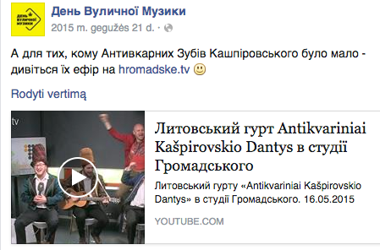
Last year the band toured in Lithuania and Ukraine, playing over 70 concerts in total. The band currently is among nominees in Lithuanian music awards M.A.M.A. for breakthru of the year and the video of the year.
So, you hold in your hand a very special debut album by Antikvariniai Kašpirovskio Dantys. It contains 11 ironic, humour flavored and even sad, nostalgic songs and 3 music videos. Please use it for good. And may God bless you!

Antikvariniai Kašpirovskio Dantys by Antikvariniai Kašpirovskio Dantys | Album language: Lithuanian

Singles: 1. Į Venesuelą, 2. Apie Tai, Kaip Žirafa Suminde Kaunieti Antaną, 3. Joga - Jega!, 4. Kur Nešviečia Saule ("Where the Sun Doesn't Shine").
Facebook: Antikvariniai Kašpirovskio Dantys | Instagram: AKDantys

Vaidas Stackevičius | M.P.3 Music Agency
T: +370 698 70122 E: vaidas@shownet.lt WEB: www.shownet.lt

