PILL & HARDIES TECHNICAL RIDER

TECHNIC:

Things on the technical rider, that isn’t agreed or approved on text and aligned with the booker, can have a result, that the artist won't complete the show. Although, the booker would still be charged full payment.

PA, Front & DJ booth on stage delivered by organizer.

2 Pioneer CDJ 2000 Nexus Players (Should be linked to use USB)

1 900 DJM Nexus Mixer

Players and mixers is required to be placed besides each other. This is very important.

1 6 x 3 table for CDJs and Mixer. NOT IN COFFIN.

1 Microphone

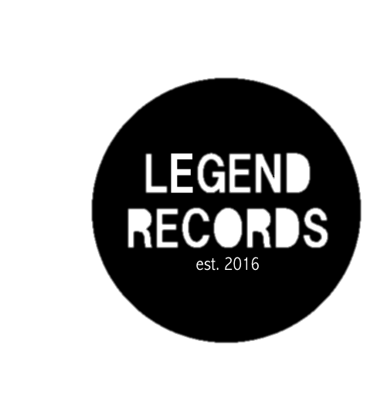
2 Monitors - Monitor volume must be controlled by DJ mixer

The artist doesn’t have star caprices, so should the organizer have a difficulty getting the things above, the artist can compromise, and find a solution.

Questions? Ask our manager

Lukas Lund-Abelsen
hardiesmanagement@outlook.dk

