Bernt Hertz

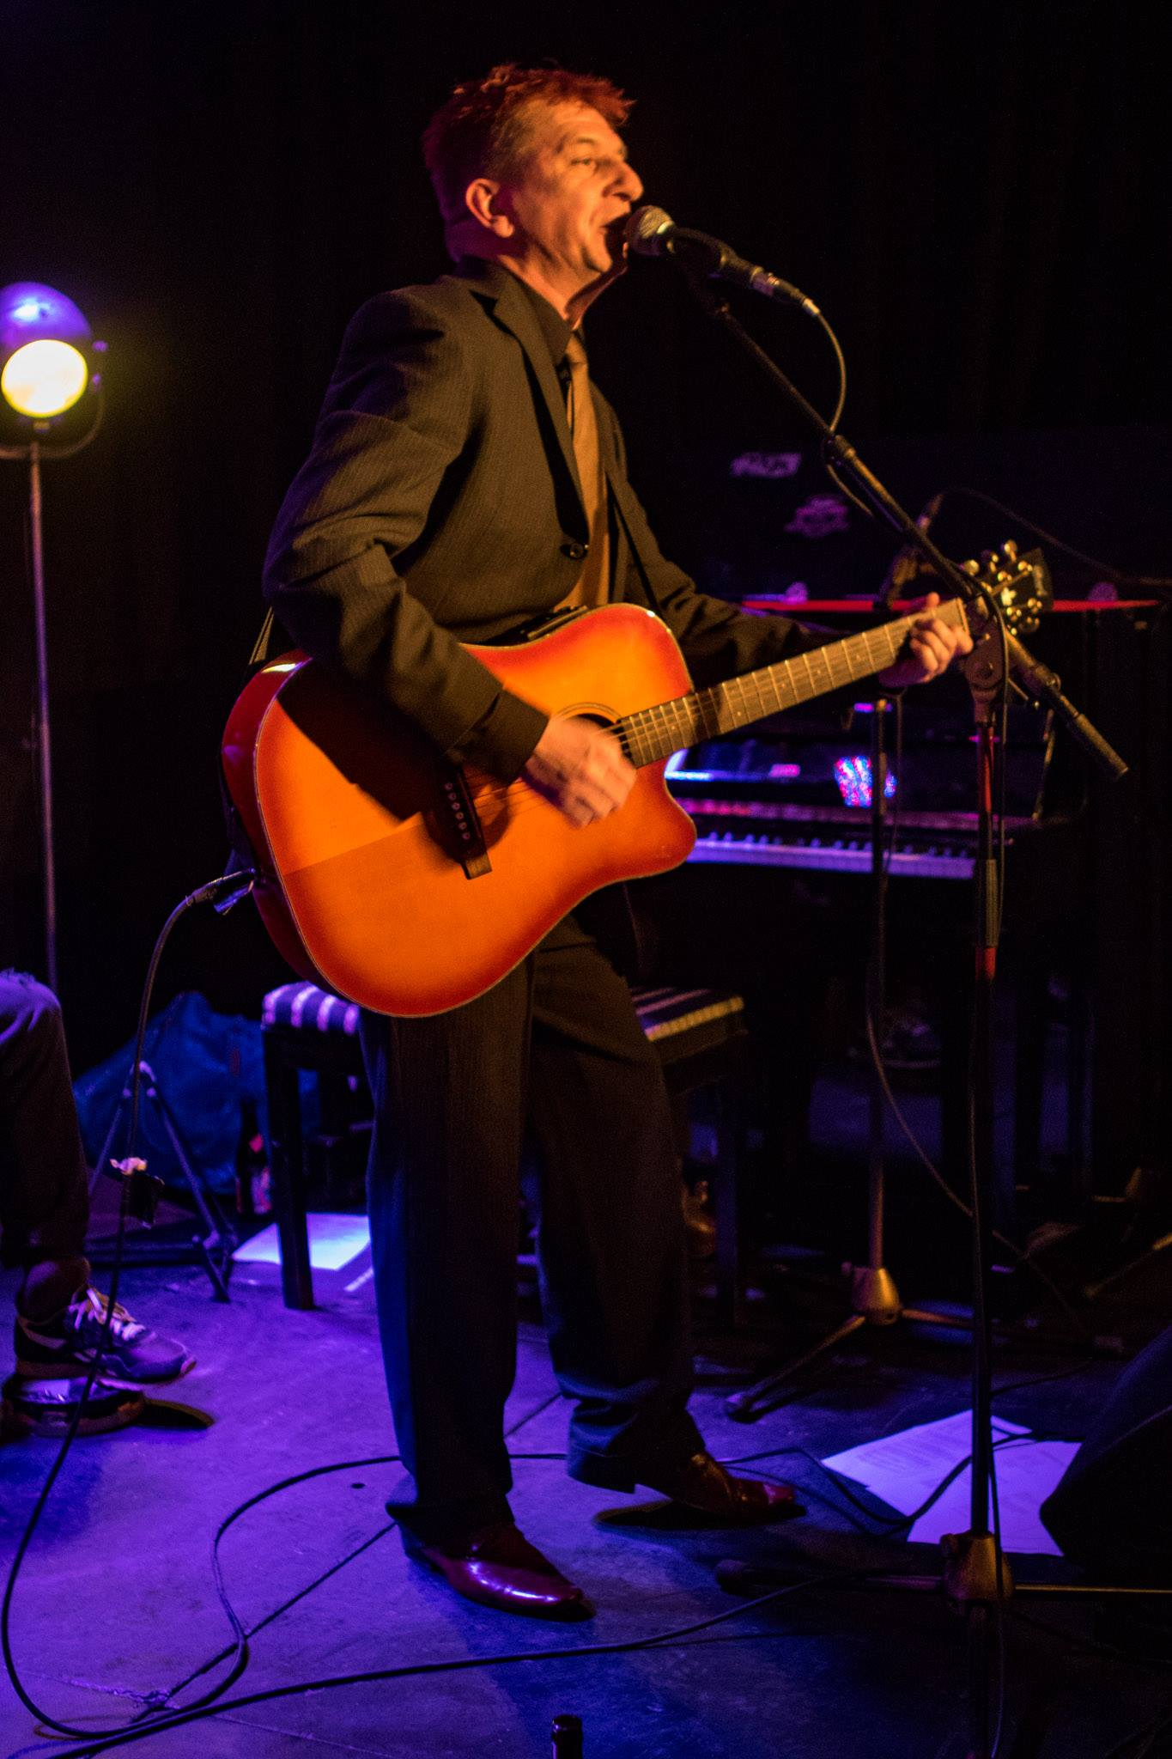

Bernt Hertz is a Copenhagen-based singer/songwriter, singing in Danish and English. The music is folk-based, but with very distinct hints of punk, blues, rock and pop. Bernt Hertz’ songs are often cynical, sarcastic commentaries to life, the powers that be or himself – when they’re not melancholical odes to the misery of mankind. He has made a name for himself on great songwriting and truckloads of attitude, and he’s a frequent performer on Copenhagen’s Songwriter-stages.

Bernt Hertz performs solo with his acoustic guitar, as a duo with pianist and singer Mette Rehling or as the five-man-entourage Bernt Hertz & The Badass Backing Band.

Bernt Hertz was born in the town of Nakskov on the island of Lolland in the outskirts of Denmark in 1971 and moved to Copenhagen after becoming a journalist in 2000. He started writing songs in 2006 and was first seen on stage i Copenhagen in 2014. The first EP is yet to be funded, and you will therefore be likely to find Bernt Hertz out playing at a bar, café, small venue or summer-festival.

www.hertznet.dk/hz - www.facebook.com/hertzallover - www.soundcloud.com/bernt-hertz

