Listen to the sweet soulful sounds of Rawenergee........
Rawenergee, whilst performing, producing and writing their own works is a band that aim to feature different singers and Rappers on their songs and to work with session players for its live performances and studio work depending on what the songs requires
Delivering a brand of music that is unique to Rawenergee, their self styled soul funk, soulful Jazz fused with hip hop and rnb is ready to excite any audience that they perform to
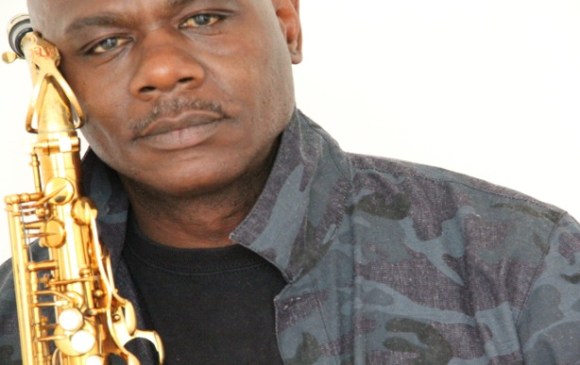The founder of the band Gee is a saxophonist, writer and producer. His vision of the band is a six/seven piece band made up of Saxophone, Guitar, Keyboards, Drum, Bass Guitar and a 1/2 Vocalist’. The players are all friends or people that both Gee and Brian have known throughtout their years of playing music. The band is able to deliver an exciting live show; they are versatile and accomplished musicians with a presence on stage that is magnetic with an ability to communicate with any audience.
Apart from the sweet soulful Saxophone sound of Gee Chambers and the bass playing of Brian, Rawenergee is supported by 2 world class vocalists.
Jacqui George is a Professional singer/songwriter who has worked with most major record companies labels sessioning for live shows backing vocals, lead vocal
...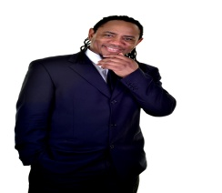
Elvis Chambers Wolverhampton, living in London. He emerged from the music business, where he worked with the likes of M People and Andy Taylor from Duran Duran, and supported acts like Blur, Chaka Khan and Alexander O' Neal.

The session musicians used are professionals’ who know how to communicate with an audience through their instruments. Between them they have many years performing for different occasions

The main nucleus of the band is: Along with Gee Chambers is Bryan McKenzie bass player

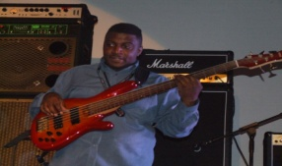
Brian is the music director of his church and has played for national male voice, youth and Convention choirs. His specialist instrument are the electric bass, playing in a variety of genres such as Jazz, Gospel, R&B, Reggae Pop etc and does arrangements. Brian has recently passed his BA’s degree in Music Performance and Professional Practise. He also does arranging and session works both live and in the studio for other artists. Brian’s experience has also seen him perform before famous personalities of British T.V such as Hugh Grant and Trevor Eve.

The leader of the band Gee has a saxophone sound that is sweet and soulful. When he plays up-tempo he makes you want to dance the night away, his performance of a ballad leaves you in a deep and peaceful mood. You can groove or kick off your shoes, lay back and listen to his expert delivery of a song by Rawenergee.
The bands single, ‘Climb The Wall’ was released on the 15th January 2016. This single features the talented Rapper K.C. When you hear the sound of Rawenergee your aural palette is bound to be ignited

