HAROSHKA CATERING RIDER
About 2 p.m.
soup, coffee, pasta

Dinner
About 6 p.m.
glass of wine, salad, water

Lunch
About 10 a.m.
a large cup of coffee, orange juice, toast, cheese, salad leaves, ham
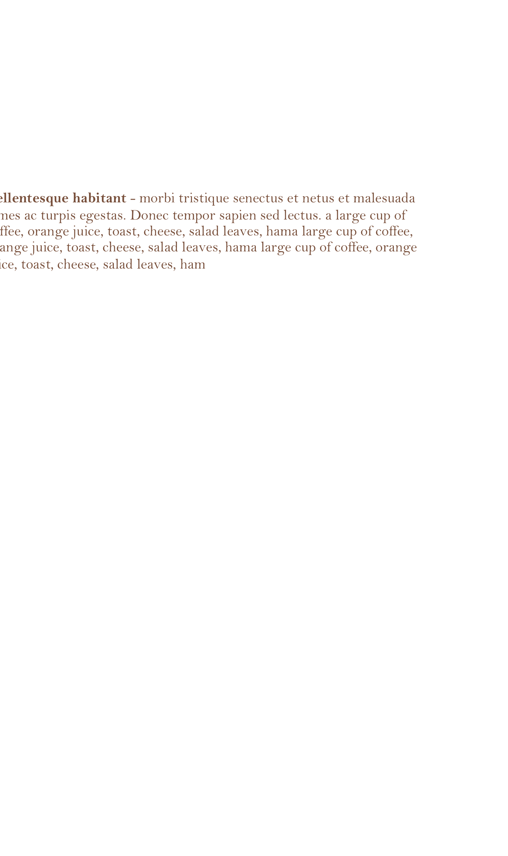
[Street Address] [City], [State] [Postal Code]
Phone: [Your Phone] Web: [Web Address]
Lorem ipsum dolor sit amet, consectetuer adipiscing elit.

Breakfast

