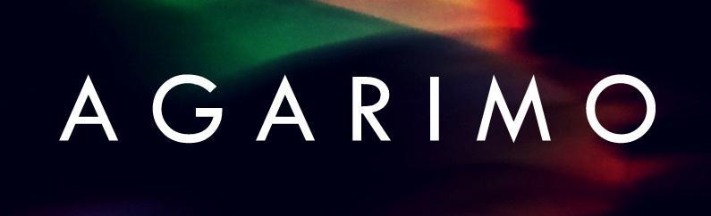
Agarimo is a new project from Bristol based brothers Pablo and Juan Mestres (Aye Aye, Waven400). The band’s name comes from the Galician word for “in the shelter of”.
Their self-titled EP, due for release August 2015, was recorded by the band at their home studio in Bristol, and also partially in their home country of Spain.
The music is progressive, exciting and highly spontaneous. Agarimo brings a mature and seductive edge to their blend of electronic-rock and psychedelic-pop. Pablo harnesses a unique vocal style and fluent use of multiple languages to captivate and transport the listener.
The band gained co-production guidance during the early stages of recording from Transgressive Producer David Pye (previous collaborative productions include Wild Beasts and Egyptian Hip Hop etc), who also mixed the record. Shawn Joseph (Portishead - ‘Third’) applied the final touches when mastering the EP.
Press quotes: - "…driving indie-rock with an electronic flourish and intensity levels set to a constant, adrenaline-fuelled peak..." Rewind Record Play - UK.
“Awesome dreamy Rock, simply a unique product” Indie Apex - USA
Live: Main Support act for – Dengue Fever, Portugal the Man, Jagwar Ma, La Shark.

Contact:
E - agarimomusic@gmail.com
M – +447768271973
Web: https://soundcloud.com/agarimo

