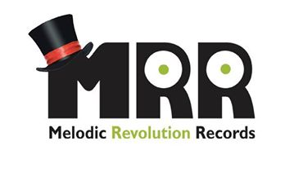
Halo Music Production Ltd
Halo Press Sheet
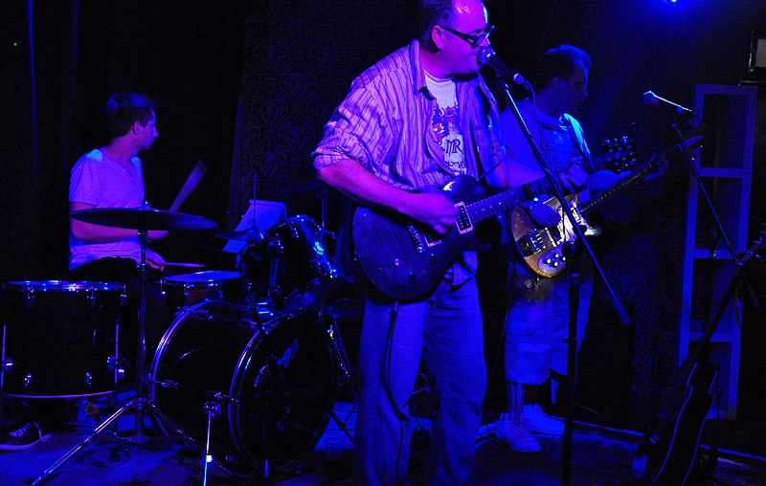
The Halo Sound Is…..

Really hard to categorize, as our musician's influences are so wide and diverse. We like to call it "Cross-Over Progressive Rock" or “Prock” as we think all genres of music are hit on in our songs. When one listens to Halo its really nice to hear the influences mentioned before but put across in their own style, each song tells a story of life today, the good, the bad and the broken. Outside the band the music has been described by critics as Rock, Progressive, Alternative and even English Grunge! We think it's that and more.
Halo Is….
Simon Talbot: Vocals, Rhythm Guitar
Ashley Turner: Bass, Backing vocals
Paul Wiffen: Piano, Keyboards, Guitars

How do you spend your “Nights and Days”?

Still undecided? Then let members of London band Halo show you how they are spending theirs through the release of their first EP entitled “Nights and Days” on U.S. Label Melodic Revolution Records. Presently, the fourpiece cross-over prog band is out and about in town honing its live sound and will soon be returning to the studio to record its first full album “The Halo Effect”.
Front man and rhythm guitarist, Simon Talbot explains: “We’ve only been together as a band since February2012, and the speed of which things have happened is totally mind blowing. We all met on dating site for musicians called “Join My Band”, and have recorded and released this first EP in just 6 months. The album is obviously our next big project, and we are hoping to have it out later this year!” He adds: “We are hoping as well to secure a deal here in the UK, and our dream would be to get a support slot for one of our hero’s in the Prog-rock world either here, Europe or Stateside”.
Discography
“Nights And Days – EP” - Catalogue No. MRRCD22008 – Released October 2012
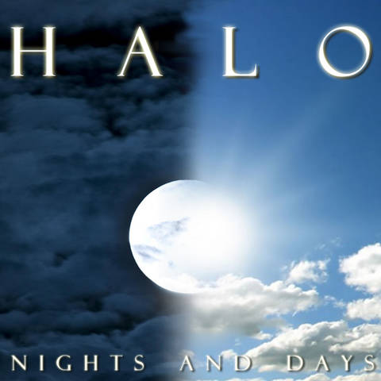 | - Secrets (04.10)  - Love on the Internet (03.37)  - Modern Day Regime (04.40)  - Face The Pain (04.54)  - Intrinsic Frustration (05.01)  - By My Side featuring Zefora (5.28)  Bonus Track: My Appeal to Reason  (Multi-Media Presentation – Street Photography Oleg Zadnipryanyy)

All Songs written by Simon Talbot and Robert Furman
Performed By
Simon Talbot – Vocals Guitars
Robert Furman – Guitars
Ashley Turner – Bass/Backing Vocals
Hitman - Drums

Recorded July/August 2012 at Halo Studios
Produced By: Robert Furman
Mixed and Mastered By: Colin Tench

Art direction, design and illustrations by Robert Furman

“Remembrance” - Released October 2014 MRR Download

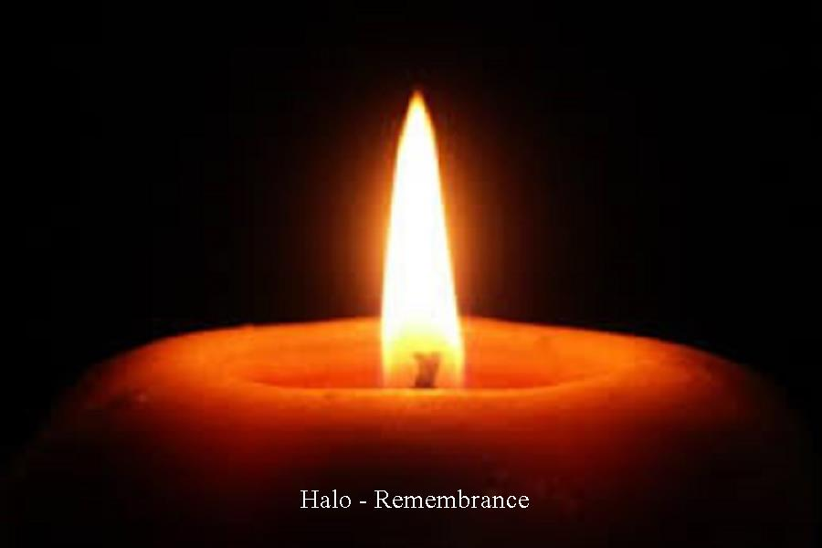 | - My Compromise (04.51)  - Blamer (06.12)  - Knowitall (08.56)  - Full Speed (06.16)  - Darkness Alone (06.02)  - Dictator (5.53)  - Simon Says (5.12)  - Just one of Many (04.42)  - Knowitall – Acoustic (08.57)  - My Appeal to Reason Re-Mix (09.15)
All Songs written by Simon Talbot and Robert Furman
Performed By
Simon Talbot – Vocals Guitars
Robert Furman – Guitars
Ashley Turner – Bass/Backing Vocals

Official Website: http://halo-band-london.com
Label: http://www.melodicrevolution.com/page/halo
Facebook: www.facebook.com/halostudioproject
Sound cloud: www.soundcloud.com/thehalostudioproject
PowerofProg: http://powerofprog.com/profile/Halo
Twitter: https://twitter.com/haloltd
MySpace: http://www.myspace.com/thehalostudioproject
Reverb nation: http://www.reverbnation.com/halo

For Booking and Interviews: Simon Talbot – talby1@outlook.com 079-1099-1736

