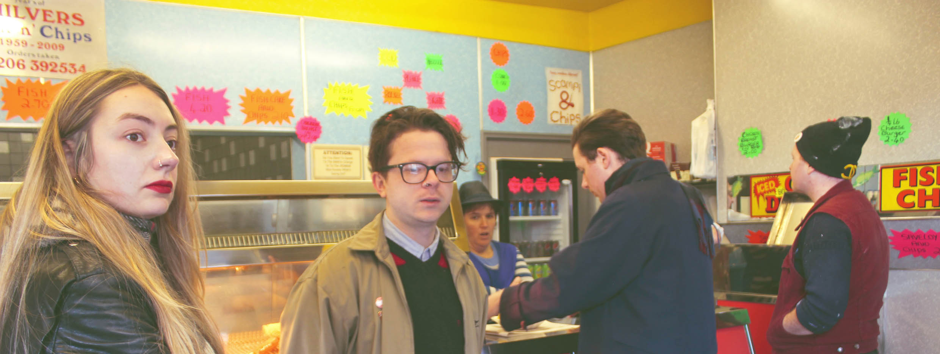
SuperGlu stream new EP and embark on UK tour
Title: Horse Release date: 24.02.16
Link Soundcloud: https://soundcloud.com/antigenrecords/sets/superglu-horse/s-Djd3i Premiere stream link via DIYMAG.COM: http://diymag.com/2016/02/19/superglu-horse-ep-premiere-neu-pick Watch live on YouTube: https://www.youtube.com/watch?v=jLp71gzGCxA&feature=youtu.be Buy: http://antigenrecords.com/releases/horse/
Press: Jason Whittaker (antigen records): 07894 598781 or info@antigenrecords.com
SuperGlu announce new record “Horse” and promote lead track “Rounder” with UK tour.

Formed in 2014 by two Bens (Brown and Ward), Brown’s brother Alex and girlfriend Krista Lynch, SuperGlu are a garage pop four-piece from Manningtree, Essex. They’ve been championed by Amazing Radio and BBC Introducing's Huw Stephens, who broadcast their first demo on Radio One in October 2014, before the band had even played a gig. They released their debut single "Diving Bell" via Ipswich-based antigen records in April 2015, generating an instant online buzz, sufficient to secure their first festival appearance, at Latitude 2015, only nine months after the band first formed.
The band has been hard at work on the follow-up and they are set to share six tracks of furiously exciting lo-fi pop-punk which will be premiered via DIY magazine on 19 February. “Horse” will be released by antigen records on CD and all digital platforms on 24 February. The band will promote their new release with a string of live dates around the UK in February and March (see below).
Tour dates
12.02.16 - Reading – Rising Sun Arts Centre
13.02.16 - Norwich - Arts Centre
18.02.16 - Hertford - Dog and Whistle
20.02.16 - Ipswich - The Swan
22.02.16 - Leicester - Pi Bar
23.02.16 - Hull - Polar Bear Club
26.02.16 - Colchester - V bar
02.03.16 - London - The Kings Head, E2 8AS
09.03.16 - Bury St Edmunds - The Hunter Club
10.03.16 - Brighton - Green Door Store
From the media:
"Bands don’t come more instantly infectious than SuperGlu". - DIY MAG
"Oozing with catchy melodies, this energetic track somehow manages combines raw rock with bouncy pop, resulting in two and a half minutes of innocent rebellion, that’s ridiculously addictive". - London on The Inside
"Furiously exciting... SuperGlu are going to be one of the hottest bands around next year." - It's All Indie.
"If anyone's talking about the resurgence of the 'guitar band', then SuperGlu are the very essence of it." - Drunken Werewolf.
“A band everybody will be talking about by the end of this year... a damning account of the music industry that SuperGlu are not already a household name" - BBC Introducing
Latitude 2015 press:
“Friday saw arguably the best set of the weekend. SuperGlu descended onto the Lake Stage and were greeted by hundreds of screaming kids, shouting every word, crowd surfing, annoying balding fathers and generally causing a ruckus... they excelled and were my personal favourites of the whole weekend” - TMRW magazine.
“SuperGlu... are rewarded with a dedicated crowd who responded to their raucous indie-punk set in a huge way... it’s the selection of tunes the four-piece offer which truly impresses and set highlight ‘Diving Bell’ leads to the festival’s first mosh-pit.” - Wow 24/7.
“If we're offering out awards, then the title for ‘one to take home with you’ must surely go to the Lake Stage set from Superglu. The frisky Manningtree foursome made the most of their Latitude stage time and should now follow on the heels of last year’s breakthrough stars, Slaves.” - Virtual Festivals.
Photo credit: Keita Lynch

