Josh Robins - Tech Spec
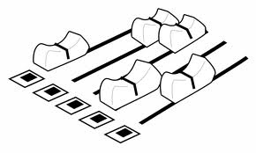

Solo Performances
Channel No. | Description | Suggested / Min Spec
01 | Josh Vocal | Min Shure SM58
02 | Acoustic Guitar | Boom Mic Stand  DI
Outboard Equipment
2 x Channels of Reverb. Vocs & Guitar
1 x Compressors - Guitar [preferred but not essential]
1 x DI Box
Monitors
1 x Stage Monitor with independent mix & EQ.

