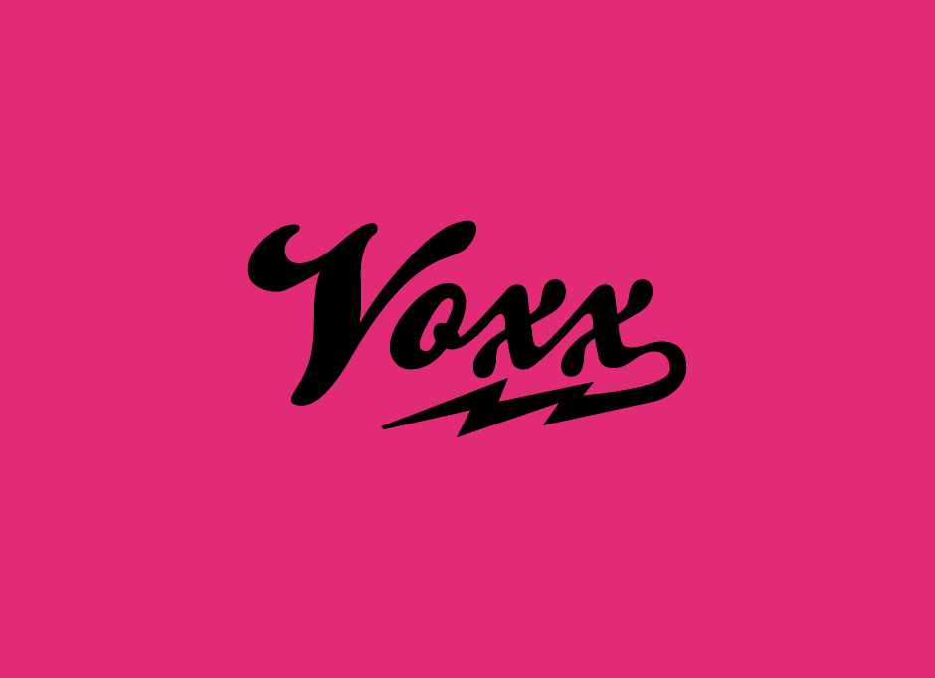

PRESS RELEASE – ‘GLAMOUR PUSS’ SINGLE 7” VINYL RELEASE DATE & LAUNCH PARTY - 06.02.16

VOXX are :-
Conor ‘Coco’ Thornton – vox/guitar
Tim ‘Slice’ Wyse – bass
Andrew ‘Drew’ Martin – drums

VOXX love :-

Ziggy & The Spiders from Mars’ High Heel Boots
Keith Richard’s Hair
Marc Bolan’s Eyeshadow
Josh Homme’s Tats
Michael Hutchence’s Hips
Jesse Hughe’s Sex Drive
Alex Turner’s Wordplay
& everything else dirty, dark, sexy, trashy and beautiful..

VOXX release their single - ‘Glamour Puss’ on limited edition 7” coloured vinyl on Saturday 06.02.16 at a Launch Party in Whelan’s Upstairs, Camden Street (Doors 8.30pm). Tickets are e5. 7” Coloured Vinyl w/digital download code will be available to buy on the night and on the website from 06.02.16

Glamour Puss has already been well recieved by the likes of
Joe Donnelly of TXFM
“Glamour Puss os a cracking song reminiscent of early QOTSA and channelling the vocal styling of Marc Bolan.”
Ian Wilson of RTE 2fm
“Tune! Great big sound. Quite retro – just the right amount... Sounds amazing.”
And of course, Piers Morgan
“This is great – reminds me on INXS.”

VOXX’s previous release – ‘Stuck On My Mind’ was reviewed by Jim Carroll of The Ticket and the Irish Times as “a crackling, broody, noir-doused hit of uber sweet Rock N Roll..Here’s hoping for more..” and by Edwin McFee – Hot Press as “A slice of dark, brooding rock.. A striking debut studio effort.”

VOXX played Electric Picnic 2014, Trinity Ball 2015, Indiependence 2015, Electric Picnic 2015. They reached Hot Press The Big Break 2015 – Final 5 and were nominated for Best New Act in the Hot Press Hotties Awards 2015

www.thevoxxmusic.com

