Press Release: Cosmopolitan Girl

An EP by Lucy DK

On the 21st October 2015, Lucy DK’s first EP, Cosmopolitan Girl, will be released on iTunes and Spotify.

Lucy has been writing songs since she can remember; they began as melodic poems inside her head, before she had ever picked up a guitar. At 14, she found her Grampy’s old guitar in the back of his study and started strumming, it was horribly out of tune but she knew she had latched onto something special. She started performing her own songs at the age of 16, soon making her way round all the live music venues in Leicester.

At 17, she won a scholarship to study at Vanderbilt University in Nashville, Tennessee. She moved there a few days before her 18th birthday.

She recorded Cosmopolitan Girl in the summer before she left for America, and released it on the birthday of her Auntie Wendy, who came to all her shows, and her Grampy, whose guitar and love for Johnny Cash had begun it all.

The title track, Cosmopolitan Girl, paints a picture of a brave independent who knows she needs more than a “small town boy” to make her happy. In Everybody Says, this same girl laments lost love and wishes she still believed in “meant-to-bes and destiny”. In the last song, she sings “all the other girls throw themselves at love…but all the other girls haven’t learnt to be afraid”. Lucy’s cosmopolitan girl doesn’t have it all figured out. She’s breaking free of her small town but that doesn’t mean she’s ready for the big, wide world she’s entering into.

Lucy has written literally hundreds of songs, mostly on her living room floor. These were the three that she wanted to share at this particular moment, as she launches herself into taking on a Newfoundland.

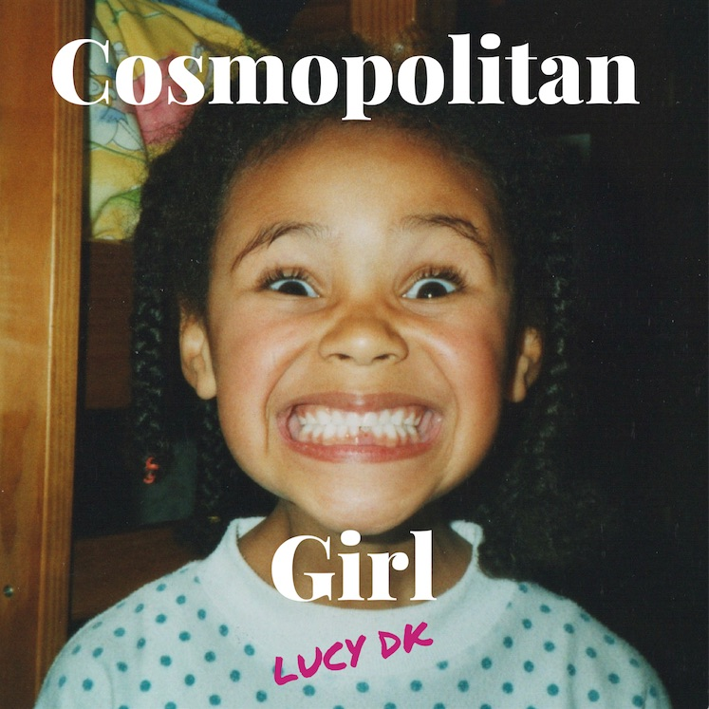
Buy Cosmopolitan Girl on iTunes:
https://itunes.apple.com/gb/album/cosmopolitan-girl-single/id1050501401

Listen to more of Lucy’s music free on SoundCloud:
www.soundcloud.com/lucydk

Watch music videos and live performances on YouTube:
www.youtube.com/lucydkmusic

Keep up to date with gigs and new releases on Facebook:
www.facebook.com/lucydk

For booking enquiries please email:
ldaviesk@gmail.com

